

LANZHOU UNIVERSITY OF TECHNOLOGY

毕业设计

题目 | 基于用户行为分析的实时信息流排序与分发系统

学生姓名 | 甄弘硕
学 号 | 220162701059
专业班级 | 软件工程2022级1班
指导教师 | 韦慧怡，崔高翔
学 院 | 计算机与人工智能学院
答辩日期 | 2026年 6 月 日

基于用户行为分析的实时信息流排序与分发系统
Real-time Information Flow Ranking and Distribution System Based on User Behavior Analysis

甄弘硕(ZHENG HongShuo)
220162701059

摘 要

随着社交媒体内容规模持续增长，传统时间倒序信息流已难以满足个性化阅读需求。本文设计并实现基于用户行为分析的实时信息流排序与分发系统，采用 Spring Boot、Vue 3 与 MySQL 的前后端分离架构，支持注册登录、发帖、评论、点赞、转发、引用、关注、搜索、通知、私信、用户画像、AI 问答和广告投放等功能。系统通过浏览、点赞、评论、转发、搜索和负反馈等行为构建用户画像，融合多行为加权、TF-IDF 内容相似度、协同过滤、时间衰减、热门话题和作者多样性等策略完成推荐排序，并提供推荐效果对比、权重调节和画像可视化，验证了系统功能链路与排序策略的可行性。

关键词：信息流推荐；用户行为分析；用户画像；混合排序；Spring Boot

Abstract

With the rapid growth of social media content, chronological feeds can no longer meet personalized reading needs. This thesis designs and implements a real-time feed ranking and distribution system based on user behavior analysis. The system adopts a front-end and back-end separated architecture with Spring Boot, Vue 3 and MySQL, and supports authentication, posting, comments, likes, reposts, quotes, following, search, notifications, private messages, user personas, AI question answering and advertisement delivery. It builds user profiles from views, likes, comments, reposts, searches and negative feedback, and combines multi-behavior scoring, TF-IDF similarity, collaborative filtering, time decay, trending topics and author diversity to generate explainable ranking results. Recommendation comparison, weight tuning and persona visualization are also provided to verify the feasibility of the functional workflow and ranking strategy.

Key words: feed recommendation; user behavior analysis; user profile; hybrid ranking; Spring Boot

目 录
摘 要 I
Abstract II
第1章 绪论 1
1.1 研究背景及意义 1
1.1.1 研究背景 1
1.1.2 研究意义 1
1.2 国内外的发展状况及应用 2
1.2.1 国内外发展状况 2
1.2.2 实时信息流排序与分发系统的应用 3
1.3 毕业设计主要内容及说明书的组织结构 4
1.3.1 毕业设计主要内容 4
1.3.2 说明书的组织结构 4
第2章 系统需求分析 6
2.1 功能需求 6
2.2 性能需求 7
2.3 技术可行性分析 8
2.4 非技术经济因素和工程伦理 8
第3章 系统总体设计 10
3.1系统体系架构设计 10
3.2 功能模块设计 10
3.3 数据库设计 12
3.4 推荐算法设计 16
3.5 实现系统的关键技术 19
3.6 安全与实时通信设计 20
3.7 广告分发设计 21
3.8 算法可视化设计 21
3.9 核心 REST 接口与 DTO 约定 22
3.10 关键术语与符号说明 23
3.11 推荐流水线与复杂度分析 24
第4章 系统详细设计及实现 26
4.1 开发环境与项目结构 26
4.2 部署配置与运维要点 27
4.3 用户认证与内容互动实现 28
4.4 推荐排序实现 31
4.5 AI模块与管理后台实现 34
4.6 广告智能分发实现 37
第5章 系统测试及使用说明 40
5.1 系统测试报告 40
5.1.1 测试的目的及原则 40
5.1.2 测试过程及结果 40
5.1.3 测试总结 50
5.1.4 测试数据构造与实验建议 51
5.2 系统使用说明 51
5.2.1 系统简介 51
5.2.2 系统运行环境 51
5.2.3 系统操作说明 52
设计总结 53
工作总结 53
不足与展望 54
个人收获 55
系统功能验证流程概要 55
参考文献 56
外文翻译 57
原文 57
译文 58
附录 程序源代码 59
致 谢 60

第1章 绪论

1.1 研究背景及意义

1.1.1 研究背景
随着移动互联网和社交媒体平台的快速发展，用户每天面对的信息规模持续扩大。以微博、X、抖音、B站等平台为代表的内容社区，已经从单纯的信息发布工具发展为内容消费、社交互动、广告分发和智能服务的综合平台。在这样的场景下，平台的内容供给远远超过用户能够主动浏览和筛选的范围，信息过载成为影响用户体验的重要问题。
信息过载意味着“看不完”，导致注意力资源的稀缺分配：用户在同一停留时间内只能消费有限条内容，平台必须在海量候选中做出取舍。传统时间流假设“越新越重要”，隐含前提是用户对所有发布者具有均匀关注度，这与真实社交网络中的兴趣差异、互动强度和内容偏好并不一致存在较大偏差。推荐排序试图依据浏览、点赞、评论、关注等行为推断用户偏好，使每一次刷新更具针对性，从而提升用户满意度与平台粘性，这与基于用户浏览行为的个性化推荐研究以及深度学习推荐系统的基本目标一致[7][11]。
传统信息流通常采用发布时间倒序排列方式，即最新发布的内容排在最前面。这种方式实现简单，能够保证时效性，但缺少对用户兴趣、内容质量、社交关系和行为反馈的综合考虑。当平台内容数量增加后，用户需要花费大量时间从时间流中寻找有价值内容，容易错过真正感兴趣的帖子。同时，优质内容也可能因为发布时间较早而快速失去曝光机会，平台内容分发效率受到限制。

1.1.2 研究意义
推荐排序技术为解决上述问题提供了有效途径。系统可以通过采集用户浏览、点赞、评论、转发、搜索、关注、点踩、快速滑过等多维行为，分析用户兴趣偏好和互动习惯，并结合内容标签、文本相似度、热门话题、社交关系和时间衰减等因素，对信息流进行个性化排序。相比单一时间倒序，个性化推荐能够在保持内容新鲜度的同时提高兴趣命中率，使用户更快获得符合自身需求的信息。
本课题以类 X/Twitter 社交媒体平台为业务背景，设计并实现一套基于用户行为分析的实时信息流排序与分发系统。系统既包含注册登录、发帖、评论、点赞、转发、引用、关注、搜索、通知、私信等社交媒体基础功能，也重点实现用户画像、混合多因子推荐、协同过滤、TF-IDF 内容相似度、AI 推荐策略、算法效果对比和信息流广告智能分发等核心模块。通过该课题的设计与实现，可以综合训练 Web 系统开发、数据库建模、推荐算法工程化、实时通信、数据可视化和 AI 服务集成等能力。
本设计的主要目的是构建一个具备完整业务链路和推荐排序能力的社交媒体信息流系统。系统需要在前后端分离架构下实现用户端、管理员端和算法验证端，并通过统一的数据模型将用户行为、内容特征、社交关系和推荐结果连接起来，形成可验证、可测试、可扩展的软件系统。
本设计的总体目标是在项目周期内交付一套可运行、可演示、可验证的社交媒体信息流推荐系统，并形成覆盖需求分析、系统设计、编码实现和测试验证的技术文档。功能层面，系统需要贯通用户认证、内容生产、社交互动、实时通知、私信、搜索、广告与后台治理等链路；算法层面，需要实现以用户行为画像为核心的混合排序，并结合 TF-IDF、协同过滤和 AI 推荐策略进行对照；工程层面，需要保持后端分层清晰、前端组件职责明确、接口命名稳定，并在 AI 推理、数据导入等长耗时场景中提供降级或补齐机制；评测层面，需要通过对比实验、评分明细、漏斗图和参数调节面板展示推荐策略的有效性。

1.2 国内外的发展状况及应用

1.2.1 国内外发展状况
工业界推荐系统已从早期协同过滤与矩阵分解，逐步演进为融合深度模型、多任务学习与海量日志训练的排序架构。YouTube 推荐系统相关研究表明，深度神经网络可以综合用户历史行为、上下文和候选内容特征，从而服务于大规模视频推荐场景[21]。X 平台开源的推荐算法也展示了候选召回、过滤与重排序等工程流水线思想，为本课题“关注源 + 全站源”的双源候选组织提供了现实参照[15]。
在国内学术语境下，信息流推荐、用户画像和算法治理同样是研究热点。已有研究从科技传播、用户浏览行为、用户画像构建和推荐去偏等角度指出，推荐系统既要提升内容匹配效率，也要兼顾用户兴趣漂移、信息茧房和结果可解释性等问题[1][7][8][20]。因此，本文在实现混合推荐排序时，不只追求点击与互动分数，还加入作者多样性、负反馈衰减、冷启动探索和评分拆分展示，使算法逻辑能够对应系统实际功能与可视化分析要求。
近年来，深度学习推荐模型和 CTR 预估模型不断强化对用户兴趣序列、交叉特征和上下文信息的建模能力，DeepFM、DIEN 等方法说明了深度模型在点击率预测与兴趣演化建模中的价值[18][19]。本文中的系统没有直接训练大规模深度推荐模型，而是在可解释混合打分基础上增加 AI 推荐策略，用于候选理解、排序解释和降级对比，从而在毕业设计规模的数据条件下体现智能推荐思想[11][14]。
矩阵分解和深度推荐模型通常通过低维向量表示用户与物品，并利用历史交互学习潜在偏好，能够在大规模行为日志中发现人工标签难以覆盖的兴趣关系[16][18][19]。与这类需要持续训练和较大数据规模的方法相比，本文当前实现更强调可运行、可解释和易调参的多因子启发式排序；协同过滤加成、文本相似度加成和动态权重共同构成了适合本系统数据规模的折中方案。
在国内的工程语境中，Spring Boot、Vue 与 MySQL 的组合具有较低学习成本和较好的资料基础，适合完成任务书要求的前后端分离信息系统[6][9][10]。数据库层面，本文以关系型模型承载用户、帖子、互动、消息、通知、广告和推荐日志等核心对象，并通过索引与业务分层控制查询复杂度[13]。算法层面，矩阵分解、协同过滤和深度学习推荐系统的理论为本文理解用户兴趣建模、隐式反馈和排序评估提供了方法参照[11][16][17]。
接口设计方面，系统围绕用户、帖子、互动、关注、消息、通知、广告、画像和推荐策略等资源划分 RESTful API，使前端页面能够通过统一路径访问后端服务；实时私信和通知则通过消息通道实现近实时推送。该设计符合任务书对 Spring Boot RESTful API、Vue 单页应用和前后端分离 B/S 架构的要求，也便于后续进行接口测试、权限控制和功能扩展[6][13]。

1.2.2 实时信息流排序与分发系统的应用
实时信息流排序与分发系统主要应用于社交媒体、新闻资讯、内容社区和广告投放等场景。本文系统以类 X/Twitter 平台为原型，将内容生产、用户互动、实时通知、私信通信、用户画像、推荐排序和广告分发组织在同一业务闭环中，使推荐算法不再停留于离线实验，而能够直接服务于用户刷新信息流、管理员切换策略和答辩演示中的效果对比。
在具体应用中，推荐流用于根据用户行为和内容特征生成个性化帖子列表，关注流用于保留社交关系带来的确定性内容来源，广告分发模块则利用画像标签和广告统计实现较为基础的智能投放。该应用形态能够较好体现任务书中“实时信息流排序与分发”“AI 辅助功能”“算法效果可视化”和“广告智能分发”等要求。

1.3 毕业设计主要内容及说明书的组织结构

1.3.1 毕业设计主要内容
本文所称“实时”主要指交互层面的及时反馈，例如通知推送、私信到达、信息流刷新和策略切换后的结果更新，而非面向超高并发生产环境的极限吞吐指标。传统混合推荐路径以毫秒级到秒级响应为目标；AI 推荐路径由于依赖本地大模型推理，采用缓存优先与异步预计算思路，在缓存未命中时先返回传统推荐结果，同时后台触发 AI 排序计算，以保证信息流主链路可用。
本课题的主要内容包括以下几个方面。第一，设计并实现系统基础平台，包括用户注册登录、角色管理、内容发布、图片上传、评论与多级回复、点赞、点踩、转发、引用、关注、搜索、热门话题、通知和私信等功能。第二，设计统一的用户行为数据模型，记录浏览、点赞、评论、转发、搜索、点踩、快速滑过等行为，为用户画像和推荐算法提供数据基础。第三，构建用户画像模块，从兴趣标签、作者偏好、行为强度、互动风格、内容深度偏好和新鲜度偏好等维度描述用户。第四，实现混合多因子推荐排序算法，将多行为加权评分、互动率、关注来源加成、标签匹配、TF-IDF 相似度、协同过滤、热门话题加成、时间衰减、负反馈过滤、作者多样性惩罚和随机探索机制结合起来。第五，集成 AI 大语言模型，提供 AI 自动打标、AI 推荐和智能问答能力。第六，实现广告智能分发模块，根据用户兴趣标签、广告标签、出价和历史点击率计算广告匹配分，并按配置在信息流中插入原生广告。第七，实现算法效果可视化对比，包括推荐流与时间流对比、多用户画像对比、推荐评分详情、参数调节面板和排序管道漏斗图。
通过上述设计，系统能够较完整地覆盖从内容产生、行为采集、画像构建、候选召回、排序分发到效果验证的推荐链路。该系统在软件工程完整性与推荐算法应用价值之间形成相互支撑的整体。

1.3.2 说明书的组织结构
全文包含中文摘要与关键词、英文 Abstract 与 Key Words。正文按照模板相关要求进行组织编写：第 1 章为绪论，介绍研究背景及意义、国内外发展状况与系统应用，并说明毕业设计主要内容和说明书结构；第 2 章为系统需求分析，阐述功能需求、性能需求、技术可行性以及非技术经济因素和工程伦理；第 3 章为系统总体设计，说明体系架构、功能结构、核心算法、数据库设计和关键技术；第 4 章为系统详细设计及实现，围绕用户认证与内容互动、推荐排序与用户画像、AI 与广告及管理后台等模块展开；第 5 章为系统测试及使用说明，给出测试报告、运行环境和操作说明。文后依次安排设计总结、参考文献、外文翻译、附录程序源代码和致谢。

第2章 系统需求分析

2.1 功能需求
根据课题任务要求和系统业务场景，系统面向两类主要角色：普通用户和管理员。普通用户主要完成内容消费与社交互动，包括注册登录、浏览推荐信息流、发布帖子、上传图片、评论、点赞、点踩、转发、引用、关注、取关、搜索内容、查看通知、发送私信和查看个人画像等操作。管理员主要完成平台治理与运维配置，包括用户管理、角色切换、封禁用户、平台统计、推荐策略切换、AI 批量打标、Kaggle 数据导入、广告管理和算法验证等操作。
表 2-1 系统功能需求表
功能模块 | 主要需求
用户模块 | 注册、登录、用户资料查看与编辑、头像上传、角色管理、封禁管理。
内容模块 | 发帖、图片上传、评论、多级回复、转发、引用、删除、帖子详情查看。
社交模块 | 关注、取关、关注状态查询、关注列表、粉丝列表和推荐关注。
行为模块 | 记录浏览、点赞、评论、转发、搜索、点踩、跳过等行为事件。
推荐模块 | 个性化推荐、关注流、传统推荐策略、AI 推荐策略和策略热切换。
画像模块 | 兴趣标签、行为统计、活跃时段、用户类型、内容偏好、词云和雷达图。
搜索模块 | 综合搜索、帖子搜索、用户搜索、话题搜索和搜索建议。
通知私信模块 | 点赞、评论、关注、转发、引用通知，未读数管理和实时私信。
广告模块 | 信息流广告插入、广告匹配、广告创建编辑、展示点击统计。
管理模块 | 用户管理、平台统计、推荐策略管理、Kaggle 数据导入、AI 打标和广告管理。

上表按模块聚合需求，可与课题需求条目逐项对照；实际实现时仍存在跨模块耦合点需要注意。例如推荐模块依赖行为模块的完备性——若搜索行为（SEARCH）未记录，则画像缺少主动意图信号；广告模块依赖画像模块的标签质量——若 AI 打标失败则匹配度下降；通知模块依赖内容模块的评论层级正确性——若父内容字段（parentContent）关联错误，将导致通知定位失败。职责划分并不能取代集成测试，第 4 章据此给出端到端场景用例。
系统的非功能需求主要包括可用性、可维护性、可扩展性、实时性、安全性和可视化能力。可用性要求普通用户能够按照常见社交媒体操作习惯完成浏览与互动；可维护性要求后端分层清晰、前端组件职责明确；可扩展性要求推荐策略可替换、广告策略可扩展；实时性要求通知和私信能够及时推送；安全性要求登录状态与角色权限具备基本控制；可视化能力要求推荐效果和用户画像能够通过图表进行展示。
普通用户视角：需要稳定登录与会话保持、清晰的信息流切换（For You / Following）、可靠的互动反馈（计数与通知）。管理员视角：需要便捷的用户治理、策略切换与外部数据导入能力。推荐与画像视角：需要统一 behavior 模型与足够的日志字段支撑离线分析与在线排序。广告视角：需要定向字段与统计闭环。AI 视角：需要可配置模型地址与超时降级。
普通用户侧细化：除发帖与互动外，需保证会话失效后可重新登录且不丢失历史行为沉淀；推荐流与关注流切换时应维持分页或刷新策略一致，避免误跳。私信侧需支持未读状态与送达感知。
管理员侧细化：后台操作应具备明确反馈与列表刷新；批量导入与批量打标属于长耗时任务，理想情况下可进一步异步化并以任务 ID 查询进度；当前实现通过限制单次导入规模和失败时使用内置内容库补齐，保证演示数据可以稳定生成。
推荐子系统：需暴露策略类型与评分明细字段以便算法验证页展示；候选为空时应返回空列表而非错误码，以便前端区分“无内容”与“接口故障”。
广告子系统：需区分广告启用与全局插入开关；无可用广告时不应阻断信息流主体加载。
AI 子系统：需区分打标模型与推荐模型的配置键；云端对话与本地推理失败时应互不牵连。

2.2 性能需求
系统性能需求主要体现在信息流刷新、推荐排序、实时通知、数据导入和可视化展示等方面。普通用户刷新推荐流或关注流时，系统应在可接受时间内返回分页结果；传统混合推荐路径应优先保证稳定性和响应速度，AI 推荐路径可通过缓存、异步预计算和降级策略避免阻塞主链路。
性能与可扩展性：中小规模部署下单机即可满足需求；后续可通过 Redis 缓存热门话题与画像摘要、异步线程池执行 AI 打标降低接口尾延迟。安全性：当前实现侧重功能链路完整性，生产环境需加固密码存储、HTTPS、CSRF 与接口鉴权。可维护性：Java 包结构与 Vue 目录结构遵循约定，便于团队协作。可观测性：关键路径打印耗时日志可辅助定位推荐瓶颈。兼容性：前端采用现代浏览器特性，WebSocket 降级由 SockJS 处理。

2.3 技术可行性分析
从技术可行性看，系统采用的技术均较成熟。Spring Boot 能够支撑后端 REST API 开发和业务模块组织；Vue 3 能够完成前端单页应用开发；MySQL 能够满足本文数据规模下的存储要求；WebSocket 能够实现实时通知和私信；ECharts 能够完成算法效果、画像和广告报表可视化；Ollama 和 DeepSeek API 能够为 AI 推荐、AI 打标和智能助手提供模型能力。因此，系统在技术上具有可实现性。
从经济可行性看，系统主要依赖开源框架和本地开发环境。Spring Boot、Vue、MySQL、ECharts、Maven、Node.js 等工具均可免费使用，AI 推荐可以通过本地 Ollama 模型运行，降低外部接口调用成本。在本项目约束下，开发与部署成本可控。
从操作可行性看，系统界面参照主流社交媒体交互方式设计。普通用户能够通过首页信息流完成浏览、发帖、点赞、评论和关注等常见操作，管理员能够在后台完成用户管理、推荐策略切换、AI 打标和广告管理。系统操作流程符合常见 Web 应用习惯，具备可操作性。
数据可行性：系统可通过 DataSeeder、Kaggle 公开数据集导入和内置内容库补齐构造多标签、多用户、多行为样本，满足算法验证所需的最小数据规模。风险可行性：主要风险包括外部数据源不可用、本地模型资源占用与推理延迟；对策包括本地缓存、内置数据兜底、超时降级与切换传统算法。综上，项目在既定资源约束下可完成开发与验证。

2.4 非技术经济因素和工程伦理
从经济因素看，本系统主要基于 Spring Boot、Vue、MySQL、ECharts、Maven、Node.js、Ollama 等开源或本地可运行工具构建，开发和部署成本较低，适合毕业设计阶段完成原型验证。系统引入 Kaggle 数据导入和内置数据补齐机制，也降低了真实业务数据获取不足带来的实验成本。
从社会和伦理因素看，信息流推荐系统会影响用户看到的内容范围，因此需要关注隐私保护、算法透明度、负反馈尊重和信息茧房风险。本文在设计中加入评分拆分、推荐理由、作者多样性惩罚、负反馈过滤和冷启动探索等机制，使用户和管理员能够理解推荐结果的主要来源，并避免单一作者或单一主题长期占据信息流。
从环境因素看，本系统以本地开发和单机部署为主，硬件资源消耗可控。AI 推荐部分采用可切换策略和传统算法降级，避免在模型不可用或计算资源不足时持续占用系统资源。后续若进入生产环境，还应进一步完善密码哈希、HTTPS、访问审计、数据脱敏和权限拦截等安全措施。

第3章 系统总体设计

3.1系统体系架构设计
系统采用 B/S 架构和前后端分离模式。浏览器端运行 Vue 3 单页应用，负责页面展示、用户交互、状态维护和图表渲染；后端采用 Spring Boot 提供 RESTful API 和 WebSocket 服务；数据库采用 MySQL 存储用户、内容、行为、标签、关注、通知、私信、广告等业务数据；AI 服务通过 Ollama 和 DeepSeek API 提供内容打标、AI 推荐和智能问答能力；外部数据导入模块用于导入 Kaggle 公开数据集，并在导入不足时使用内置内容库补齐候选内容。
前后端分离使界面迭代与算法迭代可并行：前端专注交互与可视化，后端专注业务一致性与数据完整性。推荐链路在逻辑上可分为数据层（行为与内容持久化）、特征层（画像与 TF-IDF 向量）、排序层（Hybrid 或 AI 策略）、展示层（信息流混合广告）。异常与降级集中在排序层实现，避免向上层泄漏实现细节。
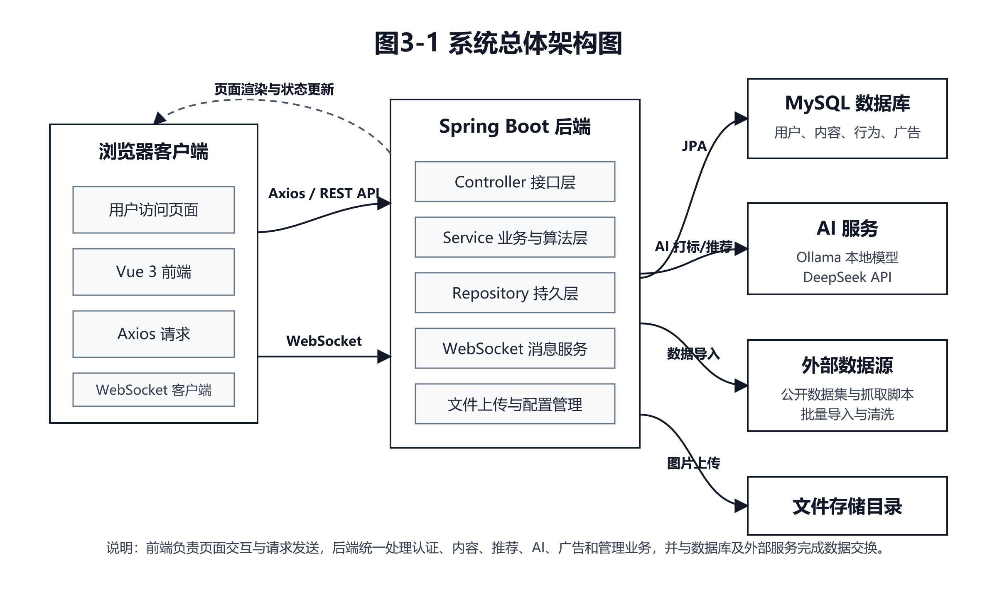图3-1 系统总体架构图
后端分层设计能够提高系统可维护性。controller 层负责请求入口，service 层负责业务规则和算法逻辑，repository 层负责数据访问，model 层定义 JPA 实体，dto 层封装前后端交互对象，config 层管理跨域、安全、WebSocket 和文件映射等配置。推荐系统相关逻辑集中在 service 层，便于传统推荐策略、AI 推荐策略和策略管理器之间解耦。DTO 中的评分拆分对象（ScoreBreakdown）、画像响应对象（PersonaResponse）等与前端字段一一对应，减少重复拼装字段。

3.2 功能模块设计
系统功能模块按照业务领域划分为用户认证与资料模块、内容发布与互动模块、社交关系模块、行为采集模块、推荐排序模块、用户画像模块、搜索与热门话题模块、通知与私信模块、广告分发模块、AI 智能模块、管理后台模块和数据导入模块。各模块之间通过 REST API、WebSocket 推送与共享数据库表协作：行为采集模块为画像与推荐提供输入；推荐排序模块依赖画像输出动态权重；通知与私信模块依赖内容与行为事件触发；广告分发模块依赖画像标签与广告定向标签匹配。
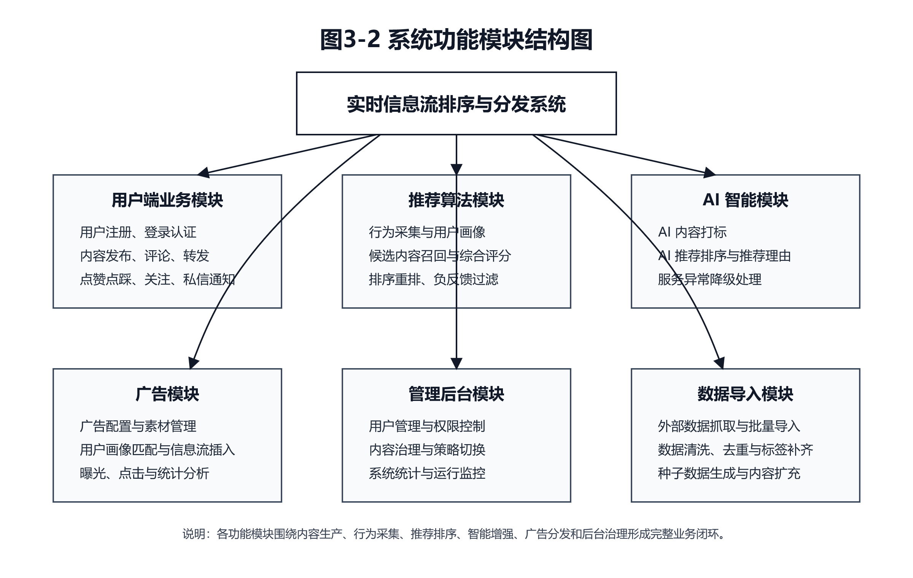图3-2 系统功能模块结构图
从软件工程角度，每个核心模块可归纳为输入、处理逻辑、输出与异常处理四个要素，以保证后续实现与测试有据可依。用户认证与资料模块的输入为注册信息、登录凭证与资料编辑表单；处理包括用户名唯一性校验、密码校验、封禁状态检查、JWT 生成与返回；输出为用户实体与 Token；异常包括用户名冲突、密码错误、账号封禁等。内容发布与互动模块的输入为帖子正文、图片、评论父节点及转发引用关系；处理包括上传文件映射、内容持久化、标签解析与异步 AI 打标；输出为 Content 实体及互动计数更新；异常包括上传失败、内容为空、删除权限不足等。
社交关系模块维护关注者标识（followerId）和被关注者标识（followeeId），输入为关注或取关请求；处理包括重复关注过滤、双向列表查询；输出为关注状态与列表数据；异常包括关注自身、目标用户不存在等。行为采集模块输入为前端上报的行为类型与可选停留时长；处理为写入 behaviors 表并在部分场景更新内容计数；输出为行为记录 ID；异常包括未登录、非法类型等。推荐排序模块输入为用户 ID 与分页参数；处理为候选池构建、策略选择、打分与采样；输出为排序后的帖子列表及可选评分拆分对象（ScoreBreakdown）；异常包括候选为空、AI 服务超时触发降级等。
用户画像模块输入为用户 ID 与时间窗口；处理为聚合行为、统计标签与偏好并计算动态权重集合（DynamicWeights）；输出为画像 DTO 供推荐与广告使用；异常包括冷启动用户数据不足时返回默认权重。搜索与热门话题模块输入为关键词与分页；处理为全文或字段检索、话题聚合；输出为帖子、用户、话题等多类型结果；异常包括关键词过短返回提示。通知与私信模块输入为互动事件或私信载荷；处理为持久化并经由 WebSocket 推送；输出为通知列表或未读数；异常包括接收者离线仅保留数据库记录。广告分发模块输入为用户画像与广告配置；处理为匹配分计算与间隔插入；输出为广告卡片与统计字段；异常包括无可用广告时跳过插入。
表 3-1 核心模块输入输出概要
模块 | 主要输入 | 主要输出 | 典型异常
用户认证与资料 | 用户名、密码、资料字段 | 用户信息与 Token | 用户名重复、账号封禁
内容与互动 | 帖子、评论、转发参数 | Content 与计数更新 | 上传失败、权限不足
行为采集 | 行为类型、contentId、时长 | Behavior 记录 | 类型非法、未登录
推荐排序 | userId、分页 | 排序 Feed、评分明细 | 候选为空、AI 降级
用户画像 | userId | 标签分布、动态权重 | 冷启动默认策略
通知与私信 | 事件、消息体 | 通知记录、WS 推送 | 连接断开仅落库
广告分发 | 画像标签、广告配置 | 排序广告、展示统计 | 无启用广告

3.3 数据库设计
数据库设计围绕用户、内容、行为、社交关系和推荐辅助数据展开。核心实体包括用户、帖子、行为、标签、关注、通知、私信、负反馈、广告和广告配置。用户可以发布多条内容，可以产生多条行为记录，也可以关注多个用户；内容可以拥有多个标签，可以触发多条通知，也可以作为评论、转发和引用的目标；广告根据标签、类别、出价和历史效果参与信息流插入。
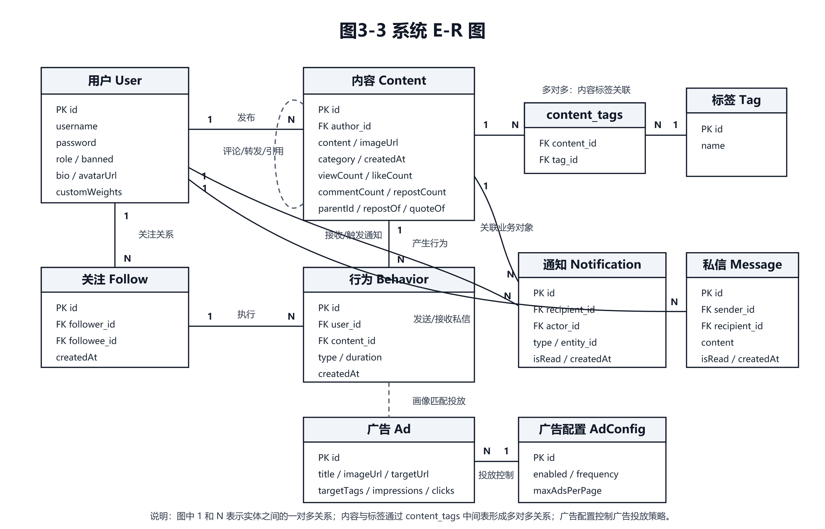图3-3 系统 E-R 图
表 3-2 用户表设计
字段 | 类型 | 说明
id | BIGINT | 用户 ID
username | VARCHAR | 用户名，唯一
handle | VARCHAR | 用户昵称标识，如 @user1
avatarUrl | VARCHAR | 头像地址
bio | VARCHAR | 个人简介
password | VARCHAR | 登录密码
role | VARCHAR | USER 或 ADMIN
banned | BOOLEAN | 是否封禁
customWeights | TEXT | 用户自定义推荐权重 JSON
createdAt | DATETIME | 创建时间

表 3-3 内容表设计
字段 | 类型 | 说明
id | BIGINT | 帖子 ID
author | BIGINT | 作者 ID
parentContent | BIGINT | 父评论 ID
content | TEXT | 正文内容
imageUrl | VARCHAR | 图片地址
category | VARCHAR | 内容分类
viewCount | INT | 浏览数
likeCount | INT | 点赞数
commentCount | INT | 评论数
dislikeCount | INT | 点踩数
repostCount | INT | 转发或引用数
createdAt | DATETIME | 发布时间

表 3-4 行为表设计
字段 | 类型 | 说明
id | BIGINT | 行为 ID
userId | BIGINT | 用户 ID
contentId | BIGINT | 内容 ID，搜索等行为可为空
type | VARCHAR | VIEW、LIKE、DISLIKE、SKIP、SEARCH 等
duration | INT | 浏览停留时长
createdAt | DATETIME | 行为发生时间

关注表用于表达用户之间的有向社交关系，是“网内候选”的数据来源：若 followerId 关注 followeeId，则 followeeId 发布的内容可优先进入该 followerId 的候选池并给予 In-Network 加成。标签系统通常采用标签实体表与内容标签关联表的多对多结构：标签名称唯一，内容与标签通过中间表关联，便于热门话题统计与检索索引。通知表记录点赞、评论、关注等事件型消息；私信表或消息实体记录会话与聊天内容，可与 WebSocket 推送配合实现实时性。
表 3-5 关注表设计概要
字段 | 类型 | 说明
id | BIGINT | 主键
followerId | BIGINT | 关注者用户 ID，逻辑外键指向 users.id
followeeId | BIGINT | 被关注者用户 ID
createdAt | DATETIME | 关注时间，可用于推荐中新关注加权

表 3-6 标签实体与内容标签关联（逻辑结构）
对象 | 说明
tags | 标签表：id、name（唯一）、可选统计字段。
content_tags | 关联表：contentId、tagId，联合唯一约束防止重复绑定。

表 3-7 通知表设计概要
字段 | 类型 | 说明
id | BIGINT | 主键
recipientId | BIGINT | 接收者
actorId | BIGINT | 触发者
type | VARCHAR | LIKE、COMMENT、FOLLOW、REPOST、QUOTE 等
entityId | BIGINT | 关联帖子或内容 ID
isRead | BOOLEAN | 是否已读
createdAt | DATETIME | 通知时间

表 3-8 广告表设计概要
字段 | 类型 | 说明
id | BIGINT | 主键
title、description、imageUrl | VARCHAR/TEXT | 展示文案与素材
targetUrl | VARCHAR | 点击跳转地址
advertiser | VARCHAR | 广告主标识
targetTags、category | VARCHAR | 定向标签与类别
bidPrice | DOUBLE | 出价，用于排序加权
impressionCount、clickCount | INT | 展示与点击计数
active | BOOLEAN | 是否启用投放

表 3-9 负反馈信号表（negative_signals）
字段 | 类型 | 说明
id | BIGINT | 主键，自增
user_id | BIGINT | 发起负反馈的用户
target_type | 枚举 | CONTENT（单条内容）或 AUTHOR（作者）
target_id | BIGINT | 目标内容 ID 或用户 ID
signal_type | 枚举 | NOT_INTERESTED、BLOCK、MUTE
created_at | DATETIME | 创建时间

表 3-10 私信消息表（tb_message）
字段 | 类型 | 说明
id | BIGINT | 主键
sender_id | BIGINT | 发送方用户 ID
recipient_id | BIGINT | 接收方用户 ID
content | TEXT | 消息正文
created_at | DATETIME | 发送时间
is_read | BOOLEAN | 是否已读

负反馈表与推荐候选过滤直接对应：target_type=AUTHOR 时在候选阶段剔除该作者全部帖子；target_type=CONTENT 时剔除指定帖子。signal_type 区分不感兴趣、屏蔽与静音的业务语义，便于后续扩展撤销策略。私信表采用扁平消息行存储会话消息；会话列表可由双方 userId 聚合查询实现；本文未单独引入会话头表以降低建模复杂度。删除用户时的级联策略应在生产环境通过外键或定时清理任务补齐。
数据库设计的冗余与一致性方面：内容表的浏览数（viewCount）、点赞数（likeCount）等计数字段属于适度冗余，可通过事务或异步修正保持一致性，换取列表页与推荐打分时的读取性能。行为表保留停留时长字段（duration）支撑停留时长画像；搜索行为（SEARCH）的内容标识（contentId）可为空，以表达“主动检索意图”而不绑定单一帖子。负反馈相关实体用于屏蔽作者、隐藏帖子等，推荐流水线在候选合并后立即过滤，避免无效打分消耗。

3.4 推荐算法设计
推荐排序模块采用策略模式设计，统一定义推荐策略接口（RecommendationStrategy），传统混合推荐策略（HybridRecommendationStrategy）和 AI 推荐策略（AiRecommendationStrategy）均实现该接口。推荐策略管理器（RecommendationStrategyManager）持有两种策略实例并维护全局策略标识（如 traditional、ai），推荐服务（RecommendationService）在组装候选池后通过 getActiveStrategy() 获取当前策略执行排序，从而避免在业务代码中硬编码单一算法实现。管理员通过 PUT /api/admin/rec-strategy 切换策略后，全体用户的 For You 请求立即生效，从而在线对比两种策略的输出差异。该模式符合开闭原则：新增策略仅需实现接口并注册到管理器即可，也便于在个性化重排序实验中扩展新的策略分支[5][12]。
（1）候选池与双源机制。参考公开信息流架构中的多源候选思想[15]，本系统将候选拆分为 In-Network 与 Out-of-Network。In-Network 来自当前用户所关注用户发布的最新内容，体现社交关系的信任传递与兴趣同质性；Out-of-Network 来自全站公开池，用于探索用户尚未关注但可能感兴趣的作者与话题。两路候选合并去重后形成统一列表，再进入过滤与打分。候选规模可通过上限截断与时间窗口控制，避免单次请求遍历全库。
（2）负反馈与合规过滤。负反馈信号包括屏蔽作者、对单条内容不感兴趣、静音等，存入独立实体后在候选阶段直接剔除或强降权，减少无效曝光与用户挫败感。该步骤位于打分之前，可降低后续 TF-IDF、协同过滤等计算开销。
（3）多行为加权互动分。不同行为类型对用户兴趣的揭示强度不同，一般转发、评论高于点赞，点赞高于浏览。系统对用户历史行为赋权并叠加时间衰减，形成 engagement 分量；互动率因子可采用点赞加评论量与浏览量的比值刻画内容“有效密度”，抑制刷量低质内容。
（4）TF-IDF 与余弦相似度。对文本内容分词后，词项 i 在文档 d 中的 TF-IDF 权重采用式（3-1）计算，其中 N 为语料文档数，df_i 为包含词 i 的文档数，tf_i,d 为词项 i 在文档 d 中的词频。
w_{i,d} = tf_{i,d} × log(N / df_i) （3-1）
系统在用户画像侧使用近期互动内容构造兴趣向量，在候选帖子侧构造内容向量，并按式（3-2）计算用户 u 与候选内容 c 的余弦相似度。该相似度作为内容相似度加成（tfidfSimilarityBoost）的主要来源，用于刻画语义层面的兴趣匹配，从而弥补纯标签匹配粒度较粗的问题。
sim(u,c) = Σ_i w_{i,u} w_{i,c} / (||u|| · ||c||) （3-2）
用户画像构建与行为偏好抽取的相关研究也说明，文本内容、浏览行为和显隐式反馈可以共同服务于个性化推荐[7][8]。
（5）协同过滤加成。协同过滤服务（CollaborativeFilteringService）基于用户—物品交互矩阵，结合多行为权重与时间衰减计算用户相似度，产出 Top-K 相似用户及其偏好内容集合；若候选帖子 ID 落在协同推荐集合中，则给予协同过滤加成（collaborativeBoost），并可由动态权重集合（DynamicWeights）中的协同权重进行调节。该方法能够在标签稀疏或新话题出现时利用群体智慧补全兴趣，与图卷积协同过滤、矩阵分解和基于物品协同过滤等推荐思想具有一致性[2][16][17]。
（6）时间衰减分段函数。设帖子年龄为 ageHours，可对不同区间施加不同衰减速率：黄金期（0–6h）衰减慢以突出时效；常规期（6–24h）线性或对数衰减；长尾期（72h+）加速衰减但仍保留非零底值以保留优质存量内容曝光机会。最终 timeDecay 作为除数作用于 engagement，实现“越新越靠前，但不绝对压制长尾”。
（7）作者多样性与探索。对同一作者（author）在候选列表中的多条内容施加递减系数，避免单一来源刷屏；随机扰动项（jitter）或加权随机洗牌在高分区间内引入可控随机性，实现探索与利用折中，缓解过滤气泡。评分拆分对象（ScoreBreakdown）将各分项写入 DTO，前端可展开查看，以支撑推荐结果的可解释性。该思路与推荐系统中多样性、质量偏好和去偏建模的研究方向相呼应[20]。
多因子综合评分可概括为：
（8）综合评分。传统混合推荐策略在候选过滤后计算最终推荐得分（finalScore）。为避免公式过长，式（3-3）采用缩写表示各分项，其中 E 为互动得分（engagement），D_t 为时间衰减因子（timeDecay）；B_topic、B_author、B_personal、B_tfidf、B_trend、B_cf、B_depth、B_fresh 分别表示话题亲和度、作者亲和度、个性化加成、内容相似度加成、热门话题加成、协同过滤加成、内容深度匹配加成和新鲜度偏好加成，ε 为随机扰动项（jitter）。
finalScore = E / D_t + B_topic + B_author + B_personal + B_tfidf + B_trend + B_cf + B_depth +
B_fresh + ε （3-3）
其中互动得分（engagement）、话题亲和度（topicAffinity）、协同过滤加成（collaborativeBoost）等分项均由用户行为画像服务（UserBehaviorProfileService）输出的动态权重集合（DynamicWeights）进行加权组合，使冷启动用户自动提高热门与探索权重，活跃用户自动提高个性化与协同权重。
（8）重复曝光惩罚。重复曝光惩罚在最终推荐得分（finalScore）计算完成后执行，用于降低用户已明确反馈内容的再次曝光概率。与项目代码中的常量保持一致：已点踩内容乘以点踩惩罚因子（DISLIKE_PENALTY_FACTOR，取值 0.02），已点赞内容乘以点赞惩罚因子（LIKE_PENALTY_FACTOR，取值 0.15），已浏览内容乘以浏览惩罚因子（VIEWED_PENALTY_FACTOR，取值 0.5）。其中点踩属于强负反馈，惩罚最重；已点赞和已浏览内容并非完全屏蔽，而是降低优先级，以便在保留少量回访可能的同时提升新内容曝光。
（9）AI 推荐与降级。AI 推荐策略（AiRecommendationStrategy）将画像摘要与候选摘要（含 id、正文片段、标签、互动统计）封装为提示词（Prompt），约束模型仅输出 JSON 结构，其中排序字段（ranking）表示候选顺序，理由字段（reasons）表示推荐解释。解析成功则重排列表；若 Ollama 不可用、超时或 JSON 非法，则降级为按基础互动分排序并在前端标识降级模式，保障系统可用性。该设计并非替代传统推荐模型，而是在混合排序基础上增加智能解释与对比实验入口，与深度学习推荐系统中“特征理解 + 排序优化”的发展方向保持一致[11][14][18][19]。
（10）加权随机采样。对候选按最终推荐得分（finalScore）降序排序后，若直接截取 Top-N，则每次刷新结果高度相似，列表多样性不足。工程上可在前 M 条候选中按式（3-4）计算前缀和并抽样：先计算前缀和 S_k，再取随机数 r 进行二分定位，重复直至凑满页大小。该机制对应课题要求中的加权随机采样与探索—利用平衡，使低分但非零分内容仍具曝光机会。若需可复现实验，可固定随机种子或关闭采样仅用于对比基线。
S_k = Σ_{i=1}^{k} w_i，r ∈ (0, S_M] （3-4）
（11）作者多样性惩罚的窗口化描述。在按分数初排后，可沿列表滑动长度为 L 的窗口，统计同一 author 出现次数；当次数超过阈值 t 时，对后续同作者候选追加惩罚项或将其后移。该策略与“同一作者刷屏”问题直接对应，且与第（10）条采样可组合：先窗口重排再加权抽样，或先抽样再轻量去重。隐式反馈（浏览、停留）在协同侧可视为弱正信号，与显式反馈联合建模的思想与融合显隐式反馈的推荐研究一致[4][16]。

3.5 实现系统的关键技术
用户画像模块由行为数据驱动生成。系统读取用户历史行为记录后，查询相关内容和标签，并根据行为类型赋予不同权重。一般而言，转发和评论代表较强兴趣，点赞代表正向兴趣，浏览代表弱兴趣，点踩、跳过和屏蔽代表负向兴趣。系统还结合行为发生时间进行衰减，使近期行为对画像影响更大。搜索行为（SEARCH）记录用户主动检索意图，可与标签偏好共同用于查询类兴趣发现；浏览行为（VIEW）附带的停留时长用于推断属于“浅阅读”还是“深度阅读”，进而调节内容深度匹配加成（depthMatchBoost）与新鲜度偏好加成（freshnessBoost）的权重。
图3-4 用户画像构建流程图：读取行为记录，按行为类型和时间赋权，统计兴趣标签、作者偏好、互动风格、内容深度偏好和新鲜度偏好，最终生成动态推荐权重。
画像输出通常包括：兴趣标签分布（标签名与权重）、作者偏好列表、活跃时段直方图、用户类型（创作者、互动型、浏览型）、行为强度统计、内容长度偏好与新鲜度偏好。动态权重集合（DynamicWeights）将这些偏好映射为推荐公式中各分项的系数，例如提高协同过滤权重（wCollaborative）、文本相似度权重（wTfidf）或热门话题权重（wTrending）。冷启动阶段若行为稀少，则回退到全局热门、时间新鲜度与随机探索，并逐步过渡到个性化；该策略与用户画像构建和深度学习推荐系统中对用户兴趣表征的讨论一致[8][11]。
系统将用户阶段划分为冷启动用户、初级用户和活跃用户。冷启动用户行为较少，推荐策略更依赖热门内容、时间新鲜度和随机探索；初级用户已有一定行为数据，推荐策略采用热门与个性化混合；活跃用户行为数据较丰富，推荐策略更依赖兴趣画像、协同过滤和作者偏好。通过不同阶段的动态权重调整，系统能够适应用户行为数据从少到多的变化过程。
表 3-11 用户阶段与推荐策略
用户阶段 | 判定条件 | 推荐策略特点
冷启动用户 | 行为数少于 10 | 更多依赖热门内容、新鲜内容和探索因子。
初级用户 | 行为数 10 到 49 | 热门内容与个性化标签匹配混合排序。
活跃用户 | 行为数不少于 50 | 更多依赖个性化画像、协同过滤和作者偏好。

3.6 安全与实时通信设计
系统登录成功后由后端生成 JWT 令牌（JWT Token）并返回给前端，前端将用户信息与令牌持久化于 localStorage，并在 Axios 全局拦截器中附加 Authorization 头。当前实现中，Spring Security 采用无状态配置，JWT 认证过滤器（JwtAuthFilter）主要完成令牌解析与上下文注入，接口层以功能联调和演示为重点；前端路由与管理页面根据管理员角色标识（role=ADMIN）控制入口，部分敏感操作仍需要在服务端进一步补充强制权限校验。正式部署时应将全放行策略（permitAll）调整为按角色授权，并补充 BCrypt 密码哈希、刷新令牌、接口审计日志和敏感操作拦截。
实时通信模块基于 WebSocket、SockJS 与 STOMP 协议实现可靠传输与浏览器兼容。后端配置消息代理与用户目的地前缀，使通知推送到 /user/{userId}/queue/notifications 等队列；前端订阅后在 UI 上增量更新未读徽标。私信同理可走独立队列或 REST 轮询兜底。断线重连时，数据库中的通知与消息记录仍保留，用户刷新页面可补偿展示，满足“实时优先、最终一致”的工程目标。
安全细节方面，生产环境应为 WebSocket 启用同源策略与令牌校验，防止未订阅他人队列；当前实现侧重功能链路验证，若暴露于公网必须补齐握手阶段的身份绑定。
总结而言，认证授权解决“谁能调用接口”，实时通信解决“如何把事件送达在线会话”，二者共同构成社交应用的体验底座。
后续若引入多设备同时在线，可在用户维度之外增加设备维度的推送策略，并与离线推送互为补充，形成连续可用的通知链路。

3.7 广告分发设计
信息流广告与社交内容共享同一浏览上下文，需兼顾用户体验与商业目标。系统在服务端或前端插入环节读取广告配置（如每隔 N 条帖子插入一条广告），再调用广告服务按用户画像兴趣标签与广告定向标签（targetTags）计算广告匹配分（adScore），并结合出价（bidPrice）与历史点击率（CTR）得到质量分。排序最高的若干条广告进入展示队列；展示与点击通过接口回写展示次数（impressionCount）和点击次数（clickCount），形成闭环优化数据。
广告与推荐共享画像数据源，但优化目标不同：推荐侧重长期留存与点击多样性，广告侧重转化与收益，因此二者公式分离且可通过配置限制每日曝光频次（可在后续版本扩展）。当前设计对应课题需求中的“标签匹配 + 出价加权”投放思路。
从指标体系看，展示次数反映库存消耗，点击次数反映创意吸引力，点击率（CTR）则是二者的比值；若仅优化标签匹配而忽略点击率，可能出现“匹配但不点击”的低效投放。因此质量分（qualityScore）引入历史点击率作为校正项，能够在新广告缺少统计时退化为中性权重，随着样本累积逐步提高区分度。若未来接入转化率埋点，还可进一步扩展为后置 ROI 模型。

3.8 算法可视化设计
算法验证页（CompareView）承担对比评测与结果解释职能：其一，双栏对比个性化排序与时间倒序，输出平均分、标签命中率、TF-IDF 均值、互动量与个性化倍率等统计量；其二，多用户画像对比展示不同用户的动态权重与 Top 推荐，体现“千人千面”；其三，排序管道漏斗图呈现候选规模在各过滤阶段的变化；其四，权重调节组件（WeightTuner）支持在线调节权重，并通过 /api/compare/tuned 重新计算推荐结果，验证参数敏感性。图表采用 ECharts，词云与雷达图用于画像页，以支撑数据驱动的观察与记录。
可视化模块强调先呈现中间结果再给出结论：读者可通过漏斗图观察候选在各阶段的收缩过程，通过双栏指标比较个性化排序相对时间序的差异，通过权重调节组件（WeightTuner）观察权重调整对指标的影响方向。

3.9 核心 REST 接口与 DTO 约定
为保证前后端并行开发与后期测试可追溯性，系统在控制器层采用统一 REST 风格资源命名，DTO 承载结构化输出，避免直接泄露实体内部字段。认证接口返回认证响应对象（AuthResponse），内含令牌（token）与用户概要；内容接口返回内容传输对象（ContentDTO）列表或分页包装；推荐接口支持附带评分拆分对象（ScoreBreakdown）的扩展字段以便调试；管理员接口统一前缀 /api/admin。错误响应包含 HTTP 状态码与简要消息（message），前端 Axios 拦截器集中提示。
表 3-12 主要 REST 接口一览（节选）
路径 | 方法 | 说明
/api/auth/register | POST | 注册并签发 Token
/api/auth/login | POST | 登录校验与签发 Token
/api/content/feed | GET | 个性化或时间序信息流
/api/content/publish | POST | 发帖
/api/behavior/view | POST | 浏览行为与停留时长
/api/search | GET | 综合搜索，附带 userId 记  SEARCH
/api/compare/feed | GET | 算法对比数据
/api/compare/tuned | GET | 调参后的对比数据
/api/admin/rec-strategy | GET/PUT | 查询或切换推荐策略
/api/user/{id}/persona | GET | 用户画像

DTO 命名遵循 Java Bean 规范，前端按接口字段约定进行渲染与状态维护，可减少字段遗漏和命名不一致。对于大数据量导入与 AI 推理等耗时操作，可采用异步任务 ID 查询模式扩展；当前版本仍以同步返回和缓存预计算为主，以保持实现简洁。

3.10 关键术语与符号说明
为便于阅读，对文中频繁出现的术语、符号与缩写集中说明。下列定义侧重于本文语境下的含义，不等同于某一文献中的唯一标准定义。
表 3-13 术语与缩写
术语或符号 | 含义说明
In-Network | 网内候选，主体来自当前用户关注对象发布的内容。
Out-of-Network | 网外候选，主体来自全站公开内容，用于兴趣探索。
TF-IDF | 词频—逆文档频率，用于构建文本向量并与兴趣向量计算相似度。
CTR | 点击率，click/impression，用于广告质量评估。
JWT | JSON Web Token，一种紧凑的令牌格式，用于无状态会话。
REST | 表述性状态转移风格的 HTTP API 设计范式。
STOMP | 面向消息的文本协议，常与 WebSocket 组合实现订阅推送。
DTO | 数据传输对象，封装接口响应字段。
ScoreBreakdown | 推荐得分拆分对象，记录各分项贡献。
DynamicWeights | 动态权重集合，由画像阶段输出并作用于打分公式。
Ollama | 本地大模型运行环境，本课题用于打标与 AI 推荐。
冷启动 | 新用户或新内容缺少行为历史时的推荐难题。
探索—利用 | Exploration-Exploitation，在尝试新内容与巩固已知兴趣之间权衡。

表 3-14 主要数学符号（与正文约定一致）
符号 | 含义
u,c | 分别表示用户与候选内容。
wi,d | 词项 i 在文档 d 上的 TF-IDF 权重。
sim(u,c) | 用户兴趣向量与候选内容向量的余弦相似度。
ageHours | 内容自发布时刻起的小时年龄，用于时间衰减。
finalScore | 推荐最终得分，由多分项线性或分段组合得到。

上述术语表随系统迭代可能新增字段（例如新增行为类型或广告约束），应以实现中的枚举与配置为准保持一致。

3.11 推荐流水线与复杂度分析
以下用文字化步骤描述一次 For You 请求的推荐流水线，将第 3、4 章涉及的接口与类组织为连贯的处理序列，并对单机环境下的时间复杂度做数量级估计。
步骤一：身份与会话。前端附带 JWT，后端过滤器解析 userId 并注入上下文；当前演示版本以软校验为主，前端在本地会话缺失时跳转登录，后续可扩展为服务端强制 401 拦截。该步骤时间复杂度 O(1)。
步骤二：候选收集。查询关注用户近期发帖构成网内集合 S_in，查询全站候选构成网外集合 S_out；合并为候选集合 C，并按内容标识（contentId）去重。若采用上限截断，复杂度约为 O(K_in + K_out)，其中 K 为截断规模。
步骤三：负反馈过滤。读取屏蔽列表与不感兴趣集合，从 C 中剔除；若使用哈希集合判断，总体近似 O(|C|)。
步骤四：画像与协同。读取用户画像向量与协同过滤 Top 列表；画像聚合复杂度与用户历史行为条数 B 成正比，约为 O(B)；协同过滤若预先缓存相似用户结果则可降为 O(1) 查询。
步骤五：逐条打分。对候选集合 C 中每条内容计算评分拆分对象（ScoreBreakdown）；若 TF-IDF 需要向量点积，长度取决于词典维度 L，则单条 O(L)，整体 O(|C|×L)。在本文数据规模下该路径可接受；若迁移到大规模生产，应改为离线特征缓存或近似最近邻检索。
步骤六：排序与多样性。按分数排序 O(|C| log |C|)；作者多样性惩罚可能采用滑动窗口或频次哈希，近似线性。
步骤七：加权随机洗牌。为列表引入可控抖动，避免每次刷新完全一致；实现可使用前缀和与二分或权重蓄水池抽样。
步骤八：策略分支。若启用 AI 策略，则将候选摘要拼接 Prompt 调用 Ollama；主导耗时来自网络推理，可达数秒；若超时则降级为步骤五结果按互动分重排。
步骤九：分页返回。截取当前页返回前端并附带可选评分明细字段。
综上，传统路径瓶颈主要在逐条 TF-IDF 与排序；AI 路径瓶颈在外部推理延迟。后续可通过批量向量缓存、倒排索引与异步预热画像缓解。

第4章 系统详细设计及实现
本章从工程落地角度说明系统如何在既定架构下完成编码实现与验证。实现阶段遵循三项原则：一，业务写入路径与推荐读取路径分离——发帖、点赞等行为先保证事务一致写入数据库，再由推荐服务异步或同步聚合画像；二，算法策略与候选构建分离——候选池逻辑保持稳定，策略仅负责打分与重排，便于单元测试与策略替换；三，交互可用性与健壮性——AI 相关调用必须具备超时与降级分支，避免单次推理阻塞整体信息流请求。
测试阶段遵循“场景驱动 + 指标对照”方法：场景驱动覆盖用户侧与管理侧完整故事线；指标对照依赖 CompareView 输出的平均分、标签命中率、TF-IDF 均值等量化差异，避免仅凭主观观感评价推荐优劣。对于表格中标记为通过的用例，均在本地开发环境重复执行至少两次以降低偶然性。

4.1 开发环境与项目结构
系统开发环境以 Windows 为主，后端运行环境为 JDK 17 和 Maven，前端运行环境为 Node.js 和 npm，数据库采用 MySQL，后端默认端口为 8888，前端默认端口为 5173。后端服务启动后提供 http://localhost:8888/api 作为 API 基础地址，WebSocket 地址为 http://localhost:8888/ws，前端通过浏览器访问 http://localhost:5173。
表 4-1 开发环境配置
项目 | 配置
操作系统 | Windows
后端运行环境 | JDK 17、Maven
前端运行环境 | Node.js、npm
后端框架 | Spring Boot 3.2.1
前端框架 | Vue 3、Vite、Element Plus
数据库 | MySQL rec_db
图表工具 | ECharts、echarts-wordcloud
AI 服务 | Ollama、DeepSeek API

项目目录分为 backend、frontend、scraper 与论文文档等部分。backend 下 src/main/java/com/example/rec 包含 controller（REST 入口）、service（业务与算法）、repository（JPA）、model（实体）、dto（传输对象）、config（全局配置）；src/main/resources/application.properties 配置数据源、JPA、跨域、文件上传路径、Ollama 模型名与温度等。frontend 下 src/views 为页面级路由组件（如 HomeView、AdminView、CompareView），src/components 为可复用组件（如信息流列表组件 FeedList、帖子卡片组件 TweetCard、权重调节组件 WeightTuner），src/router 定义路由守卫与懒加载。scraper 存放辅助脚本或抓取逻辑，与后端批量导入接口协同。
构建与运行命令：后端在 backend 目录执行 mvn spring-boot:run 启动服务，也可执行 mvn -q test 或打包命令进行编译与依赖装配校验；前端在 frontend 目录执行 npm install、npm run dev 本地调试、npm run build 生产构建。数据库需预先创建 rec_db 并导入初始化脚本或依赖 DataSeeder 自动生成种子数据。
前端路由侧，views 目录按业务分包：首页与个人主页承担消费路径；CompareView 专注算法对比展示；AdminView 聚合后台治理；AdDashboard 承担广告报表；GrokView 承载 AI 助手。通过路由懒加载减轻首屏体积，路由 meta 可挂载标题与权限标记，便于后续接入全局导航守卫统一鉴权。

4.2 部署配置与运维要点
本节面向单机部署与小型局域网访问场景，给出可复现的部署步骤与常见问题排查思路，以降低环境迁移成本。
（一）依赖安装：后端需 JDK 17、Maven 3.8+；前端需 Node.js 18+ 与 npm；数据库需 MySQL 8.x；AI 功能需本机安装 Ollama 并拉取打标模型与推荐模型镜像；DeepSeek API 需在配置文件中填写密钥并注意外网连通性。操作系统以 Windows 为例时，应注意防火墙放行 8888、5173 端口以便浏览器访问。
（二）数据库初始化：创建数据库 rec_db，配置字符集 utf8mb4 以兼容 emoji 与多语言正文；导入建表脚本或首次启动依赖 JPA ddl-auto 自动生成（开发环境可选用）。随后运行 DataSeeder 或导入 JSON，确保至少包含多领域标签帖子与多名模拟用户，以便协同过滤与热门话题模块有足够信号。
（三）配置文件：application.properties 中需核对数据源 URL、用户名密码、文件上传目录映射、跨域来源列表、Ollama 服务地址与模型名称（打标模型与推荐模型分离）、DeepSeek API Key、JWT 密钥长度与过期策略。修改配置后应重启后端进程使变更生效。
（四）启动顺序：建议先启动 MySQL，再启动 Ollama（若使用 AI），然后 mvn spring-boot:run 启动后端，最后 npm run dev 启动前端。若前端使用代理转发 API，应检查 vite.config 中 proxy 目标端口与后端一致，否则将出现跨域或 404。
（五）功能巡检清单：登录注册成功后访问首页；切换 For You 与 Following；执行点赞、评论、搜索并观察行为是否入库；打开 CompareView 查看对比指标；进入 Admin 切换推荐策略并返回首页确认徽标；关闭 Ollama 再次请求 AI 模式验证降级。若某一步失败，应优先查看浏览器控制台网络面板与后端控制台堆栈。
（六）性能与日志。中小规模负载下通常无需 JVM 大规模调优；若 AI 推理耗时过长，可降低候选摘要条数或提升超时阈值并启用降级。建议在 ContentController 与 RecommendationService 的关键路径打印耗时日志，以便定位瓶颈。
（七）备份与版本管理。数据库定期导出 SQL；前端 package-lock.json 与后端 pom.xml 锁定依赖版本；Git 可使用发布标签标记稳定版本，避免在未完成特性合并后即部署验证。

4.3 用户认证与内容互动实现
认证链路。注册 POST /api/auth/register：服务端校验用户名唯一性，密码明文入库仅为开发测试阶段的简化处理，生产应替换为单向哈希。登录 POST /api/auth/login：根据用户名加载 User，校验密码与 banned 标记，通过后签发 JWT（包含 userId、username、role 等声明）。前端 LoginView 成功后将 token、user 写入 localStorage；router 可在 meta.requiresAuth 的路由上校验本地会话。
内容与多媒体。发帖 POST /api/content/publish：请求体含正文、作者 ID 和可选 imageUrl。若含图片，前端先 POST /api/upload multipart，后端存储至映射目录并返回可访问 URL，再随正文一并提交。服务端持久化 Content 后解析正文中的 #话题 标签并写入 content_tags；随后可触发 AIService 生成语义标签，失败不影响发帖成功返回。
互动与行为上报。点赞 POST /api/behavior/like、浏览 POST /api/behavior/view、点踩 POST /api/behavior/dislike、快速滑过 POST /api/behavior/skip：服务端写入 behaviors，并在点赞、点踩等场景同步维护内容计数。点赞与点踩互斥逻辑在 BehaviorService 中保证状态一致。搜索 GET /api/search：增加 userId 查询参数后写入 type=SEARCH 行为，以落实 SEARCH 类型行为采集。
评论与转发。评论本质是父内容字段（parentContent）非空的内容实体（Content）；转发来源字段（repostOf）和引用来源字段（quoteOf）指向原帖 ID，列表接口通过这些字段区分渲染样式，减少多套 CRUD 模板。
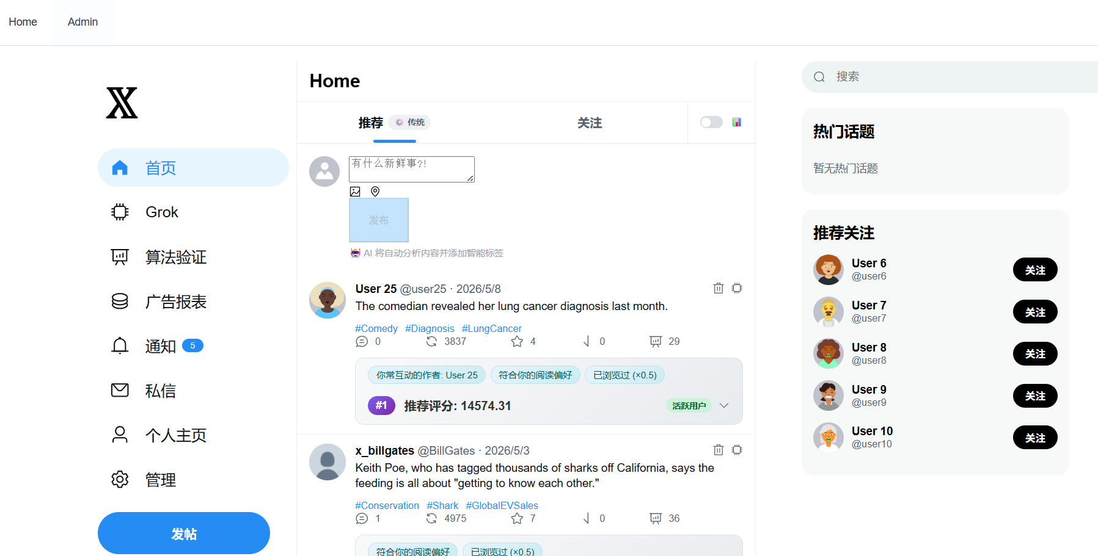图4-1 首页信息流界面

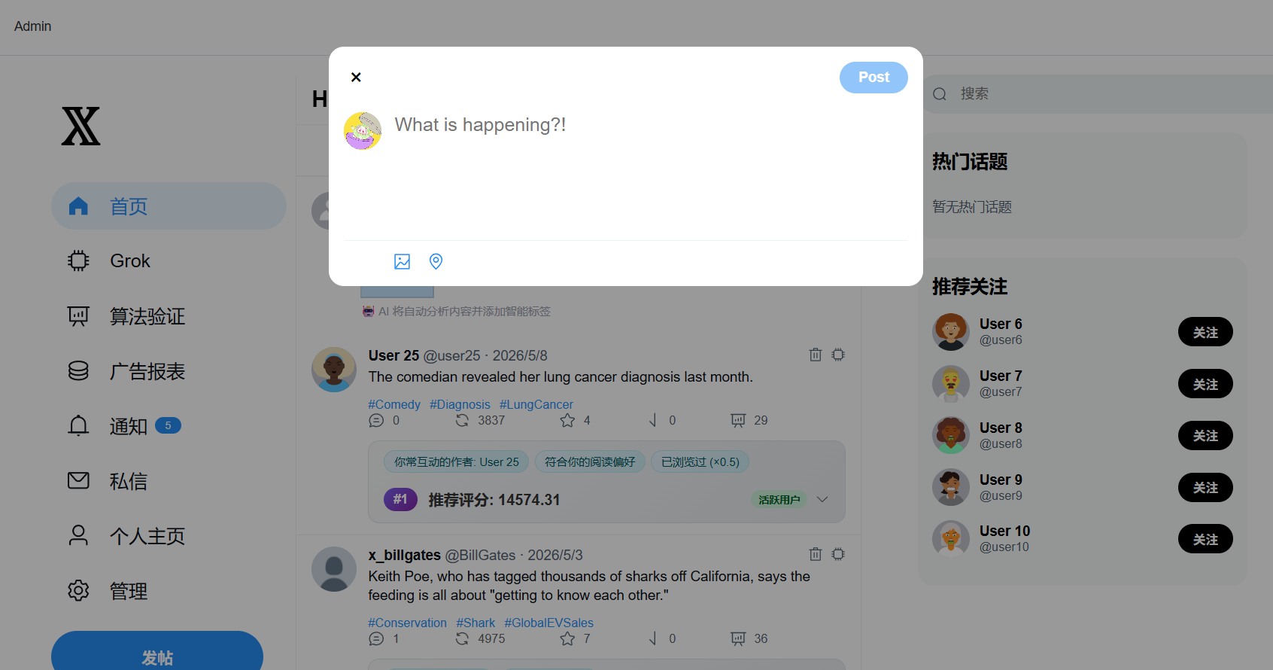图4-2 内容发布界面

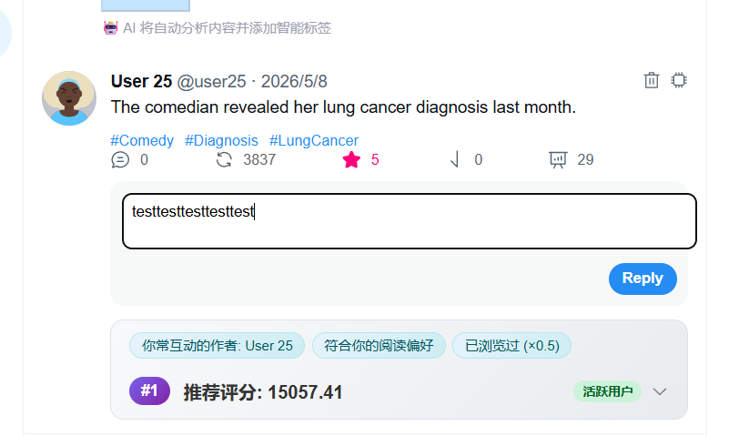图4-3 点赞评论交互界面
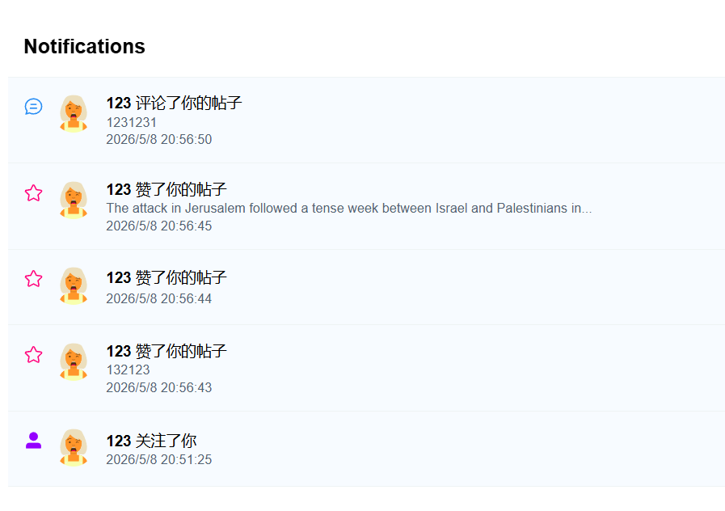图4-4 通知功能界面

4.4 推荐排序实现
推荐服务是系统实现的重点。前端信息流列表组件（FeedList）请求 GET /api/content/feed?personalized=true，并在 Axios 拦截器中附带 Authorization。推荐服务（RecommendationService）负责组装候选：查询关注用户近期发帖作为网内候选（In-Network），合并全站候选作为网外候选（Out-of-Network），按内容标识（contentId）去重；随后调用负反馈服务（NegativeSignalService）完成过滤，再通过推荐策略管理器（RecommendationStrategyManager）的 getActiveStrategy() 获取当前策略。
传统混合推荐策略的带评分推荐方法（HybridRecommendationStrategy.recommendWithScore）流程如下：先调用协同过滤服务方法（CollaborativeFilteringService.getCollaborativeRecommendations）得到候选 ID 集；再对每条内容实体（Content）计算带明细的推荐分（calculateScoreWithDetails），填充评分拆分对象（ScoreBreakdown，含协同过滤加成字段）；最后按分数排序并经加权洗牌返回列表。管理员切换策略后无需重启进程，下一次请求即生效。
算法对比页面（CompareView）调用 /api/compare/feed、/api/compare/profiles、/api/compare/tuned 等接口：/feed 用于对比推荐与时间序，/profiles 用于展示不同用户画像和 Top 推荐，/tuned 用于在权重调节组件（WeightTuner）调节权重后重新拉取排序，体现参数敏感性实验。Feed 页在 For You 标签旁展示“传统算法”或“AI 推荐”徽标；AI 模式下缓存命中时直接返回 AI 排序，缓存未命中时先返回传统排序并在后台异步预计算 AI 结果。
AI 推荐策略通过 Prompt 调用 Ollama（如 application.properties 中 ollama.rec.model）。Prompt 含画像摘要与候选帖子摘要，并约束模型输出包含 ranking 与 reasons 的 JSON；解析成功后系统按 AI 返回顺序重排候选并写入推荐理由，解析失败或模型不可用时则在服务端降级为基础互动排序。策略管理接口同时返回 aiAvailable 与缓存统计，便于管理端判断 AI 服务状态。

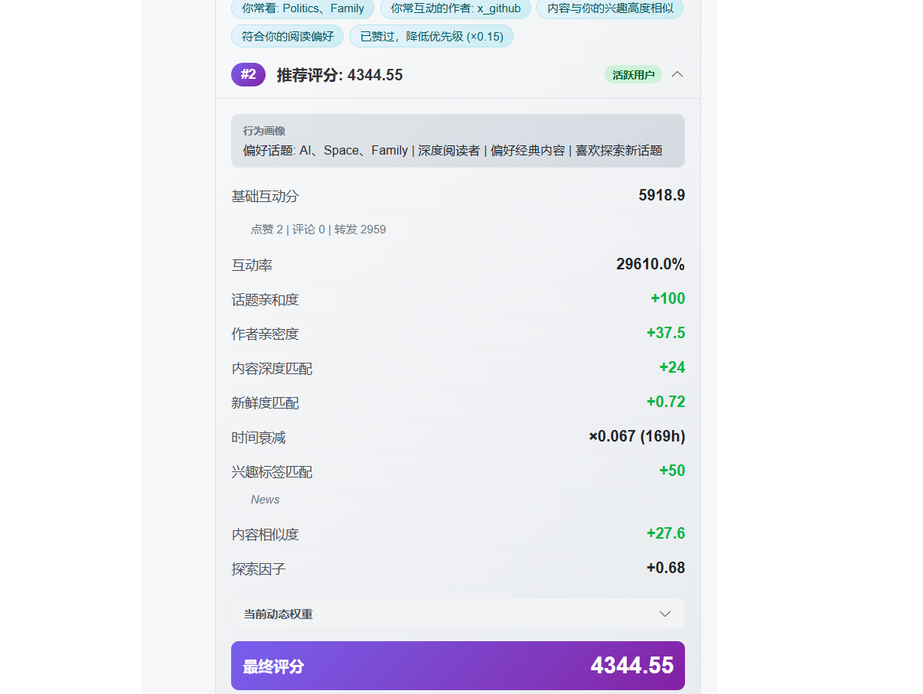图4-5 个性化推荐贴文的评分明细界面
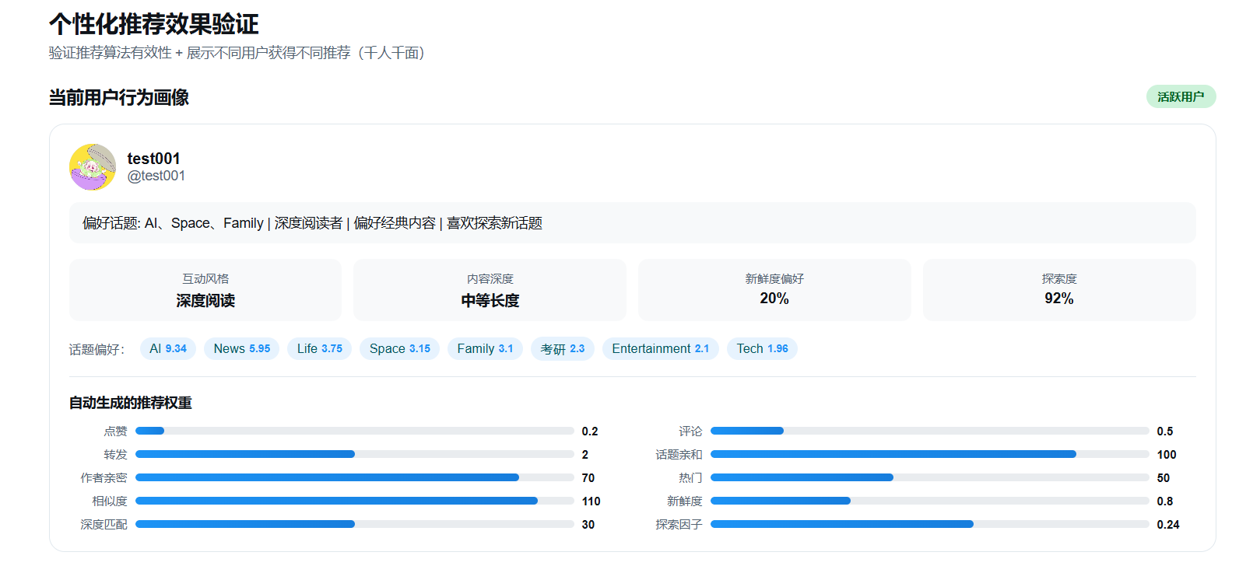图4-6 个性化推荐验证界面

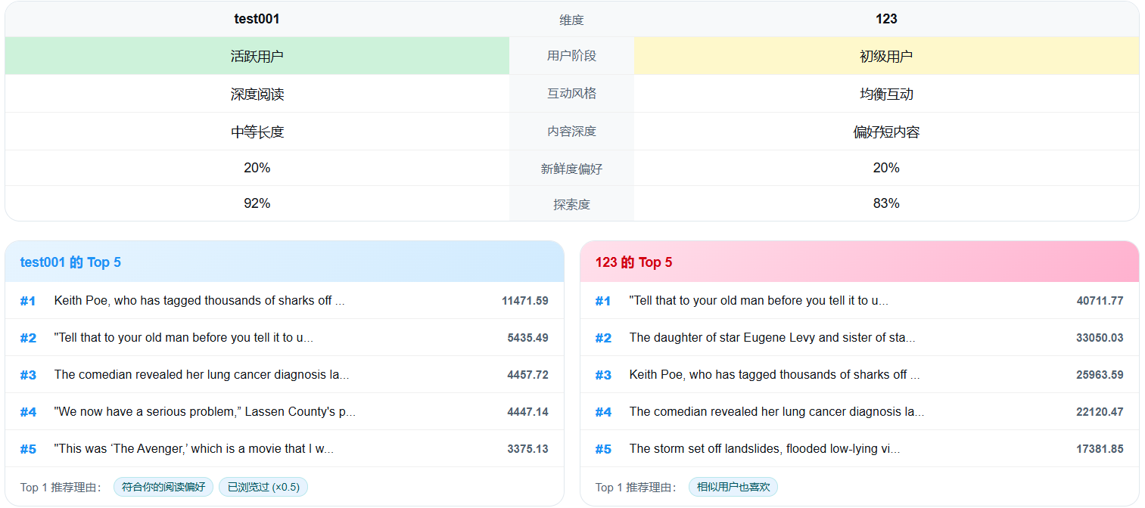图4-7 不同用户间推荐效果对比界面

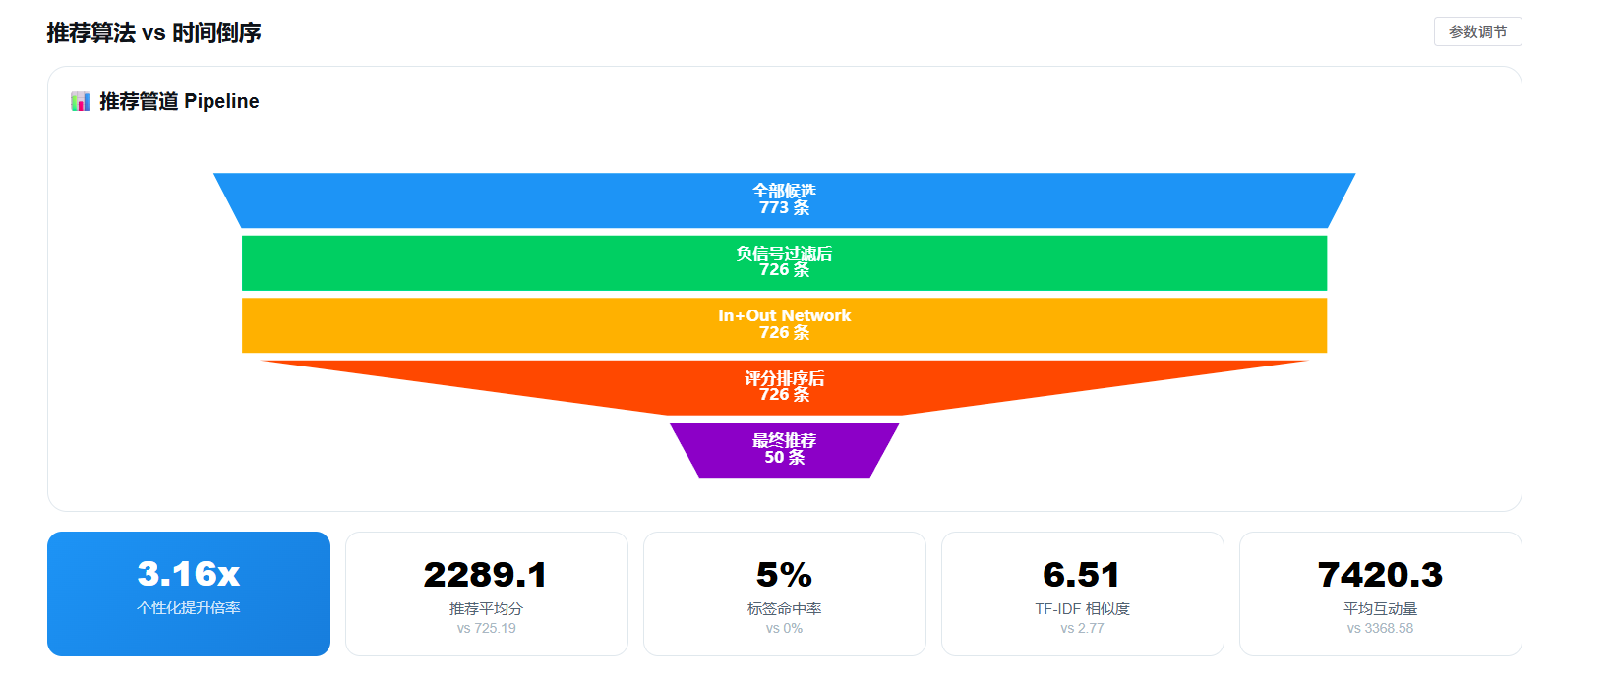图4-8-1 推荐算法与时间序算法对比界面

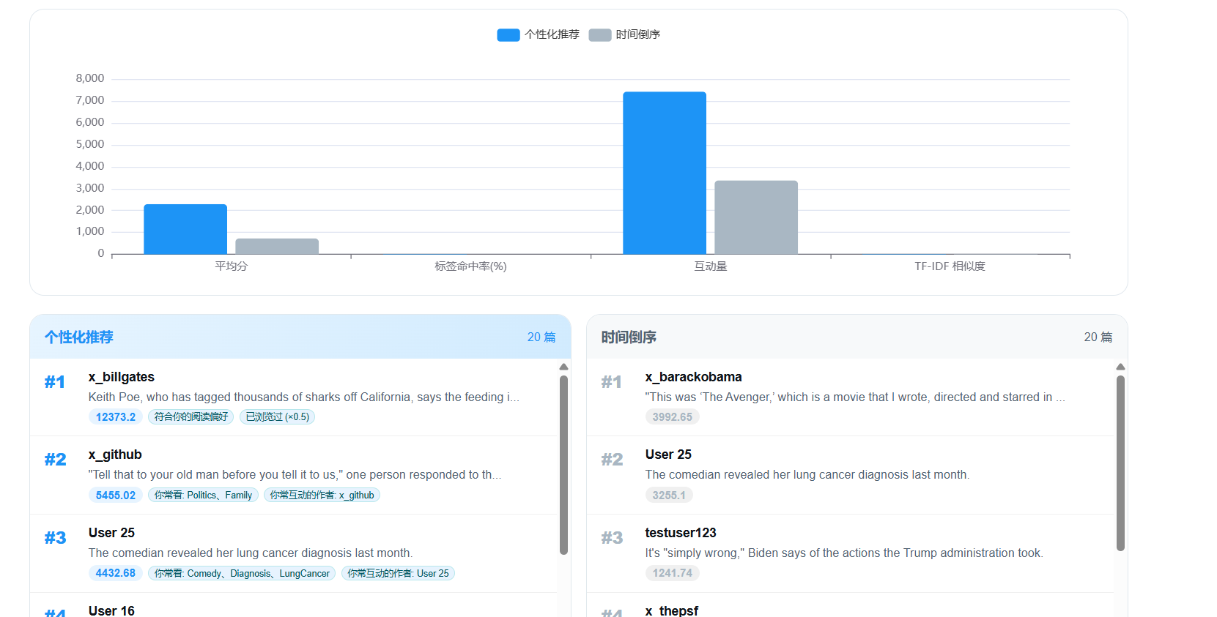图4-8-2 推荐算法与时间序算法对比界面2

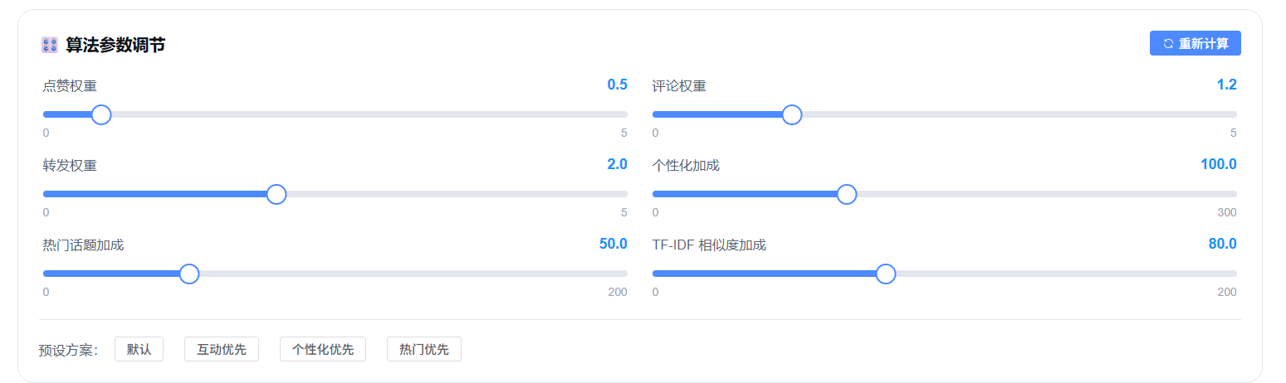图4-9 权重调节组件界面

4.5 AI模块与管理后台实现
AI 模块主要包括三类能力：自动打标使用较轻量模型（如 ollama.model）在发帖后异步执行，避免阻塞主链路；AI 推荐使用较大上下文模型（如 ollama.rec.model）专注排序决策；Grok 助手通过 DeepSeek API 提供对话，前端 GrokView 以聊天窗口呈现，与推荐链路解耦。
AdminView 集成统计卡片、用户表格、推荐策略单选卡片与 Ollama 状态展示：页面通过 GET /api/admin/rec-strategy 获取当前策略、AI 可用状态和缓存统计，并通过 PUT /api/admin/rec-strategy 切换 traditional 或 ai。批量打标接口遍历内容集合调用模型写入标签，用于历史数据补全。数据导入区域通过 /api/admin/import-kaggle-batch 或 /api/admin/import-kaggle 导入公开数据集，并在 Kaggle 不可用或数量不足时使用内置内容库补齐，以增强 Out-of-Network 候选多样性。
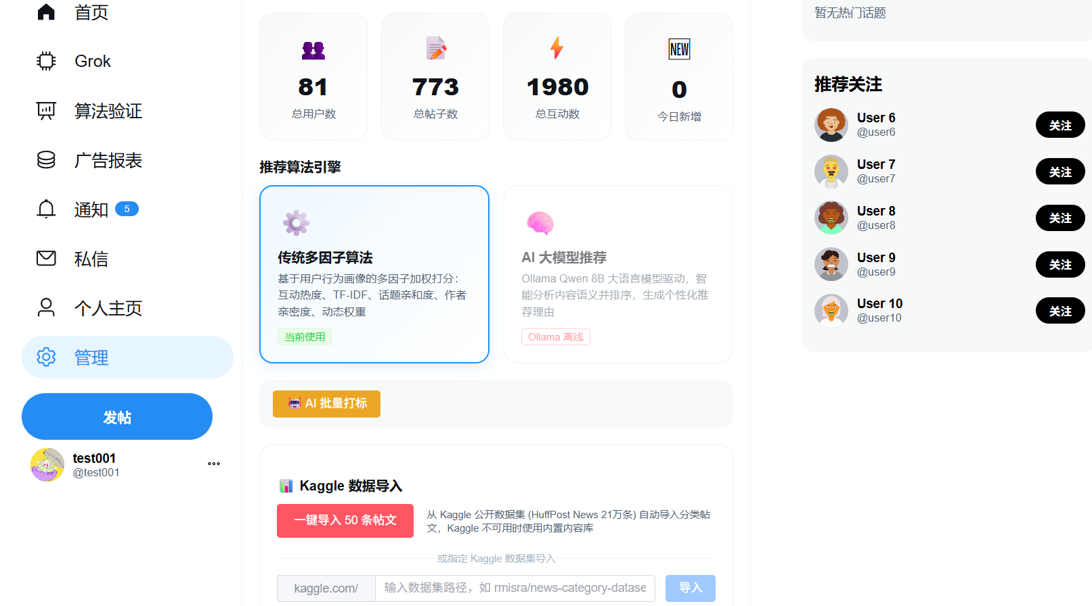图4-10 管理后台推荐策略切换与数据导入界面

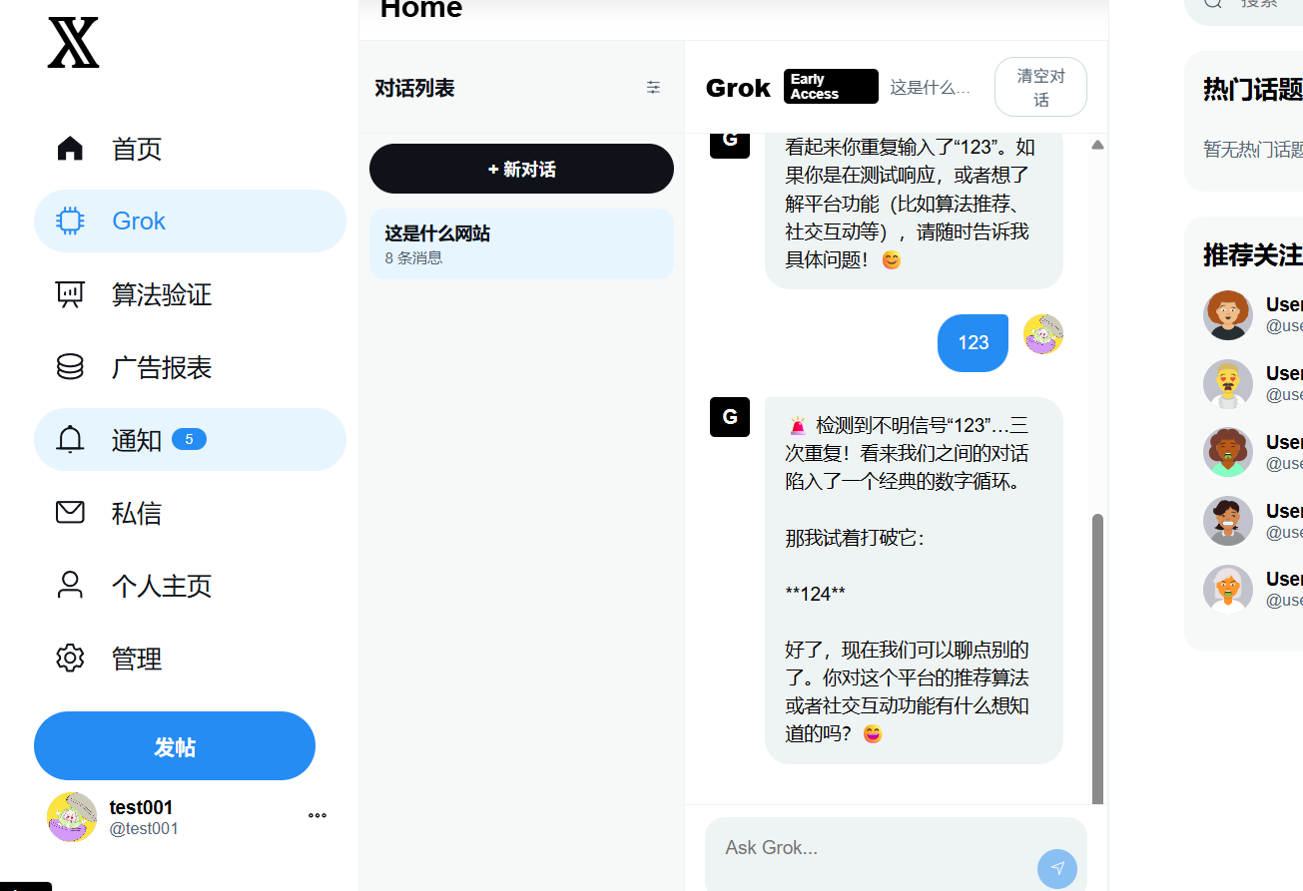图4-11 AI 助手界面

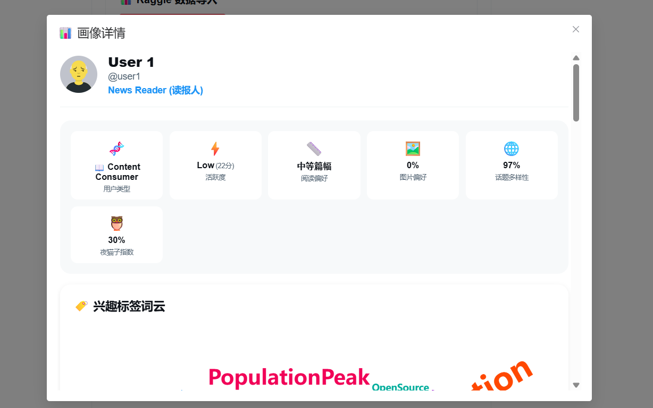图4-12 管理员界面用户画像详情界面

4.6 广告智能分发实现
广告模块采用信息流原生广告形式。管理员在广告报表页（AdDashboard）或后台表单创建广告实体，配置定向标签（targetTags）与出价（bidPrice）。首页信息流列表组件（FeedList）拉取帖子列表后，根据全局广告间隔配置（interval）计算插入下标；每条广告展示调用统计接口增加展示次数（impressionCount），点击跳转前记录点击次数（clickCount），点击率（CTR）按式（4-1）计算，并动态进入质量分（qualityScore）。
CTR = clickCount / impressionCount （4-1）
广告得分由标签匹配、出价和历史质量共同决定，可表示为：
qualityScore = CTR × 100 （4-2）
adScore = matchedTagCount × 30 + bidPrice × 10 + qualityScore （4-3）
其中匹配标签数（matchedTagCount）为用户画像高频标签与广告定向标签（targetTags）的交集规模。该线性加权实现简单可解释，便于分析参数影响；后续可改为 Logistic 组合或加入频次惩罚。
广告业务实现补充。典型路径为：管理员在广告报表页（AdDashboard）中执行创建（POST）与编辑（PUT），并通过更新启用状态字段（active）控制广告启停；列表页（GET）展示广告明细与统计数据。首页展示前再 GET /api/ads/relevant 或等价接口拉取当前用户最相关广告，与帖子流在客户端按广告间隔（interval）合并。展示、点击分别调用统计接口回写展示次数（impressionCount）和点击次数（clickCount）。本系统以用户画像、广告标签和互动统计为基础实现规则排序，属于个性化广告推荐系统在毕业设计规模下的工程化实现[3]。
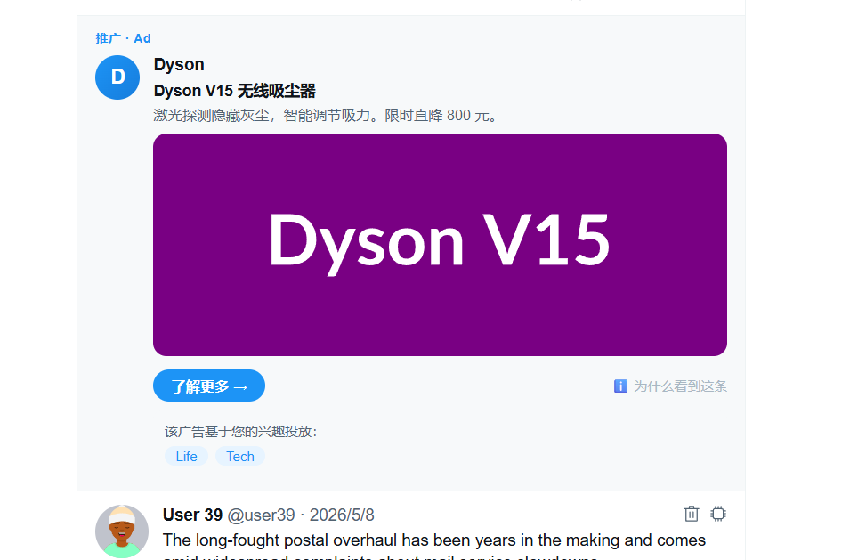图4-13 信息流广告展示界面

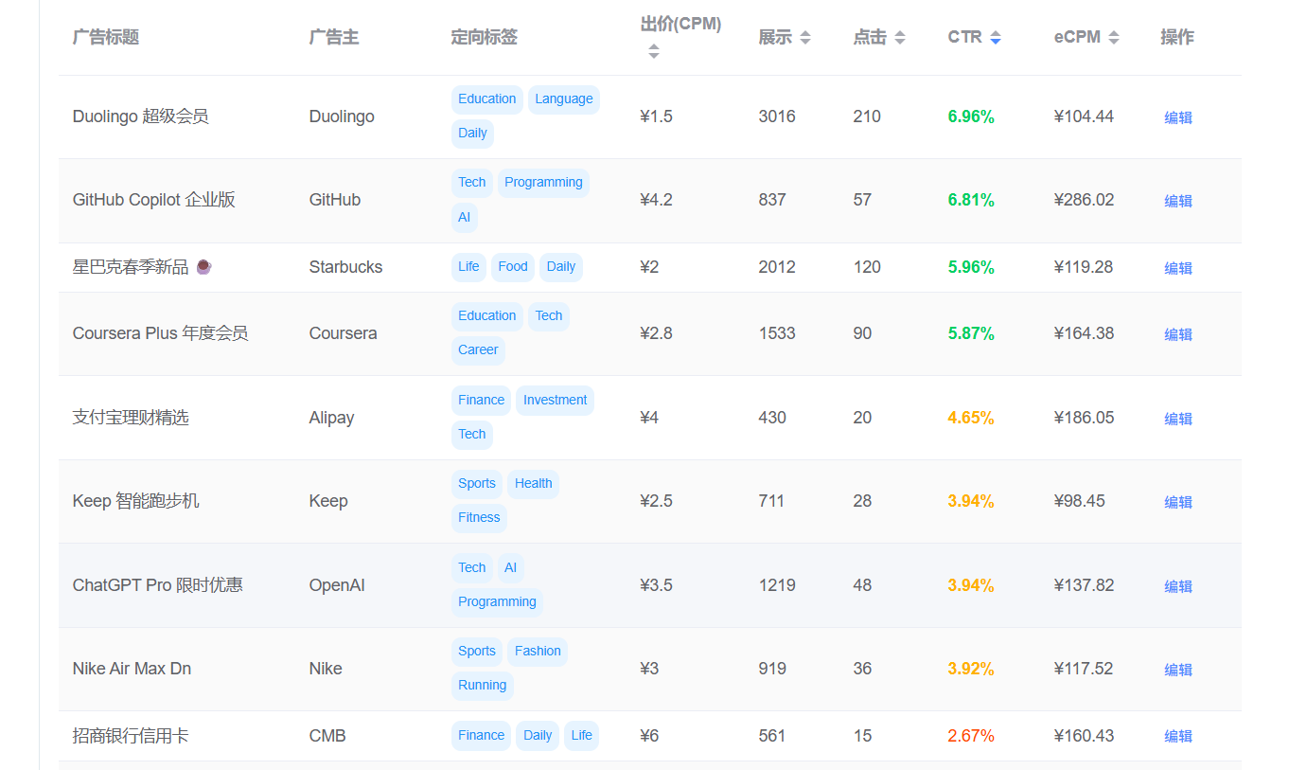图4-14 广告管理界面1
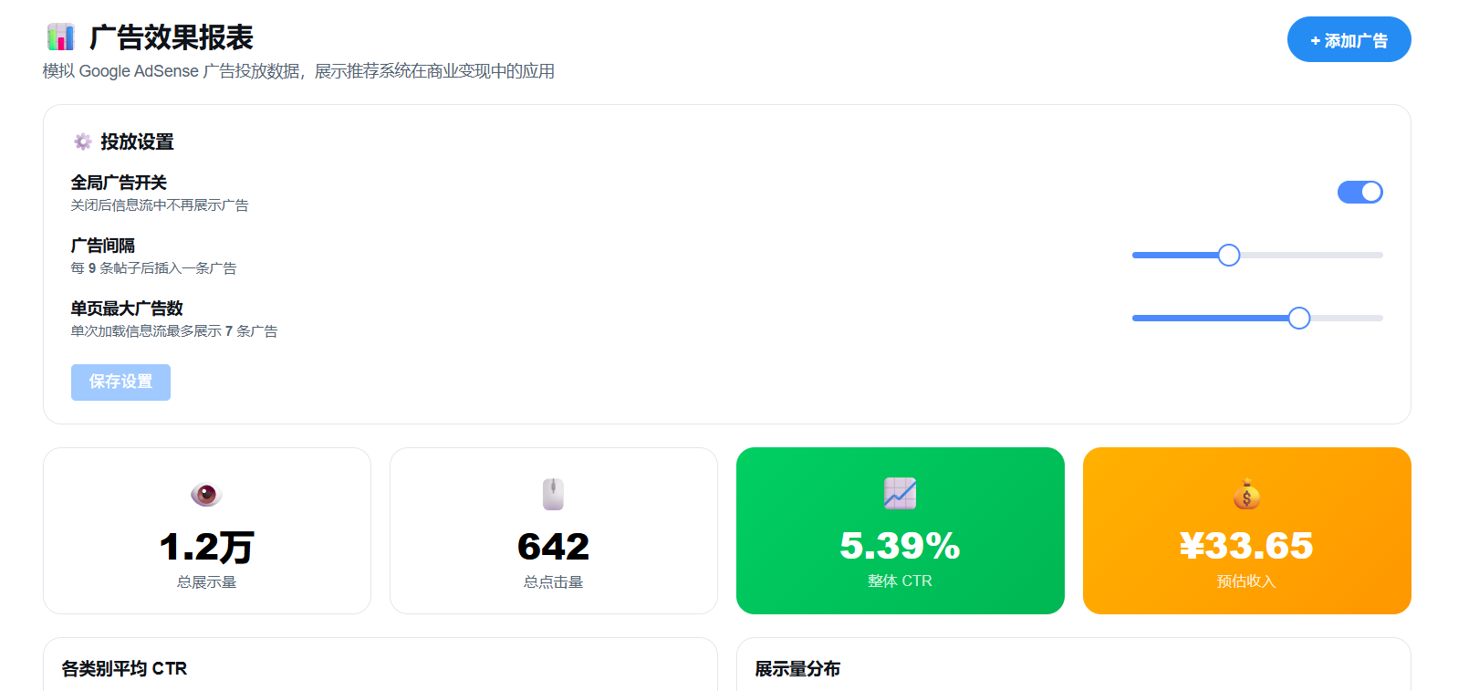图4-14 广告管理界面2

第5章 系统测试及使用说明

5.1 系统测试报告

5.1.1 测试的目的及原则
系统测试的目的是验证系统功能链路、推荐排序效果、数据导入与管理后台等核心模块是否满足任务书要求，并检查前后端联调过程中的接口稳定性和页面可用性。测试遵循覆盖核心业务流程、突出推荐算法效果、兼顾正常路径与异常路径的原则，测试证据主要包括页面运行结果、接口响应、构建输出和推荐对比页面截图。

5.1.2 测试过程及结果
系统测试采用功能场景测试、接口联调验证、构建验证和推荐对比验证相结合的方式进行。考虑到当前项目尚未建立独立的后端单元测试目录和前端组件测试脚本，本文不将测试结论表述为持续集成自动通过，而是以手工执行记录、接口响应结果、页面运行截图和构建命令输出作为验证依据。
测试过程围绕系统核心业务链路展开，重点验证用户认证、内容发布、互动反馈、社交关系、实时通知、推荐排序、AI 模块、广告分发、后台管理和系统构建等功能是否能够按照预期运行。测试结果中的“通过”表示在当前本地开发环境、既定测试数据和操作步骤下能够得到预期结果，不等同于高并发压力测试或安全渗透测试结论。
- 用户注册登录的测试过程及结果
用户注册登录测试主要验证系统基础认证功能是否正常，包括新用户注册、已有用户登录、登录成功后 Token 返回、前端页面跳转和用户信息展示等内容。测试过程中，首先在注册页面输入用户名和密码提交注册请求，观察系统是否能够成功创建用户并返回用户信息；随后使用正确账号进行登录，验证系统是否能够正常进入首页，并在前端保存登录状态。
测试结果表明，系统能够完成用户注册、登录和角色识别等基础功能，登录成功后前端能够正确保存用户状态，为后续内容发布、互动操作和后台管理提供身份基础。

表 5-1 用户注册登录测试结果
编号 | 测试内容 | 测试过程 | 预期结果 | 测试结果
T01 | 用户注册 | 输入用户名和密码，提交注册请求 | 注册成功并返回用户信息和 Token | 通过
T02 | 用户登录 | 使用正确账号和密码登录系统 | 登录成功并进入首页 | 通过
T03 | 登录状态保持 | 登录后刷新页面或重新进入系统 | 用户状态保持，页面可正常访问 | 通过
T04 | 角色识别 | 使用普通用户和管理员账号分别登录 | 系统能够区分普通用户和管理员 | 通过

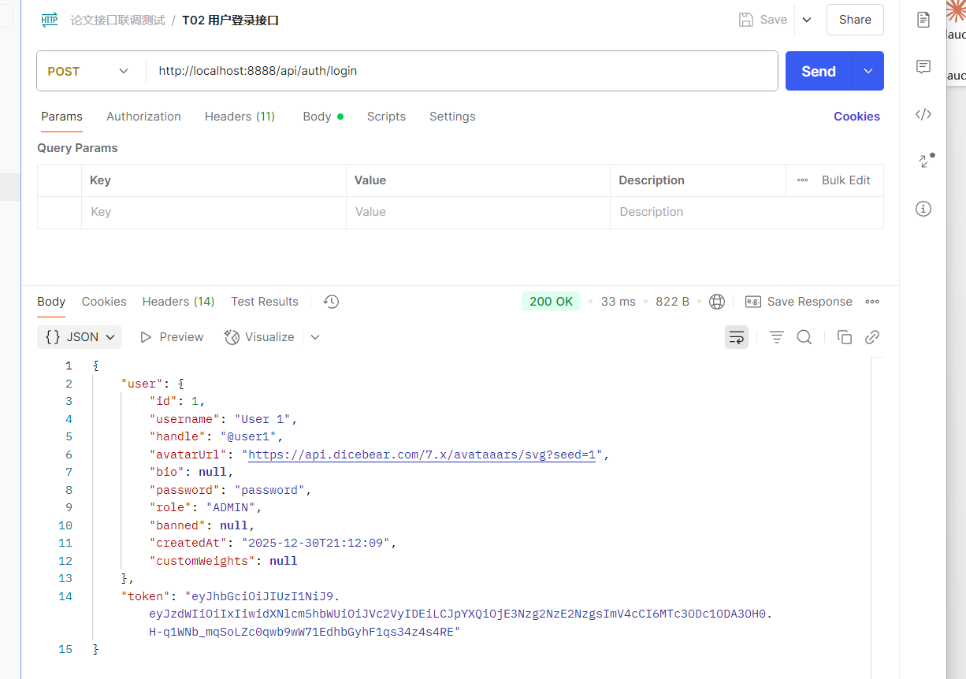图5-1 登陆功能接口测试结果截图
- 内容发布与互动功能的测试过程及结果
内容发布与互动功能测试主要验证用户能否正常发布文字帖子、上传图片、评论、点赞、点踩、转发和引用。测试过程中，先使用普通用户登录系统，在首页输入文本内容并发布帖子，检查首页是否出现新发布内容；随后对帖子执行点赞、点踩、评论、转发和引用操作，观察页面计数是否变化，数据库中是否记录对应行为。
测试结果表明，系统内容发布与互动链路基本完整，用户发布内容后能够及时在页面展示，互动操作能够更新计数并写入行为记录，为推荐排序和用户画像提供数据来源。
表 5-2 内容发布与互动功能测试结果
编号 | 测试内容 | 测试过程 | 预期结果 | 测试结果
T05 | 文字发帖 | 输入文字内容并点击发布 | 首页出现新帖子 | 通过
T06 | 图片发帖 | 上传图片后发布帖子 | 图片地址保存并在页面展示 | 通过
T07 | 评论功能 | 对指定帖子发表评论 | 评论内容显示，评论数增加 | 通过
T08 | 点赞点踩 | 对帖子执行点赞或点踩操作 | 对应计数变化，并记录用户行为 | 通过
T09 | 转发引用 | 转发或引用已有帖子 | 生成关联内容并更新转发计数 | 通过
T10 | 删除权限判断 | 对本人或他人内容执行删除操作 | 本人内容可删除，非本人内容受权限限制或提示失败 | 通过

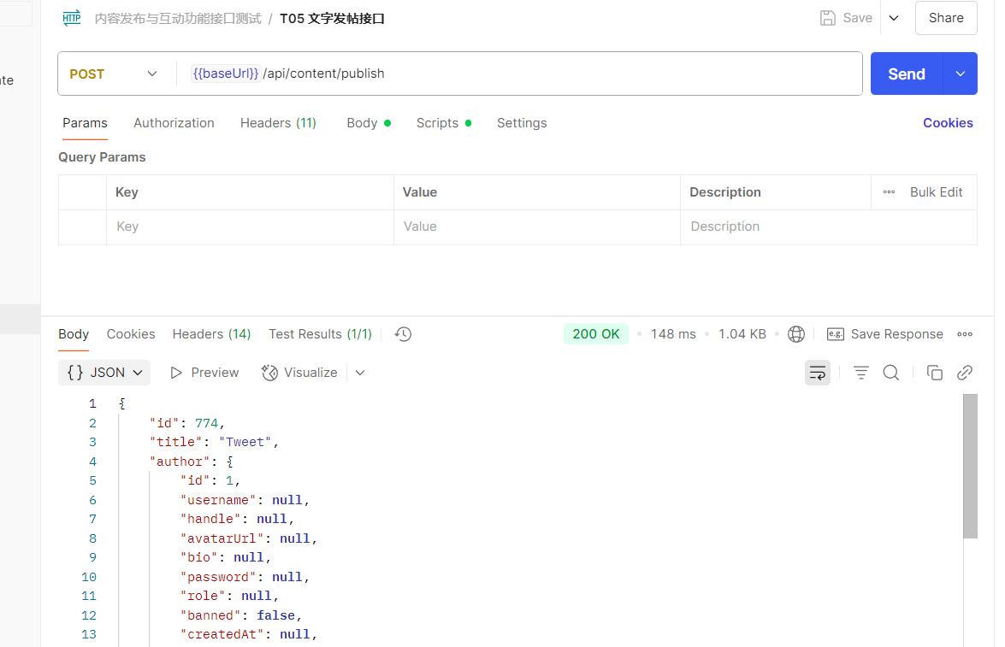图5-2 用户发帖接口测试结果截图

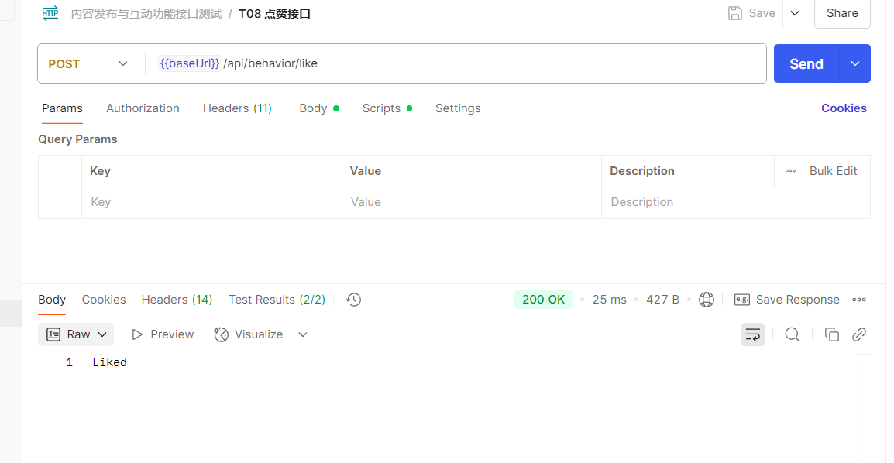图5-3 点赞接口测试结果截图
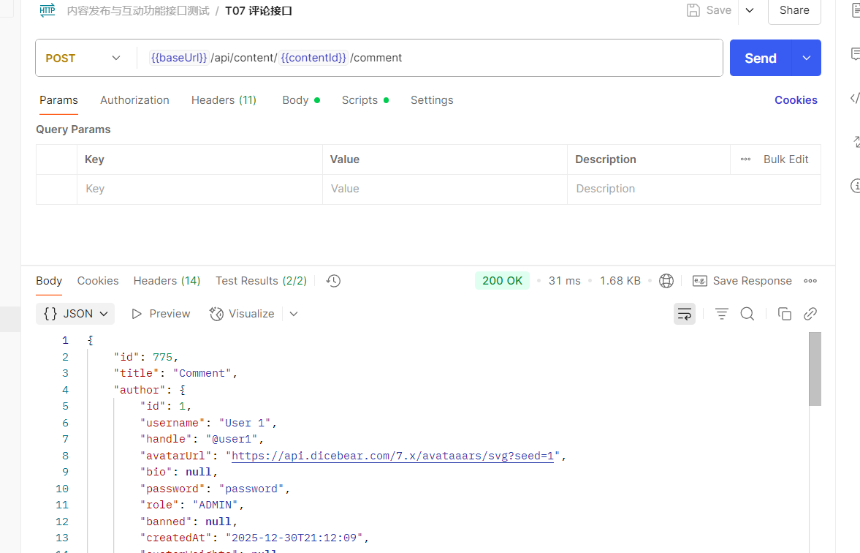图5-4 评论接口测试结果截图

- 社交关系与实时通信的测试过程及结果
社交关系与实时通信测试主要验证关注、通知和私信功能。测试过程中，使用两个不同用户账号分别登录系统，用户 A 关注用户 B，检查关注状态是否发生变化；随后用户 A 对用户 B 的帖子进行点赞或评论，观察用户 B 是否收到通知；最后测试用户之间发送私信，验证会话双方是否能够接收消息。
测试结果表明，系统能够正确维护用户之间的关注关系，并能够在点赞、评论和私信等场景下生成通知或消息记录。在线情况下，消息能够及时展示；离线或刷新页面后，也可以通过通知列表和私信列表进行补偿查看。
表 5-3 社交关系与实时通信测试结果
编号 | 测试内容 | 测试过程 | 预期结果 | 测试结果
T11 | 关注用户 | 用户 A 关注用户 B | 关注状态变为已关注 | 通过
T12 | 关注流展示 | 切换到 Following 信息流 | 仅展示已关注作者发布的帖子 | 通过
T13 | 点赞通知 | 用户 A 点赞用户 B 的帖子 | 用户 B 收到点赞通知 | 通过
T14 | 评论通知 | 用户 A 评论用户 B 的帖子 | 用户 B 收到评论通知 | 通过
T15 | 私信发送 | 用户 A 向用户 B 发送私信 | 会话双方能够看到消息 | 通过
T16 | 未读状态 | 用户收到通知或私信后查看列表 | 未读数正确变化，可标记已读 | 通过

- 推荐排序与用户画像的测试过程及结果
推荐排序与用户画像测试主要验证系统能否根据用户行为生成个性化推荐结果。测试过程中，先让用户对某一类标签内容进行点赞、评论或浏览，然后刷新推荐流，观察同类标签内容是否获得更高推荐分；再通过算法对比页面查看推荐流和时间流的排序差异，并观察评分拆分对象中标签匹配、文本相似度、协同过滤、时间衰减和热门话题等分项是否产生变化。
测试结果表明，系统推荐模块能够根据用户行为、内容标签、时间因素、协同过滤和负反馈信号对信息流进行排序。通过推荐流与时间流对比，可以观察到个性化推荐结果与单纯时间倒序结果存在差异，说明推荐排序模块能够体现用户行为分析的作用。
表 5-4 推荐排序与用户画像测试结果
编号 | 测试内容 | 测试过程 | 预期结果 | 测试结果
T17 | 推荐流访问 | 用户进入首页访问个性化推荐流 | 返回带排序结果的信息流 | 通过
T18 | 标签匹配 | 用户点赞某类标签内容后刷新推荐 | 同类标签内容推荐得分提高 | 通过
T19 | 时间衰减 | 对比新旧内容推荐得分 | 新内容获得更高新鲜度优势 | 通过
T20 | 负反馈过滤 | 对内容选择不感兴趣或屏蔽作者 | 对应内容不再进入推荐候选 | 通过
T21 | 协同过滤 | 构造相似用户行为数据 | 相似用户喜欢的内容获得加成 | 通过
T22 | 作者多样性 | 候选集中存在同作者多篇内容 | 同作者后续内容被适当降权 | 通过
T23 | 推荐对比 | 打开 CompareView 页面 | 展示推荐流与时间流对比指标 | 通过
T24 | 参数调节 | 使用 WeightTuner 调整推荐权重 | 调用接口后推荐指标发生变化 | 通过
T25 | 用户画像 | 打开个人画像页面 | 展示词云、雷达图与偏好统计 | 通过

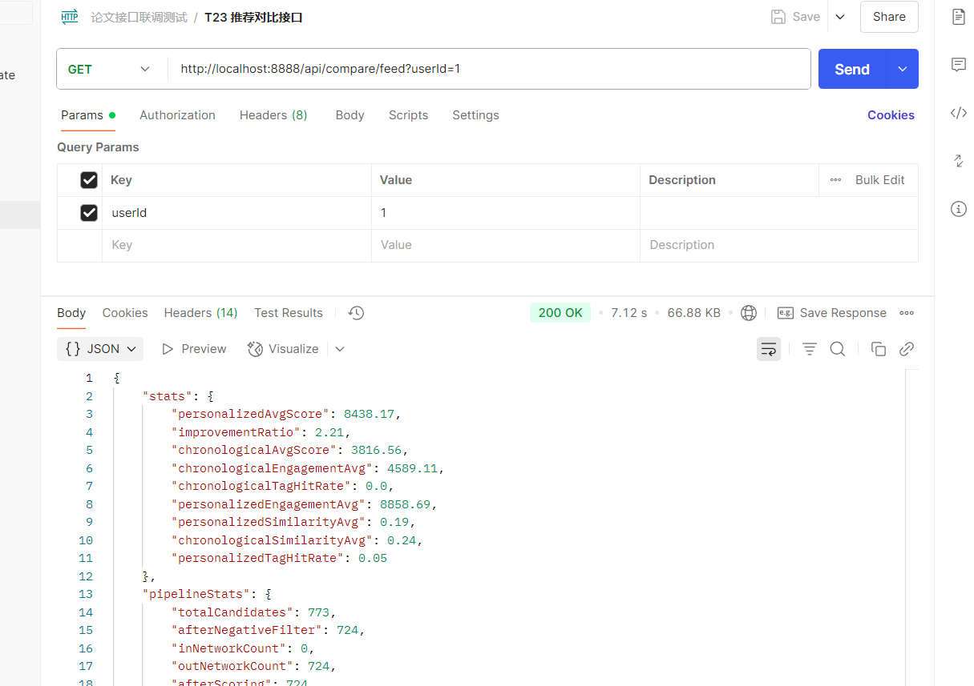图5-5 推荐信息流接口测试结果截图
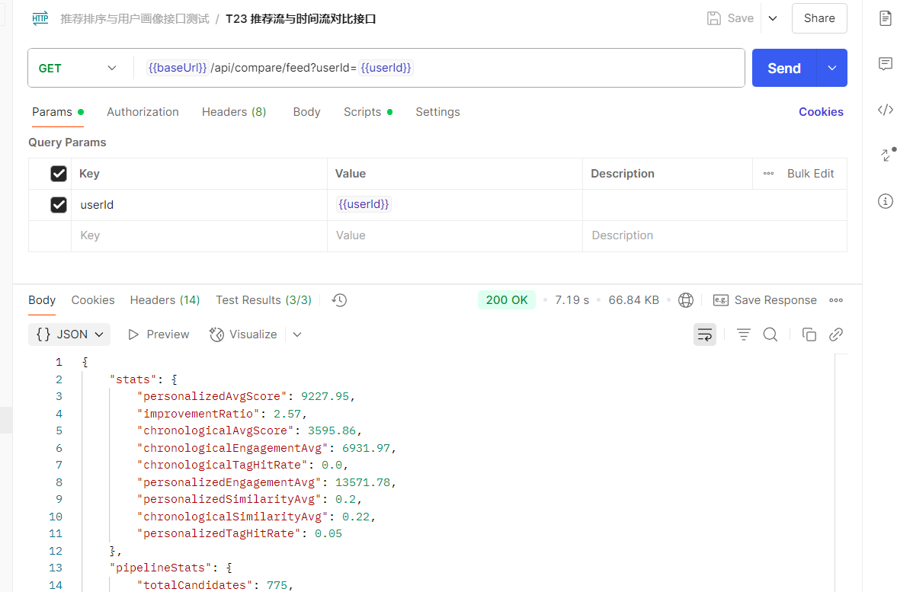图5-6 推荐流与时间流对比接口测试结果截图

- AI 模块、广告分发与后台管理的测试过程及结果
AI 模块、广告分发与后台管理测试主要验证系统扩展功能是否能够正常运行。测试过程中，管理员进入后台切换推荐策略，观察首页信息流徽标和排序结果是否变化；在 Ollama 本地模型正常运行时切换 AI 推荐模式，检查系统是否能够返回 AI 排序结果或推荐理由；关闭 Ollama 后再次请求 AI 推荐，验证系统是否能够自动降级。广告测试则通过浏览首页观察广告是否按配置间隔插入，并点击广告检查统计数据是否更新。
测试结果表明，系统 AI 模块、广告模块和后台管理功能能够正常运行。AI 推荐在模型可用时能够参与排序或生成推荐理由，在模型不可用时能够降级到传统推荐策略，保证信息流主链路不受影响。广告模块能够按照用户画像和广告配置完成信息流插入，并记录展示和点击数据。
表 5-5 AI 模块、广告分发与后台管理测试结果
编号 | 测试内容 | 测试过程 | 预期结果 | 测试结果
T26 | 推荐策略切换 | 管理员切换 traditional / ai 策略 | 策略切换成功，Feed 徽标同步变化 | 通过
T27 | AI 推荐模式 | Ollama 服务可用时切换 AI 推荐 | 返回 AI 排序结果或推荐理由 | 通过
T28 | AI 降级 | 关闭 Ollama 后请求 AI 推荐 | 系统降级为基础互动排序 | 通过
T29 | AI 自动打标 | 对帖子执行 AI 打标操作 | 系统生成内容标签 | 通过
T30 | 后台用户管理 | 管理员查看或管理用户列表 | 用户信息能够正常显示或操作 | 通过
T31 | 数据导入 | 管理员批量导入公开数据集帖文 | 内容库新增帖子或由内置内容库补齐 | 通过
T32 | 广告插入 | 浏览首页信息流 | 广告按配置间隔插入 | 通过
T33 | 广告统计 | 点击信息流广告 | 点击次数和展示统计更新 | 通过
T34 | 角色权限 | 普通用户访问后台入口或接口 | 前端隐藏入口或后端返回权限限制结果 | 通过

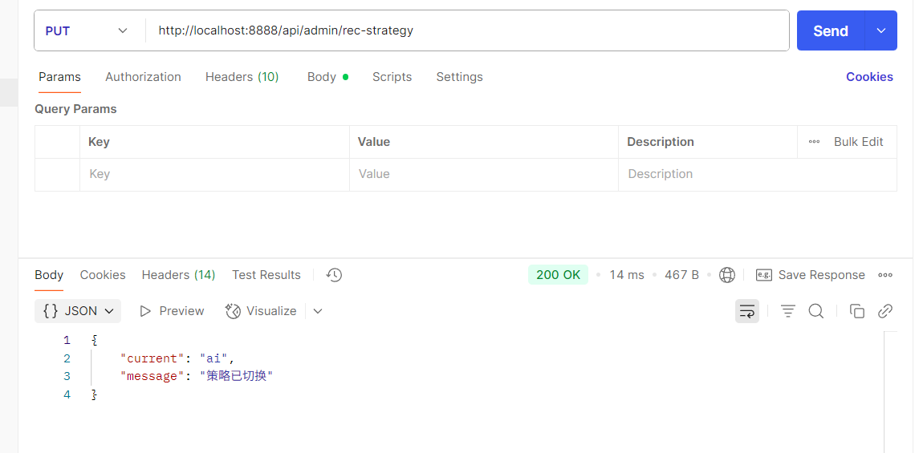图5-7 AI推荐策略切换接口测试结果截图
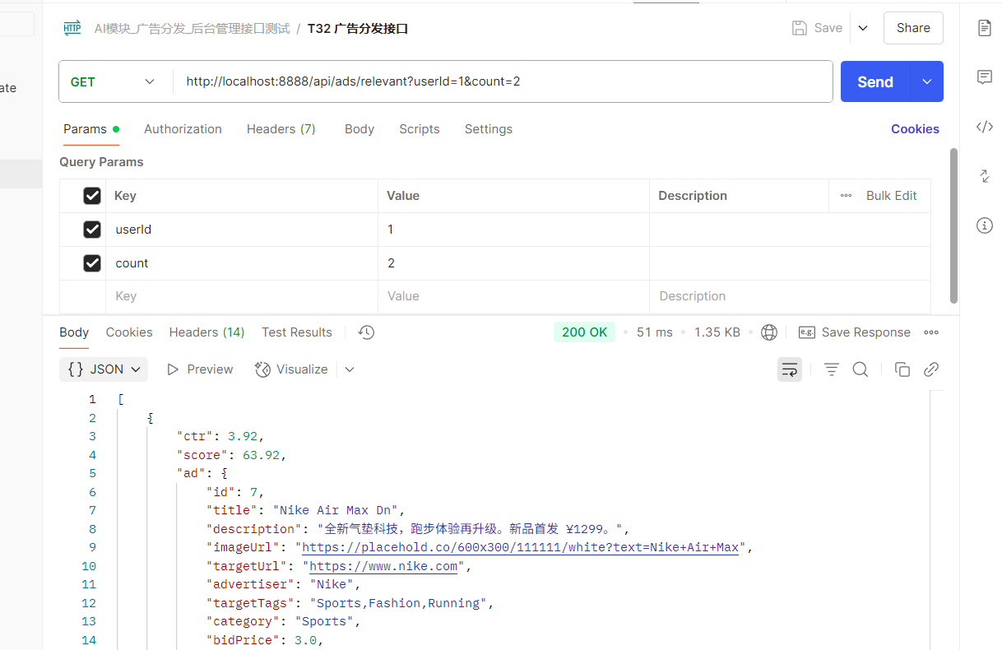图5-8 广告分发接口测试结果截图

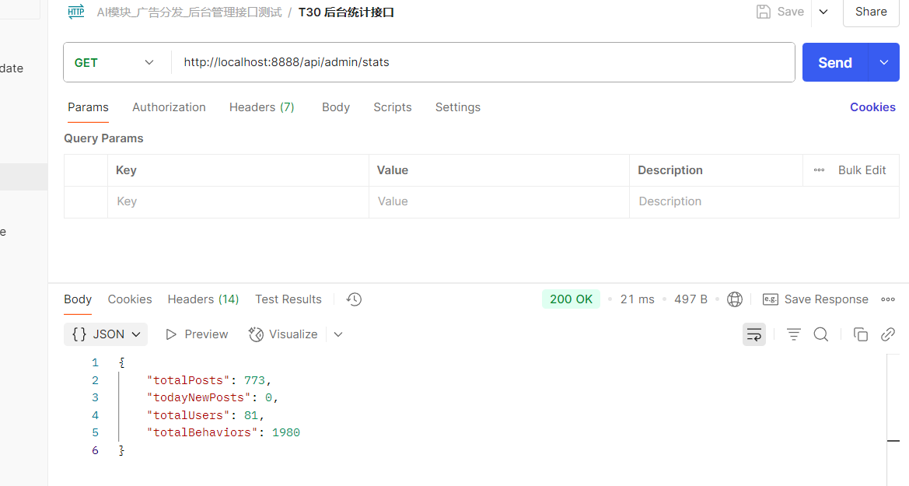图5-9 广告管理后台统计接口测试结果截图

5.1.3 测试总结
功能测试整体通过率较高，说明核心业务闭环完整。推荐相关用例（T09–T20）验证了系统的可解释性与健壮性：评分拆分对象（ScoreBreakdown）与对比页能够呈现各个分项的贡献；AI 降级用例表明在推理服务不可用或超时等条件下仍能返回可用列表。
从对比指标角度，推荐流相对时间倒序在平均推荐分、标签命中率、TF-IDF 相似度均值上通常更优，但个别场景可能出现“过度个性化”导致话题收窄，此时可通过权重调节组件（WeightTuner）降低个性化权重，或提高探索随机扰动项（jitter）缓解。协同过滤与搜索行为（SEARCH）记录互补：前者挖掘被动曝光兴趣，后者捕捉主动意图，二者共同提升画像准确度。
构建验证只能说明依赖版本、编译配置和前端打包流程在当前环境下可用，不能替代自动化单元测试和压力测试。因此，本文将构建结果作为运行可行性的证据，将功能用例表、接口响应截图和推荐对比页面截图作为业务正确性的主要依据。当前不足在于尚未形成后端单元测试、前端组件测试、自动化 UI 测试和并发压力测试，难以量化高并发场景下的接口延迟，这部分在后续展望中进一步说明。
进一步从实验设计角度补充说明：当对比推荐流与时间倒序流时，应确保二者在同一时间窗口内抓取候选集合，否则“平均互动量”等指标可能因候选偏差而失真；使用权重调节组件（WeightTuner）调参时应记录前后权重向量，以保证图表与文字描述一致。作者多样性测试可在候选池人为注入同一作者多条帖子以放大惩罚效应；协同过滤测试则需预先构造相似用户行为簇，否则稀疏交互下加成可能不明显。
关于 AI 测试，除在线与离线两类场景外，还应记录 Prompt 长度与候选条数对耗时的影响：候选摘要过多会增加 Token 消耗与推理时间，过少则可能丢失语义上下文。测试可将候选限制在约二十条作为折中。实验记录应包含所用模型版本号与 temperature 配置，并与 application.properties 保持一致（可与 4.9 节测试数据与实验说明一并保存）。
构建与联调问题回顾。后端运行验证应优先确认 rec_db 可连接、application.properties 指向本机环境，并通过服务启动日志和接口请求确认路由可用；若使用 mvn -q test 或打包命令作为构建校验，应说明当前结果主要反映编译与依赖装配状态，并不能替代独立单元测试。前端 npm run build 若因 Node 版本偏低或依赖冲突失败，可删除 node_modules 后按锁文件重装。跨域与 404 多由 Vite 代理未指向 8888 或 API 基地址写错导致，应优先对照浏览器网络面板与后端访问日志。此类问题属于工程配置与集成范畴，与算法正确性应区分排查；数据密集型系统设计也强调从数据存储、接口调用到运行维护的整体一致性[13]。

5.1.4 测试数据构造与实验建议
推荐算法输出对数据分布敏感。若帖子题材单一或行为稀疏，协同过滤与 TF-IDF 都难以体现差异。为此可在验证前构造分层数据集：用户层划分若干兴趣 persona，使其点赞与搜索关键词集中于不同标签簇；内容层为各簇准备带话题标签、长短不一的帖子，以触发深度匹配与新鲜度偏好差异；行为层安排交叉互动，使协同过滤能获得非空相似邻居。
对照实验可固定随机种子或关闭抖动因子中的随机项，以便重复刷新时观察排序稳定性；开启抖动后再观察列表多样性。对比页面上记录两种策略下的平均分与命中率差异时，应保存运行截图作为实验记录附录。
针对搜索行为（SEARCH），可设计检索词与帖子标签对齐，验证画像中出现检索意图相关的权重增量；针对负反馈，可屏蔽某一作者后刷新 For You，确认该作者内容不再进入候选集合。

5.2 系统使用说明

5.2.1 系统简介
本系统是一套面向社交媒体场景的实时信息流排序与分发原型系统。普通用户可以完成注册登录、浏览 For You 推荐流和 Following 关注流、发布帖子、评论、点赞、转发、引用、关注、搜索、查看通知、发送私信和查看画像等操作；管理员可以进行用户治理、推荐策略切换、AI 批量打标、Kaggle 数据导入、广告管理和推荐效果验证。

5.2.2 系统运行环境
表 5-3 系统运行环境配置
类别 | 环境或工具 | 说明
后端环境 | JDK 17、Maven、Spring Boot 3.2.1 | 提供 RESTful API、WebSocket 服务与业务逻辑
前端环境 | Node.js、Vue 3、Vite、Element Plus | 提供单页应用、管理后台和图表展示
数据库 | MySQL | 存储用户、内容、行为、画像、通知、私信和广告数据
AI 服务 | Ollama、DeepSeek API | 用于内容打标、AI 推荐和智能问答

5.2.3 系统操作说明
普通用户首先通过注册或登录进入系统，登录成功后可在首页切换推荐流和关注流。用户浏览、点赞、评论、转发、搜索、点踩等操作会被记录为行为事件，并参与后续画像更新与推荐排序。
内容发布时，用户填写正文并可上传图片；系统保存帖子后解析话题标签，并可通过 AI 打标服务补充语义标签。其他用户对帖子进行互动时，系统会写入通知记录并通过 WebSocket 推送未读提醒。
管理员进入后台后，可查看用户与平台统计信息，切换 traditional 或 ai 推荐策略，执行 Kaggle 数据导入和 AI 批量打标，并在广告报表页维护广告配置、查看展示次数和点击次数。
算法验证时，可进入推荐效果对比页面，查看推荐流与时间流差异、评分拆分、权重调节组件和排序管道可视化结果。若 AI 服务不可用，系统会回退到传统混合推荐策略，保证信息流主链路可用。

设计总结

工作总结
本文围绕“基于用户行为分析的实时信息流排序与分发系统的设计与开发”这一课题，完成了从需求分析、系统设计、数据库建模、核心算法设计、前后端实现到系统测试的完整开发过程。系统采用 Spring Boot 与 Vue 3 构建前后端分离架构，使用 MySQL 存储核心业务数据，使用 WebSocket 实现通知与私信实时推送，并通过 ECharts 展示用户画像、推荐对比和广告统计等可视化内容。
（1）业务与数据层面。系统实现用户、内容、行为、社交关系、标签、通知、私信、广告等实体的统一建模，覆盖注册登录、发帖评论、点赞点踩、转发引用、关注搜索、实时通知与私信等主流社交链路。行为表支持浏览（VIEW）、点赞（LIKE）、评论（COMMENT）、转发（REPOST）、搜索（SEARCH）等多类型事件，为画像与推荐提供可计算的特征基础；内容表通过父内容字段（parentContent）、转发来源字段（repostOf）、引用来源字段（quoteOf）等在一套模型上表达帖子、评论与二次传播，降低冗余代码。
（2）推荐与画像层面。混合推荐策略（HybridRecommendationStrategy）将互动分、互动率、关注加成、标签匹配、TF-IDF 相似度、热门话题、协同过滤、内容深度、新鲜度、时间衰减、负反馈过滤、作者多样性惩罚与加权随机采样统一到同一打分管线；推荐策略管理器（RecommendationStrategyManager）支持与传统算法并行存在的 AI 推荐策略（AiRecommendationStrategy），实现策略热切换与降级排序。用户画像服务输出动态权重集合（DynamicWeights），根据行为数量与偏好分布自适应调节各分项权重，缓解冷启动与兴趣漂移问题。
（3）AI 与后台治理层面。AI 打标与 AI 推荐共享 Ollama 基础设施但模型规格分离，兼顾异步标注延迟与推荐推理质量；DeepSeek API 驱动的助手模块与排序链路解耦，避免对话流量冲击核心接口。AdminView 集成用户治理、策略切换、批量打标与外部数据导入，为对照实验提供可控输入。
（4）评测与可视化层面。算法对比页面（CompareView）将对比指标、漏斗图与权重调节组件（WeightTuner）联结起来，使算法行为可通过调节权重观察指标变化；Feed 页徽标提示当前策略，便于区分实验条件。
（5）广告与商业化扩展层面。原生广告按间隔插入，匹配函数结合标签交集、出价与 CTR，展示点击统计闭环，为后续接入竞价与频次控制预留字段空间。
综上，本课题在工程完整性与算法表达之间取得了平衡：既能在有限时间内交付可运行系统，又能通过评分明细与对比实验支撑论文的技术论述。

不足与展望
由于时间与测试数据规模有限，系统仍存在一些不足。首先，当前推荐算法主要基于模拟数据和中小规模数据进行测试，尚未在大规模真实用户数据上验证效果。其次，系统的权限控制和安全校验仍有进一步加强空间，正式部署时应完善密码加密、接口鉴权、角色拦截和敏感操作审计。其次AI 推荐策略依赖本地模型运行状态，模型推理速度和输出稳定性会影响推荐接口响应时间，需要结合缓存、异步任务和超时降级机制进一步优化。
未来系统可以从以下方向继续完善。第一，引入更大规模的数据集，优化召回层和排序层结构，形成更接近工业推荐系统的多阶段架构。第二，增加推荐解释能力，使用户能够了解推荐原因并主动调整兴趣偏好。第三，完善内容审核与反作弊机制，降低低质量内容和异常行为对推荐结果的影响。第四，进一步优化广告投放策略，将预算控制、频次控制和转化率预估纳入广告排序。第五，采用缓存、消息队列、异步任务和分布式部署提升系统并发能力。通过这些改进，系统可从业态原型逐步扩展为更完整、更稳定的社交媒体推荐平台。
从评测方法论角度，本文以离线指标与对照实验为主；后续可引入在线 A/B 测试框架：将用户随机分流到不同策略桶，观察留存、停留时长与互动率的显著性检验结果；离线侧则可构建训练集与验证集分离的行为日志重放，评估 NDCG、MAP、覆盖率与多样性指标，以降低单次实验路径依赖带来的偏差。与此同时，应记录模型版本、特征词典与权重快照，保证实验可复现。
从伦理与合规角度，推荐系统直接影响用户接收的信息结构，应在产品层面提供“关闭个性化”“只看关注”“减少某类话题”之类的可控入口；日志采集需最小化原则，仅保存完成任务所需字段，并对敏感字段脱敏存储。对于广告推荐混合场景，应明确区分标注社交内容与 sponsored 内容，防止用户误判信息来源，这一点亦是主流平台用户体验规范的重要组成部分。

个人收获
通过本课题，我将面向对象设计、数据库范式、Web 开发与机器学习基础串联为贯通的需求—设计—实现链条：从需求映射到数据字段，从接口契约驱动前后端协同，从评分拆分对象（ScoreBreakdown）审视推荐结果的可解释性与健壮性。与此同时，也体会到推荐系统既依赖模型与公式，也依赖数据治理与异常处理策略。后续将在软件质量与算法评测和AI协作方向继续积累。

系统功能验证流程概要
为检验系统端到端行为一致性，按下列顺序组织功能验证：用户注册登录后进入首页，分别访问个性化推荐流与关注流，确认列表加载与策略徽标展示正常；执行发帖、话题标签解析与图片上传，校验内容出现在预期信息流路径；打开用户画像页，核对词云、雷达图与统计字段与行为记录一致；进入算法对比页，读取推荐与时间序并列指标及漏斗图，并通过权重调节组件（WeightTuner）调整权重后复查 /api/compare/tuned 输出；在管理后台切换推荐策略（传统混合与 AI），确认 Feed 排序与接口返回随之变化；在 AI 策略下验证缓存命中、缓存未命中回退传统排序以及后台预计算路径；最后验证信息流广告按间隔插入及展示、点击统计闭环。上述流程覆盖核心业务链路与关键异常分支，可作为系统验收与回归测试的检查清单。

参考文献

- 夏丽云, 徐敏赟, 丁懿楠, 等. 智能推荐算法下的科技期刊国际传播策略研究[J]. 中国科技期刊研究, 2023, 34(11): 1486-1493.
- 付峻宇, 朱小栋, 陈晨. 基于图卷积的双通道协同过滤推荐算法[J]. 计算机应用研究, 2023, 40(1): 129-135.
- 张玉洁, 董政, 孟祥武. 个性化广告推荐系统及其应用研究[J]. 计算机学报, 2021, 44(3): 531-563.
- 欧朝荣, 胡军. 融合显隐式反馈的协同过滤推荐模型[J]. 控制与决策, 2024, 39(3): 1048-1056.
- Pei C, Zhang Y, Zhang Y, et al. Personalized re-ranking for recommendation[C]//Proceedings of the 13th ACM conference on recommender systems. 2019: 3-11.
- 吴昌政. 基于前后端分离技术的 web 开发框架设计[D]. 南京: 南京邮电大学, 2020.
- 刘华真, 王巍, 谷壬倩, 等. 基于用户浏览行为的个性化推荐研究综述[J]. Application Research of Computers/Jisuanji Yingyong Yanjiu, 2021, 38(8).
- 高广尚. 用户画像构建方法研究综述[J]. 数据分析与知识发现, 2019, 3(3): 25-35.
- Horstmann C S. Java核心技术·卷I：开发基础[M]. 林信良, 译. 第12版. 北京: 机械工业出版社, 2022.
- 杨海民. Vue.js 3.0企业级管理后台开发实战：基于Element Plus[M]. 北京: 电子工业出版社, 2022.
- 王树森, 黎崎. 深度学习推荐系统[M]. 北京: 电子工业出版社, 2020.
- Freeman E, Robson E. Head First设计模式[M]. 张晓菲, 等译. 第2版. 北京: 中国电力出版社, 2022.
- KLEPPMANN M. 数据密集型应用系统设计[M]. 赵健博等译. 北京: 中国电力出版社, 2018.
- 张敏军, 华庆一, 贾伟, 等. 基于深度神经网络的个性化推荐系统研究[J]. 西南大学学报 (自然科学版), 2019, 41(11): 104-109.
- Twitter Inc. Twitter's Recommendation Algorithm[EB/OL]. (2023-03-31) [2026-03-13]. https://github.com/twitter/the-algorithm.
- Koren Y, Bell R, Volinsky C. Matrix factorization techniques for recommender systems[J]. Computer, 2009, 42(8): 30-37.
- Linden G, Smith B, York J. Amazon.com recommendations: Item-to-item collaborative filtering[J]. IEEE Internet Computing, 2003, 7(1): 76-80.
- Guo H, Tang R, Ye Y, et al. DeepFM: A factorization-machine based neural network for CTR prediction[J/OL]. arXiv, 2017 [2026-03-13]. https://arxiv.org/abs/1703.04247.
- Zhou G, Mou N, Fan Y, et al. Deep Interest Evolution Network for click-through rate prediction[C].In: Proceedings of the AAAI Conference on Artificial Intelligence. Honolulu: AAAI Press, 2019: 5941-5948.
- 刘文贤, 朱海威, 武浩. 基于流行度和质量偏好建模的去偏推荐系统[J]. 云南大学学报(自然科学版), 2025, 47(3): 523-532.
- Covington P, Adams J, Sargin E. Deep neural networks for YouTube recommendations[C].In: Proceedings of the 10th ACM Conference on Recommender Systems. New York: ACM, 2016: 191-198.

外文翻译

原文
Hybrid session-aware recommendation with feature-based models
Source: Bauer, J., & Jannach, D. Hybrid session-aware recommendation with feature-based models. User Modeling and User-Adapted Interaction, 2024, 34: 691–728.
1 Introduction
Recommender Systems are decision support systems with the purpose of helping users finding items that are relevant to them within a rich set of options. These systems are nowadays part of many modern online services, e.g., on e-commerce or media streaming sites, where they often create substantial business value for providers (Jannach and Jugovac 2019). Traditionally, recommender systems were designed to model only long-term preference of users. In session-based recommendation scenarios, in contrast, the goal is to make item suggestions during an ongoing shopping or browsing session. In such situations, short-term intents and user needs have to be estimated from the interactions of the current session and are often much more important than long-term preferences (Jannach et al. 2017, 2021; Quadrana et al. 2018; Wang et al. 2021). Being able to make accurate session-based recommendations using only a few recent observed interactions is a highly relevant problem in practice. In e-commerce settings, for example, many shop visitors might be entirely anonymous, either because they are new customers or because they or not logged in. In such cases, no long-term preference information is available at all. But even in cases the customer is already known and logged in, it often is highly important to make recommendations that match the user’s current short-term shopping intents, which may change from session to session (Jannach et al. 2017). Due to the practical relevance of the problem, various technical approaches were proposed in the past few years not only in the area of ecommerce, but also for several other application domains such as music, news, or movies (Garcin et al. 2013; Hidasi et al. 2016a; Kouki et al. 2020; Liu et al. 2018; Ren et al. 2019; Shani et al. 2005). Session-based recommendation techniques date back more than twenty years, see, e.g., Mobasher et al. (2002) for an early work. Research interest in the area however only grew substantially after the ACM RecSys Challenge in 2015 (Ben-Shimon et al. 2015). In the context of this challenge a large dataset of anonymous shopping sessions was released, which contained click events collected from an online retailer. While the availability of this and similar datasets strongly fueled research in this area, the information in such datasets is in many cases limited to certain types of recorded interactions between online users and items, in particular view and purchase events. As a result, the majority of published research in session-based recommendations is focused on developing models that solely rely on this type of collaborative information. In practice, in contrast, additional information about the items, e.g., meta-data or the actual content in case of media items, is almost always available. In traditional recommendation scenarios, a large number of hybrid techniques were proposed during the last three decades (Burke 2002). Such techniques usually combine collaborative and content-based approaches for improved recommendations. Very commonly, such hybrids were designed for user cold-start situations, i.e., situations where little is known about the users. User cold start is in fact the central characteristic of session-based recommendation problems. Nonetheless, research on content-based or hybrid session-based recommendation techniques is still comparably limited today. This seems surprising, in particular as studies like (Jannach et al. 2017) indicate that
even simple heuristics like recommending items from the same category as the last viewed one can be helpful in an e-commerce shop. Examples of works that try to combine different types of information in hybrid session-based recommenders include (Gabriel et al. 2019) or (Hidasi et al. 2016b), which rely on images, textual data, or category information for improved recommendations. Often however, only one or a few types of side information are considered in such approaches. Moreover, the integration of side information into complex sessionbased recommendation models can be challenging, leading to a technical integration approach that is tailored to the specific model that operates on the basis of collaborative information, e.g., a particular recurrent neural network (RNN) architecture. In terms of combining long-term preference models with the most recently observed interactions, only a few works were proposed in the last years, e.g., Liang et al. (2018); Phuong et al. (2019); Quadrana et al. (2017); Ruocco et al. (2017); Ying et al. (2018). However, a recent study (Latifi et al. 2021) showed that these personalized sessionbased (or: “session-aware”) methods are actually not effective in incorporating longterm preference signals, and can be outperformed by purely session-based techniques, which do not make use of the available long-term information about users. In this work, we therefore propose an approach to leverage long-term preference information and different types of side information in a generic approach to sessionaware recommendation settings. Specifically, our approach has two phases. In the first phase, a set of items is pre-selected and scored using one or more baseline item rankings. Such baseline rankings can be done solely based on collaborative information and existing (content-agnostic) session-based recommendation techniques like GRU4Rec (Hidasi et al. 2016a). In the second phase, we integrate the baseline scores with engineered features, which—among other aspects—capture long-term preference information. We do this by formulating the problem in such a way that efficient machine learning methods for tabular data—in our case Gradient Boosting Machines (GBMs)—can be used. We demonstrate the effectiveness of our approach for the e-commerce domain. Experiments with two public datasets that contain item meta-data show that the incorporation of side information and long-term preference information with our approach helps to significantly increase prediction accuracy. In this context, we also evaluate a variety of features that have not been previously explored in the context of sessionaware recommendation in e-commerce. Most of the features that were engineered in our generic approach are general and could be used for other e-commerce datasets or related applications. We analyze the importance of these features based on Shapley values, which also allows us to address interpretability aspects. To ensure reproducibility, we share the source code and links to the datasets used in our experiments online.1 While our experiments so far are limited to the e-commerce domain, we emphasize that our overall method is generic and not tied to a particular domain. We organize the paper as follows. After reviewing previous work in Sect. 2, we introduce the problem setting and general technical solution approach in Sect. 3. Details of our method are described in Sect. 4. The experimental results are reported in Sect. 5,
followed by a feature analysis in Sect. 6 and an ablation study in Sect. 7. The paper ends with a discussion of our findings and an outlook on future works.
2 Background and related work
According to Quadrana et al. (2018), session-based recommendation can be seen as a subclass of the more general class of sequence-aware recommendation problems. Specifically, the authors of Quadrana et al. (2018) differentiate between the following problem classes: – Session-based recommendation, where users are anonymous and we only know the interactions of a user in the ongoing session. – Session-aware recommendation, where the data is also organized in sessions, but users are not anonymous and we additionally have knowledge about previous sessions of the current user. This is the focus of our present work. However, we want to point out that our approach can also be used for pure session-based recommendation, simply by not incorporating any features that depend on specific user information, as will become clear in Sect. 4.3. – Sequential recommendation, where users are also not anonymous and interactions are also time-ordered, but the interactions are not organized in sessions. Recent examples of such approaches include Bert4REC (Sun et al. 2019) or SASRec (Kang and McAuley 2018). Overall, while these approaches operate on different types of data, they share the common goal, namely the recommendation of items that are expected to match the current or latest intents, needs, or interests of the user. Amazon.com’s “Customers who bought …also bought” feature could be seen as a very simple implementation of such an approach, which is non-personalized and only takes the last user interaction into account. A multitude of more elaborate methods were proposed over the years, which, from a machine learning perspective, aim to predict a user’s next interaction with an item given a sequence of past interactions. In an early work, Mobasher et al. (2002), for example, used sequential patterns to make next-page browsing recommendations. Later, Shani et al. (2005) viewed recommendation as a sequential optimization problem and modeled user sessions as Markov decision processes. At around the same time, Ragno et al. (2005) explored an approach for session-based music recommendation based on item similarities. Music recommendation was also the focus of Hariri et al. (2012), who relied on collaborative information and a nearest-neighbor technique in combination with latent topic information. A more complex model for music recommendation based on metric embedding was proposed in Chen et al. (2012). Up to about the year 2015, the literature on session-based recommendation was rather sparse, with some research published on non-public datasets from time to time, e.g., Garcin et al. (2013); Jannach et al. (2015); Tavakol and Brefeld (2014a). Since 2015, however, a large number of technical approaches for session-based recommendation were published, see (Wang et al. 2021) for a recent survey. This development was fueled both by the availability of public datasets and the general boom in deep learning for recommender systems that started at this time. GRU4Rec was probably
the first neural recommendation method designed specifically for session-based recommendation (Hidasi et al. 2016a). This widely known method is based on an adapted recurrent neural network architecture that relies on Gated Recurrent Units that were introduced a year before and which, among other aspects, help avoid the problem of vanishing gradients. Several improvements were later suggested for GRU4Rec, including alternative loss functions that have shown to lead to significantly better performance. Since then, various other types of neural network architectures were considered for session-based recommendation, including combinations of RNNs with attention layers, convolutional layers, memory networks, graph neural networks or variational autoencoders, e.g., Li et al. (2017); Liu et al. (2018); Sachdeva et al. (2019); Wang et al. (2019); Wu et al. (2019); Yu et al. (2020); Yuan et al. (2019). In the method proposed in this work, any of these complex models can be used in the first phase, which has the goal to make a pre-selection of relevant items. In our experiments evaluation, see Sect. 5, we try out two alternative methods from different families of approaches. First, we use the latest version of GRU4Rec, which is widely used and which we found to be still very competitive in a recent performance evaluation (Ludewig et al. 2021). In addition, we run experiments in which we use a sessionbased nearest-neighbor method (S-SKNN) for item pre-selection. Again, according to previous work, such methods despite their conceptual simplicity often lead to highly competitive results, and in many cases they even outperform more complex neural models, cf. Ludewig et al. (2021). Notable works on session-aware recommendation techniques started to appear around 2017. In Quadrana et al. (2017), the authors built upon the GRU4Rec system and trained two recurrent neural networks, where one GRU layer is used to model the current session and the other one models the user information across sessions. A similar RNN-based approach was proposed in Ruocco et al. (2017). The work described in Jannach et al. (2017), in contrast, is based on a two-phase reranking approach similar to our present work.2 There, a session-based technique based on nearest neighbors is used to pre-select a set of candidate items. In the second phase, various prediction features were engineered, and a neural network architecture finally was found to be the most effective method to combine the features in the prediction process. Ying et al. (2018) later on proposed a neural model that relies on two-layer hierarchical attention network. In this model, the first layer learns long-term user preferences and the second layer combines this model with the embeddings of the items of the current session. Differently from that, the NCSF method proposed in Liang et al. (2018) combines three components, a historical session encoder, an encoder for the current session, and a joint-context encoder to combine the different components. In Phuong et al. (2019), finally, also RNNs are used to model short-term and long-term models, and different ways are proposed to combine the models, e.g., with a gating mechanisms that allows to make the contribution of each component fixed or adaptive. Overall,
2 Reranking techniques are widely used in the recommender systems literature, e.g., to increase the diversity of item lists or to combine various models, e.g., in the context of similar-item recommendations (Adomavicius and Kwon 2011; Sánchez et al. 2020). Note that our method uses the selected items of several (in our experiments two) baseline recommender methods and incorporates their predicted ranks as features among many other types of features. It can therefore be considered as an ensembling approach rather than a reranking of one algorithm, although it can be used with just one baseline recommender as well.
however, while various neural models were proposed in recent years, a recent study in Latifi et al. (2021) as mentioned above indicated that these models are actually not very effective. For example, the latest version of GRU4Rec turned out to be more effective than combining two GRU4Rec models as proposed in Quadrana et al. (2017). Moreover, session-based nearest neighbor methods were consistently better than all session-aware methods discussed here. In our present work, we therefore do not compare our proposed method with these models but only with methods for session-based recommendation. The session-based and session-aware methods discussed so far are purely collaborative and do not rely on any side information. An earlier, non-neural approach that does rely on side information for e-commerce recommendations was proposed in Tavakol and Brefeld (2014b). Technically, their approach relies on factored Markov decision processes. Regarding the used side information, the approach is primarily focused on topic (category) detection, which is then used for recommendation. Since the state space can become very big, its applicability to huge datasets is however limited. An early deep learning approach that considers side information is presented in Hidasi et al. (2016b). In their work, Hidasi et al. incorporate image and text data and tried several parallel RNN architectures. Training a separate RNN for every feature and combining them in the end however worked best according to their respective experiments. Differently from our work, the work in Hidasi et al. (2016b) is however somewhat limited in the form of the features that can be taken into account. The work presented in Song and Lee (2018) also uses RNNs and user-based features, but only static ones. Dynamic features that change over time can not be included because of the underlying one-hot encoding of categorical features that is used in the approach. Similar limitations apply to Phuong et al. (2018), which incorporates user-based context information within RNNs in the form of embeddings, and Zhu et al. (2020), which only uses category information to model user intents. Likewise, Song et al. (2019) only uses n-gram features of the items, but do not consider other features. In our approach, in contrast, a multitude of features can be incorporated, in particular dynamic, timedependent ones, for example, how the users interact with items and categories in the current session and in the past. The method presented in de Souza et al. (2019), finally, is based on a hybrid RNN method and, like our work, uses more features. The approach is however specifically tailored to a certain news recommendation problem. For instance, their architecture integrates specific components for natural language processing and the creation of embeddings for the news items. Moreover, central factors like recency and general popularity are particularly important in news recommendation scenarios. Our work, in contrast, mainly focuses on e-commerce applications as well as different features and methodology.
3 Overview of the technical approach
3.1 Method overview and encoding example
Many recent approaches to session-aware recommendation and to hybrid sessionbased recommendation propose entirely neural architectures, as discussed in Sect. 2. However, in particular when it comes to modeling long-term preferences and to combining them with short-term user intents, we found that such neural models often struggle to effectively leverage the available information (Latifi et al. 2021). In this work, we therefore propose an alternative approach, which (i) leverages the power of recent (neural and non-neural) methods for session-based recommendation and (ii) combines the output of these models with long-term preference signals and side information which we encode in a uniform manner as tabular data. A particular novelty of our tabular data representation lies in the way we encode temporal (sequential) information enriched with a huge set of features and augmented with predictions from session-based recommenders. Besides the design and incorporation of novel model features, we also demonstrate that our hybrid ensembling framework yields higher increases in accuracy than often observed with newly proposed methods. Our finding suggests that different measures such as enriching various existing approaches with an extensive set of features capturing additional information can be more effective to improve performance of session-aware recommenders. This is an important finding for future work and for practitioners. We illustrate our general approach with the following example. In session-based (and session-aware) recommendation settings, we are given a sequentially ordered log of recorded user interactions (Quadrana et al. 2018) as an input. Let us assume that the last session s1 by user u1 in the log looks as follows in simplified form:
s₁(u₁): V₁, A₂, V₄, A₃, P₃, V₁₂, V₇, A₇, P₇
where V1 means a recorded item view event for item i1, A2 refers to an add-to-cart event recorded for i2, P3 is a purchase event for i3 and so on. Table 1 shows a tabular encoding of this information, extended with side information and engineered features. The first group of columns represent the information about the interactions. The second group contains possible examples of side information about items (e.g., category and prices), and the last group of columns shows an example of engineered features that may also relate to long-term preference information. Here, nb-prev-int might express how often user u1 has previously interacted with item i1 in earlier sessions. The data in Table 1 so far represent the observed interactions. To be able to learn sequential patterns in this tabular representation, we further (virtually)3 augment the training data as follows. For each row in the table, we generate additional rows that represent events in the session that happened after it. Also, the tabular representation so far only encodes the actual observations from the log data, i.e., when a user has interacted with an item later in a session. For effective training, we however also augment further negative observations in our method, items the user did not view.
3 We actually do not generate all these rows as will be discussed later.
Table 1 Possible tabular encoding of session events
SessionID | Time | User | Item | Event | Category | Price | … | nb-prev-int | …
s1 | t0 | u1 | i1 | View | C1 | 150 | … | 3 | …
s1 | t1 | u1 | i2 | Add-to-cart | C2 | 170 | … | 2 | …
s1 | t2 | u1 | i4 | View | C1 | 110 | … | 0 | …
… | … | … | … | … | … | … | … | … | …
s1 | t7 | u1 | i7 | Purchase | C3 | 50 | … | 4 | …

Enriching the training data with all possible items that the user has not interacted with would usually be too expensive, and selecting a random subset of non-interacted items might not be too informative. In our method, we therefore apply a novel approach for data augmentation in this respect. Specifically, we take the first l recommendations generated by a set of session-based techniques4 , which are trained in a rolling manner, at a given state of the session, enrich them with many additional features as outlined below, and correspondingly create additional rows (as negative examples) for the training dataset. This way, the algorithm can also learn in which cases a baseline recommendation strategy (e.g., that uses items from similar sessions) fails. At this stage, we are now able to create the actual data in the format that is used for learning. In our present work we focus mainly on learning the most significant positive events in the data—which are add-to-cart and purchase events—, and we collapse these actions into a target label, which can be true or false. However, in addition we also consider the case where views are the positive examples, which is the common approach in the literature. The final data in the form that will be used for model training by our second phase method will look like the example in Table 2. Before we go into details on the reasoning of how to generate the final form of data and specific examples, we want to provide a high-level overview to make our approach clearer. Specifically, – We consider certain points in time for each session and all additional features are calculated with respect to the corresponding times. E.g., when the “current” time is 10 min after the start of the session, various features measure the user behavior and other aspects in these 10 min of the current session as well as the sessions before. Note that for model training, the term “current” refers to the considered point in time in the past. – Based on the considered “current” times from the previous bullet point, the task is to predict what a user will do in the remainder of these sessions, after these times. – Many potential “future items” are considered, which each user might interact with in the remainder of the session, after the considered point in time. – The positive examples of future items are the actually viewed items for the view prediction problem and the actual add-to-cart and purchase events for the add-tocart/purchase prediction problem. However, only those that were selected by the first phase session-based baseline recommenders as potentially relevant items are 4 In our experiments, we used two different session-based baseline approaches, GRU4Rec and S-SKNN.
Table 2 Augmented tabular encoding with one row for each future candidate item
S-ID | Time | FutItem | FutEvent | Target | CurrCat | FutCat | SameCat | PriceDiff | …
s1 | t2 | i12 | View | 0 | C1 | C1 | True | -10 | …
s1 | t2 | i3 | Purchase | 1 | C1 | C1 | True | 20 | …
s1 | t2 | i10 | Non-view | 0 | C1 | C3 | False | 50 | …

retained (i.e., being among the top l predicted items, as described above). This is done because in production we also only have such predictions available. – The negative examples of future items are the ones predicted by the first phase session-based baseline recommenders which were not viewed afterwards. Additionally, for the main add-to-cart/purchase prediction problem also the actual items that were only viewed but not added or purchased afterwards are used as negative examples for the training. – This means that for every such considered current point in time, we have one additional training data row for every positive and negative example based on events that happened after that point in time. And we have many additional columns that represent various features, including the first phase recommender predictions for view or add-to-cart/purchase relevance. The features related to the items and their attributes are mostly calculated with respect to the potentially relevant future items, which might not be present in the respective users’ history. Now, we hightlight the aforementioned points by means of an example and provide more details on the reasoning. Assume we are at t2 in session s1 from the example. I.e., the current interaction is a view of item i4. Based on the observations seen so far (V 1, A2, V 4), a session-based recommender returns the following top-l items as recommendations: i12, i3, i10.5 These items from the session-based recommender (or several of those) form the set of future items to be scored by our second phase GBM approach. I.e., on the one hand, a filter is applied in the end so that only those items are retained as positive and negative examples which are included in a baseline recommender. On the other hand, all items generated by the session-based baseline recommendation approach which were not observed in the remainder of the session are added as additional negative examples, labeled “Non-views”. In our example, this means that i10 is added as additional negative example, since it is included in the baseline recommendations, but without any interaction in the remainder of the session. On the other hand, i7 is discarded for model building, even though there was an actual purchase event later in the session. This is done because we have no baseline rank in such cases, therefore the model could simply learn that a missing rank results in a purchase. And in production we also have only those items to score which a baseline recommender (or any other strategy for preliminary item selection) generated. We also tested an imputation of the rank, by using default values for items 5 We assume that the items are given in this ranking order by the baseline recommender (we restrict to just one baseline recommender and a few items for illustration purposes). The ranks of the baseline recommenders are in fact provided as additional feature columns, which we omitted for space reasons in Table 2.
not included in the baseline recommenders for training. However, this did not result in increased performance. A possible explanation is the fact that in this case the model is trained with additional data not present in the validation and test sets. Thus, patterns are learned which are no longer present after training, since this information can not be supplied in production. New features are then generated in a similar form to the ones in Table 1, but with respect to the future items to be predicted. This is illustrated in Table 2. The column “FutEvent” is the base for generating the target. I.e., for future events which are views or non-views the target is 0, otherwise it is 1 (of course, FutEvent is like the Target not included as a feature). The column “CurrCat” is the currently viewed category. It has therefore the same value in all rows for time t2 for the given user u1 in session s1 and corresponds to the category C1 of the viewed item i4 at t2, as visible in Table 1. The column “FutCat” corresponds to the category of the future item candidates for a recommendation. Therefore, the values depend on item attributes which might not be present in user u1’s history. From item metadata (not depicted), we obtain the category values C1 for items i12 and i3, and C3 for item i10. One relevant feature can be “SameCat” which simply checks whether the category of the candidate future item to be scored is the same as the currently browsed category. In this case, a purchase seems to be more likely, as a category interaction often reflects the current interest. Another important feature can be “PriceDiff ”, which measures the difference between the price of the currently viewed item and the price of the recommendation candidates. I.e., it indicates how much cheaper or expensive a future recommendation candidate item is in comparison to the currently viewed one. In our example in Table 2, we subtract the price $110 of item i4 with the prices $120, $90 and $60 of items i12, i3 and i10, respectively. Note that the latter prices can not be read from the example tables. In fact, most recommendation candidates are items a user never interacted with. Their prices, which can change in general, have to be calculated from dynamic (time dependent) item metadata or if this is not available, inferred from the most recent observations of other users with the same item in the log data. To summarize, in the example in Table 2 we see that while being cheaper, item i10 is from a different category than the user is browsing and thus maybe less relevant to his or her current interest. The items i12 and i3 on the other hand are from the same category as the currently viewed item. And despite the fact that the baseline recommender judged that i12 has a higher ranking than i3, item i3 is (currently) cheaper. Therefore, with this additional information, our GBM model trained on this data can learn that actually i3 has a higher probability of purchase as a recommended item, because it is a cheaper substitute from the same category and has a resulting purchase as shown in Table 2. Note that during training, the columns S-ID, User, FutEvent and Time are not considered. In the data used in the experiments, time is an absolute time stamp, which is not too informative. Instead, we include different engineered features like the time since the start of the session or the number of observed interactions since the session started.
The features in our final model are mostly more complex than the previously described ones. But we already saw that we can not simply make use of the interaction logs directly (as in Table 1, which itself already includes features we engineered). For instance, for time-based features we have to consider time deltas between features engineered with respect to the original log data and the future items. In Sect. 3.2 we provide more details of our algorithmic approach including the feature engineering based on an example.
3.2 Algorithm outline
In the following, we will outline our algorithmic approach in Algorithm 1 with the steps starting from preprocessing to model building and generating the outputs. Here, we limit our descriptions to a specific example of one additional engineered feature related to the price sensitivity of a user compared to other users, to have a more concise representation. For other features, different steps can be required, such as a logic for a time-based mapping, customized aggregations etc. For example, when calculating the time since the last and first interaction with a target category by a user, one can not directly use Table 1. In fact, there might have never been any past interaction with a category of a new item to be recommended to a user and thus no entries in Table 1. Therefore, we need to check whether there was a past interaction with the new category in Table 2 for this user in Table 1. And if so, both tables are needed to calculate the required time statistics, since this has to be done with respect to the current times in Table 2. The computational principle of combining Tables 1 and 2 with the respective constraint is shown in Line 19 of Algorithm 1. Note that DT is an abbreviation for “data table” in the algorithm.6 Algorithm 1 generates as a partial result in a rolling manner for every point in time the most recent price sensitivity with respect to the future category of the future candidate item for which a prediction shall be made (all the other features are omitted in this example). It also ensures that there is no data leakage. While it would be easier to calculate the price sensitivity over the whole training set, it would imply that future training observations are included, which are not yet known at earlier points in time in the training set. Using a moving time window approach with such time buckets is based on the reasoning of providing the most up to date estimates by the baseline recommenders in the training set, as this will be also the case for production. The time-based split into training, validation and test was motivated by mimicking the situation in production, where we train a model on past data beforehand and cache its results. When we have this model, we in turn deploy and evaluate it on future data. The final output of Algorithm 1 is a list of recommendations sorted by their estimated relevance for purchase for every session and time of interest. We want to emphasize that while we gave a specific example for one generated feature for illustration purposes, Algorithm 1 is a generic approach. The same principle can be used for other features. Depending on their nature, different constructions might 6 Note that this eventually results in a big table including all features in similar form to Table 2 from the previous example.
Algorithm 1 Outline of the proposed algorithmic approach with user price sensitivity as an example feature
Step | Clean transcription
1 | Input: a preprocessed session-user-item-interaction records table SessionItemTimeDT (like Table 1).
2 | Add category, price and other information by joining SessionItemTimeDT with an item metadata table in a time-based manner. Ensure session and time-based ordering of SessionItemTimeDT.
3 | Split the data into k time-based buckets: B_i := [t_i, t_{i+1}).
4-9 | For every session-based baseline recommender BaseRec and every time bucket index i ∈ {0, ..., k - 2}, train BaseRec on SessionItemTimeDT with Timestamp ∈ [t_0, t_{i+1}), then generate session-based predictions and rankings for data in B_{i+1}.
10 | Merge baseline results with SessionItemTimeDT to obtain SessionFutureItemTimeDT, storing top-l future candidate items and rankings.
11-14 | Filter SessionItemTimeDT on add-to-cart and purchase events; calculate category-level and user-category-level cumulative mean prices; create relative price sensitivity using (iii) = (i) - (ii).
15-17 | Carry the last observation forward for price sensitivity; aggregate by UserID, CategoryID, Timestamp; build AggUserCatTimeDT and AggUserFutCatTimeDT.
18-19 | Perform rolling non-equality join using the constraints in formulas (2)-(5).
20-21 | Add additional features, merge them into FeaturesTargetDT, add targets, and split data into training, validation and test sets in a time-based way.
22-25 | For every s ∈ {1, ..., n_GBM}, train a GBM_s model and compute predicted probabilities for train, validation and test.
26 | Compute ensemble probabilities: ŷ_GBM^(d) = f_avg({ ŷ_GBM_s^(d) | s ∈ {1, ..., n_GBM} }).
27 | Join final probabilities with IDs, group by SessionID and Timestamp, and calculate FutureItemID rankings as output recommendation lists.

The main formulas and constraints appearing in Algorithm 1 are reorganized below for clarity.
(iii) = (i) - (ii) | (1)
UserID(AggUserCatTimeDT) = UserID(AggUserFutCatTimeDT) | (2)
CategoryID(AggUserCatTimeDT) = FutureCategoryID(AggUserFutCatTimeDT) | (3)
Timestamp(AggUserFutCatTimeDT) = max(Timestamp(AggUserCatTimeDT)) | (4)
Timestamp(AggUserCatTimeDT) ≤ Timestamp(AggUserFutCatTimeDT) | (5)
ŷ_GBM^(d) = f_avg({ ŷ_GBM_s^(d), s ∈ {1, ..., n_GBM} })
4 Details of the two-phase approach and feature engineering
After having presented an overview of our overall algorithmic method in Sect. 3.2, in the following we provide the technical details of both phases including the feature engineering approach.
4.1 First phase recommender methods
The main reason for the use of the first phase recommendation algorithms is the fact that effective machine learning algorithms for tabular data—such as GBMs—have no natural mechanism to select relevant items not yet seen by a user. Therefore, there is a need to deal with this bias and the sparsity arising from the fact that users are unaware of the existence of a large fraction of the available items. This is a task for which recommender methods excel. As mentioned in the related work section, we use both the neural GRU4Rec (Hidasi et al. 2016a) method and the nearest-neighbor method S-SKNN from Ludewig and Jannach (2018) in our experiments to determine potentially relevant items.
The work of Hidasi et al. (2016a) introduced recurrent neural networks, in particular gated recurrent units (GRUs) to the next view prediction problem for session-based recommendation. The motivation is the fact that RNNs are tailored to model sequences and session-based recommenders deal with such sequences of view data. The difference of GRU4Rec to usual GRUs is mostly given by the different objective, which is a pairwise ranking based loss function. Moreover, the specific form of the batchwise training input data differs, in particular session parallel mini-batches are used. The Sequential Session-based kNN (S-SKNN) method (also known as SeqContextKNN) from Ludewig and Jannach (2018) is inspired by the successful traditional nearest neighbor methods, adapted to a session-based context. In particular, instead of finding similar users or similar items as in user–user or item–item Collaborative Filtering approach, similar sessions are determined so that items from similar sessions can be used as recommendations. Technically, it is a sequence-aware method that puts more weight on recent observations, and is based on cosine similarity as well as in-memory index data structures for faster computation. The intuition for combining both S-SKNN and GRU4Rec as preliminary item selectors is that they rely on different principles and thus learn different patterns in the data. This was partially confirmed in our experiments, although the S-SKNN method overall worked notably better for our datasets.
4.2 Second phase GBM algorithm
The idea of our proposed second phase approach is to leverage the predictions from one or several state-of-the art first phase session-based or session-aware recommender methods in a much richer context. Specifically, we propose a generic and extensive feature engineering approach (with specific examples provided in the next Sect. 4.3) that enriches the predictions by the individual first phase methods. Given these predictions or predicted ranks and this set of additional features, we propose to use a machine learning method that is, for example, able to learn in which situations what kind of first phase recommender algorithm works better, based on all additional features. The efficacy of this approach is likely due to the fact that the first phase recommenders learn different patterns in the data, which can be synergistic, and the diverse set of additional features allows the second phase model to learn additional patterns, thus improving recommendation accuracy. In particular, we use GBMs as second phase models. GBMs are state-of-the-art ensemble tree methods that can achieve a high prediction accuracy for tabular data with many features. They rely on the principle of gradient boosting. It is an iterative approach in which in every training step a new decision tree is added to the model by fitting a tree to the negative gradient of the loss based on the model built so far, thus minimizing the generalized residuals, which implies that there is a focus on the cases with the highest errors of the previous steps (Hastie et al. 2009). They work mostly by minimizing the bias from a bias–variance trade–off perspective, but common implementations also use ideas for reducing variance by subsampling training data points and features, similar to the bagging in Random Forests. Altogether, GBMs offer a high generalization ability and effective measures against overfitting. Since
they can learn a large weighted set of rules (based on the individual decision trees added by boosting) they seem to be tailored to our problem, since as we have seen in the examples in Sect. 3, user decisions can intuitively be described as such a set of rules. We used the LightGBM library (Ke et al. 2017) in our experiments, which offers a very fast as well as accurate and flexible implementation of GBMs.
4.3 Feature engineering for the second phase GBM method
As outlined in Sect. 3, the result of the recommender selection algorithms from Sect. 4.1 form the basis for our HySAR method making use of GBMs as described in Sect. 4.2. Having for every session and time stamp in consideration a set of potentially relevant future items, we obtain data in the form of Table 2. Now the task is to enrich all these data points with features that are likely relevant for predicting which items the user will buy or put in his or her shopping cart. As demonstrated by the examples and Algorithm 1 in Sect. 3, this step involves several advanced data preprocessing techniques, like aggregations on different entities with customized aggregation functions as well as time-based rolling, non-equi joins. The latter terminology means not to merge on equality conditions, but for example to take the last existent time stamp in one table before the reference time stamp in another table, similar to the example provided in Algorithm 1. Note that the model will predict the add-to-cart or purchase probability for all l items from the first phase recommenders. After sorting decreasingly by this probability, we obtain a ranked list of items that can be recommended to the user in the given session. These can be considered as the most probable candidates for being purchased after a recommendation. In the following, we provide a list of the feature groups that we engineered this way along with motivations for their choice. The detailed list of all features can be found in Appendix A. User–item–session specific features7 are based on derived user–item information, restricted to a given session. This is done because a current session might differ substantially from previous sessions of the same user. E.g., on one occasion the user was looking for a new washing machine, while in another session the user intends to purchase consumables. Such session-specific features are often highly valuable additions to pure session-based approaches. The reason is that session-based approaches typically look at the sequence of items in a given session, but neglect further information like the current user behavior related to time, interaction types and prices. For example, in this group we included features capturing how high in rank each first phase recommendation method predicts a given item to be relevant in comparison to the other items. Together with the other features, our method can learn in which situations which first phase recommender performs better. We also included prior observation (i.e., viewing) times, which could be more predictive than the so called dwell time, since times are summed up in case a user switches between items. Another example
7 Note that the items in this case do not refer to past or currently browsed items, but they correspond to all potentially relevant future items selected by the first phase recommenders, to be predicted for the user in the current session.
are absolute and relative price differences between the target item and the last item the user interacted with. Such information can be combined by the model learning with features that assess whether a customer is price sensitive according to his or her past buying behavior, as described below. User–item specific features aim to capture the preference of a given user for every item for which a prediction is made, by taking into account the whole history of the user. These features mostly capture the user behavior related to the items to be scored by looking at the recency and frequency of his or her interaction as well as the type of interaction for every item in question. This is achieved by not only looking at the users’ current session, as session-based approaches do, but also information about the users’ past. Examples include the calculation of the number of interactions and the number of sessions since the last interaction. In addition to time-based features, the number of sessions since the last interaction provides further information, as very active users might have viewed an item rather recently but are less likely to be interested in it if they had many sessions after the last view. We also measured the prior observation time of an item by a user across all sessions. This can be particularly relevant for higher priced products for which the user spends a longer time reading the details across several sessions before making a decision. Also, price changes across sessions are taken into account. For example, if the price gets cheaper compared to the last time a user checked but not yet bought an item, a purchase is more likely. These features can be synergistic. E.g., a user might have spent a lot of time checking the item, but was hesitating only because of the price. User–category specific features were created based on the motivation to deal with the fact that observations on the item level can be scarce, due to the long-tail problem of rarely sold or viewed items. This is why it is reasonable to incorporate some analogous features on the level of product categories, for which more observations exist. We furthermore used some price sensitivity features defined as differences between mean prices of items in a category and mean prices of items a user selected from this category. Moreover, we distinguish between views and purchases, since a user might for example end up buying products cheaper than the ones he or she viewed. Session specific features were added with the reasoning that some attributes only relate to the given session (and implicitly the corresponding user, but neglecting his or her past and the specific items in the session) are also relevant predictors, like the duration of a session and how many items where already viewed or purchased. This information helps to decide whether future purchases or views in the current session are likely. Feature examples include the number of observed actions in a session and its duration, allowing for a distinction how much time a user spends to check items compared to clicking through new items. Also, cumulative numbers of different actions are calculated, since if—for example—a user put 5 out of 10 items he/she viewed last into the cart, the user is probably more likely to do so with other items as well. Moreover, the weekday and time of the day of a session reflect the fact that typically more purchases are observed on certain weekdays and hours of a day. Such features allow us capture such a periodicity. User specific features were included since it is also plausible that the general user behavior over time is predictive for the users’ next actions. For example, if he or she is a very active user with many sessions and a high number of purchases in the last 100
interactions, it is more likely he or she will make a purchase. On the other hand, this is less likely if the user only viewed items without buying anything before. Other examples include the cumulative number of unique items and categories, which measure the diversity of interests of a given user. Cumulative counts for different event types were also calculated by weekday, since this information can help the purchase probability prediction (e.g., an item which would usually have a high purchase probability eventually has a lower one on a day where a user typically does not buy anything). Hour of day statistics account for the fact that users can have different times for browsing and buying. E.g., viewing items during the day, but making the purchase later in the evening. The same applies to the day of the week statistics for every user. Note that like for the other groups of features, there could be more interaction types than view, add-to-cart and purchase events. But for our datasets, no additional types of events were available. Product category specific features aim to determine the overall relevance and popularity of a given category, across all users. This includes price and sales statistics to judge the overall contribution of a category to the business figures of a company. Some price-based features are also used to relate them to the price of particular items, as described in the item specific feature group. Note that the target categories are likewise given by the items for which predictions are made, not the currently browsed categories. Item specific features were additionally incorporated in our model. Because aside from other features related to item attribute metadata that were already part of the other feature groups we discussed so far, it is also meaningful to include features that only depend on items. Examples include their time-based statistics, such as purchases by all users for different time window lengths. These features can be a more reliable substitute to the cumulative count-based features as they capture item popularity for varying recent time frames, which can be strong predictors for future interactions. Other examples include the time since first and last item appearances, since they can furthermore roughly capture when an item became available or when it was removed from the listing or became less lucrative. The number of unique users who interacted with items model the fact that some items are often revisited by the same users, but are not as relevant for others. Price differences are also part of this group and for example capture whether an item is a higher priced brand product compared to the other items from the same category, which can be predictive in conjunction with the respective attributes inferred from user behavior. Sparse categorical features are used to identify the same objects or groups throughout the whole dataset. This can help the generalization ability, as the model can implicitly learn biases (like a bias for very active users or very popular items, although such characteristics can be partially captured by other features). However, some of those categorical features in contrast led to overfitting, as did some other features, which is why they were removed in the final model. A possible explanation for this is the relatively high number of different IDs for some features. An alternative to this approach is mentioned in Sect. 8 on future works. We iterate that the aforementioned feature groups are examples that we used in our experiments. However, the data that those features are based on are often present in ecommerce applications. Therefore, the same features that we provide in our templates
can be used in other e-commerce applications, which is a broad domain. Moreover, some of the features are also relevant in other application scenarios. E.g., on a music streaming platform the items will be songs, categories will be the genre and instead of a purchase, we can consider a strong indication of preference if a user listened a song to the end or multiple times, while viewing events are just shorter samples. This way, many of the features can in principle be reused in such a context. Moreover, as we described in Sect. 3.2, in our generic approach new domain specific features can be easily integrated.
5 Experimental evaluation
In this section, we present the setup and the results of our experimental evaluation.
5.1 Experimental setup
In the following, we describe the datasets that were used in the experiments, the preprocessing we applied, and the metrics that we use to assess the effectiveness of our approach.
5.1.1 Datasets, preprocessing and memory considerations
We used two real-world datasets for our experimental evaluation, both based on e-commerce data. The first one is the Retailrocket dataset, consisting of website interaction logs distinguishing between item view, add-to-cart and purchase events. The second dataset is called Diginetica and consists of item views and purchases of users and search queries, which are however anonymized. Both datasets provide additional dynamic item metadata with varying attribute values over time. The Retailrocket dataset consists of 2,756,101 logged interactions (events), while Diginetica contains 1,235,380 interactions. However, only 372,991 interactions of the Diginetica dataset have an associated user ID, which is required to make use of all possible features provided by our method. Unlike the Retailrocket dataset, the Diginetica dataset also does not contain add-to-cart but only purchase events. The Retailrocket dataset does not provide session IDs, but only user IDs. Therefore, new sessions were identified by idle times of more than 30 min, as often done in the literature. We further applied some essential filtering on both datasets as it is common for experiments with recommender systems, including session-based recommenders. Specifically, we filter out items for which we observed less than 5 interactions, to focus on items that appear more frequently in different sessions, therefore strengthening learning by finding similar sessions. And naturally, we can only make use of sessions with at least two items. After preprocessing, we obtain the statistics shown in Table 3. As outlined before in Sect. 3, our approach results in a high number of data points and can therefore have a high working memory demand, because every candidate item to be scored results in an additional data row (i.e., with l candidate items, there are l ·
Table 3 Statistics of the datasets after common preprocessing
Statistic / dataset | Retailrocket | Diginetica
Number of unique sessions | 352,702 | 56,836
Number of unique items | 79,777 | 18,550
Number of unique users | 290,110 | 54,029

n f eat values for every observation in the original data).8 Therefore, for the Retailrocket dataset, we used more recent data for training our proposed method HySAR for lower working memory requirements and faster computations. Specifically, we chose about 37% of the data, consisting of the more recent time buckets. Using older historical data in addition will likely further increase performance. For the same reason, we sampled one time stamp per session, but all sessions of each dataset are considered. For the Diginetica dataset, we tested using more than one time stamp per session, which resulted in slightly better results for our approach. But the difference is modest, suggesting that the amount of training data is big enough already, and the various prediction situations in a session (e.g., rather in the beginning or the end of a session) are covered by the high number of sessions.
5.1.2 Baselines, evaluation setup and hyperparameters
As discussed earlier, we chose the S-SKNN and GRU4Rec methods both as first phase recommenders and as baselines due to their high performance for e-commerce data as shown in Ludewig and Jannach (2018). As in the original papers, predictions are generated in a “rolling” manner for the next item. I.e., only one step ahead is forecasted instead of the entire remaining session. This approach is also used to generate data for our HySAR method (every predicted candidate item yields a row, cf. Sect. 3.1). We both report the accuracy with respect to an evaluation scheme in which the ground truth are the immediate next items and in which all following items are considered as the ground truth. We discuss this in Sect. 5.3. Note that even in case of the next item evaluation, there can be cases of several next items with the same time stamps in the data (e.g., simultaneous purchases). In this case, both are included in the ground truth. We used a temporal splitting based on the generated time buckets for the evaluation, with the test set being after the validation set and the validation set after the training set (with the exception of overlapping sessions). This way, we also have sessions of new users in the validation and test sets, as this can be also the case in production. As described before, we focus primarily on the task of predicting item add-to-cart and purchase events, as these are the most important events in this application domain. We however also consider the “next-view” prediction problem that is commonly con-
8 Note that a possible way to lower the working memory demand is to process the data batch-wise and store it on disk. E.g., when creating features depending on users and their past behavior, batches of users can be processed and stored. The same applies to different entities. The LightGBM package (Ke et al. 2017), which we used, also supports training with most data being on disk. Despite the memory demand, the running time for the feature generation and training of our HySAR method itself is typically lower than generating the predictions from the first phase baseline methods for all time buckets.
sidered in the literature. In the results of the evaluation shown in the next section, cases are excluded in which the future item (for which an add-to-cart or purchase action is predicted) coincides with the currently viewed item. This is appropriate, because in practice we would not want to recommend a currently viewed item to a user for purchase. This simple restriction however makes a significant difference in the absolute performance values. This is due to the fact that in many cases users click on an item and directly make a purchase afterwards. In order to have a fair comparison, for the evaluation only those items were considered which were included in the first phase selection (based on S-SKNN and GRU4Rec, as described in Sect. 4.1). We observed that without that restriction, substantially higher accuracy values can be achieved. This suggests that using alternative first phase item selection strategies should be explored in future research. In terms of the hyperparameters of our approach, we used k = 20 time buckets and we generated l = 200 candidate items (per selected time stamp of each session) based on the first phase recommenders S-SKNN and GRU4Rec, according to the description in Sect. 4.1. Even better results for our method may be possible by systematically tuning these hyperparameters. E.g., higher values for k and l could lead to better results, but they also increase the memory demand as they result in an increase of the data. We initially tuned the remaining hyperparameters of our method and baselines by random search. However, we found a configuration for the baselines as well as our proposed method and its GBM parameters that works well for both datasets and prediction tasks. While small improvements can be achieved by additional parameter tunings, we used this configuration. We do this because the consistency in the performance suggest a higher robustness for new datasets and various tasks, and a reduction of time needed for hyperparameter search. Connected to this, it is important to note that unlike in common cases, the performance of our proposed method HySAR and the baselines are not independent. Our baselines are not only baselines in the common sense, but at the same time serve as first phase item selection and scoring algorithms and their results are incorporated in our method by the second phase GBM algorithm (see Sect. 4). Since our method is a stacking approach, any performance increases by better parameters of the baselines usually also increase the performance of our proposed method. This is because the better quality of the predictions and the selected items is a benefit to the stacking GBM model, which is build on top of them.
5.1.3 Running time considerations
In the following, we want to address aspects regarding the running time complexity of our proposed method. To summarize the most important points regarding the computational demand, the generation of the first phase session-based recommenders takes the highest proportion of the running time. Compared to using only one first phase recommender directly without our approach, there is a considerable overhead, but this process has to be done only one time with all the available historical data. As described in Sect. 3.2, this is done by iteratively training models on all previous time buckets and making predictions for the next time buckets. The training time depends on the
chosen number of time buckets k and lowering k will therefore reduce the running time and may still give good accuracy. The same applies to other settings. By noting that the successive training times can be expressed as a geometric series, we can estimate the one time running time demand to be approximately by a factor (k − 1)/2 higher than training a first phase recommender on the whole data, assuming a linear increase with the amount of data. There is also an additional need to generate predictions from the trained first phase recommender on every time bucket, which can be longer, but these predictions might be already available in practice, since they correspond to the calculations needed to deliver recommendations to customers (i.e., the successive training and prediction for next time buckets can arise naturally in practice and in this case there is no initial computational overhead). After these potentially needed one time additional computations, the required running time can be substantially decreased, since only incremental updates are needed to train the newest models (with all data at once or weight updates just with new data) and make predictions for the last time folds for the use in production. The same applies to the feature generation, the running time of which can also be decreased respectively by only calculating the features for the newest data and using cached data for the features based on historical records. We have assessed more thoroughly the one time running time of our method for the whole historical data. We considered the bigger Retailrocket dataset and the next view prediction case commonly used in the literature. We further point out that we did not employ any performance enhancements. The GRU4Rec method was running on a machine with 6 CPU cores, while substantial performance increases could be achieved by using a GPU, which partially also would be the case for our GBM based method. The same applies to using a possible multiprocessing for the S-SKNN method, which was running on a single core in our experiments, as well as many parts of the feature engineering, since performance optimization was not in our scope for this paper. The total time needed to train and generate the predictions of the GRU4Rec method for all historical time buckets was about 24 h 23 min in our experiments. The corresponding time for the S-SKNN method was shorter with around 11 h 14 min. The time needed for the feature engineering from all the historical data and generating optional cache files for future reuse was approximately 2 h 18 min, and training the second level GBM model of our HySAR method itself including the postprocessing took about 1 h 42 min. Further note that aside the remedies to improve running times discussed so far, upscaling is more easily possible and of lower cost, since the calculation for the whole historical data has to be performed only once if required at all. For example, it would be possible by using cloud computing with instances having more resources. Also note that for the use in production, the period of model retraining can be adapted and for a short time frame of new data, tangible differences in performance are unlikely. Therefore, already trained models can be used. Choosing computationally better performing first phase methods is also an effective remedy in this regard, since this directly impacts the running time of our proposed method. Increasing the learning rate would offer faster training with only small accuracy decreases for training the HySAR GBM model in particular. Moreover, if a substantial amount of more recent data is available
for training, the less important it will likely be for accuracy to use older historical data, so restricting to fewer recent time buckets would also be an effective measure.
5.1.4 Evaluation metrics
Precision@K = |R_K ∩ G| / K
Recall@K = |R_K ∩ G| / |G|
AP@K = 1 / min(|G|, K) × Σ_{j=1}^{K} Precision@j × rel(j)
MAP@K = 1/N × Σ_{i=1}^{N} AP_i@K
MRR = 1/N × Σ_{i=1}^{N} 1/rank_i
DCG@K = Σ_{j=1}^{K} rel_j / log₂(j+1)
nDCG@K = DCG@K / IDCG@K
Here, R_K denotes the top K results in the recommendation list, G denotes the set of truly relevant items, and rank_i denotes the position of the first correctly predicted item in the i-th test case.
We report the results with respect to several well-known metrics, which are tailored to measure ranking accuracy (i.e., the higher, the better), in particular for the top items. For this purpose, we use the popular Mean Average Precision (MAP) metric. Precision measures how many items from the list of the items with the highest predicted values were actually relevant and the precision values at different positions are averaged in the MAP metric. We report this metric at the threshold of 10, since the topmost items are the most relevant ones. In addition to Precision, Recall measures how many of all the truly relevant (e.g., bought) items are included in the prediction list. Specifically, we include Recall@1, which coincides with the HitRate in case of only one true item. This metric was used extensively in the previous literature on session-based recommender systems. We also report the common Mean Reciprocal Rank (MRR) metric, which is given by the mean of 1/ranki over all cases i, where ranki is the rank of the first correctly predicted item in list i (e.g., the position of the first item in the sorted prediction list that was actually bought). The metric puts special emphasis on the fact that the first relevant item should be placed as high as possible in the recommendation list. In addition, we report the often used ranking measure normalized Discounted Cumulative Gain (nDCG). In the definition of the nDCG that we used, the list of the actual items afterwards in a session determine the ideal score, each with the same relevance. The list of the predicted items (determined by the first phase recommenders and the score by the respective algorithm) is matched with this list of true items, and according to the definition of the DCG each position is logarithmically downweighted depending how far the true items appear in the prediction list.
5.2 Experimental results for the next item prediction task
We present our results both with respect to the central purchase or add-to-cart recommendation prediction problems, as well as the case of the next view prediction problem that is more common in the literature, as outlined in Sect. 3. The ground truth is given by the immediate next items. For the purchase or add-to-cart case, the results are reported in Table 4 for the Retailrocket dataset and in Table 5 for the Diginetica dataset, each with respect to the average values of all metrics. For the case of views, the respective results can be found in Table 6 for the Retailrocket dataset and in Table 7 for the Diginetica dataset. In addition to the performance results of our HySAR method, the performance of the S-SKNN and GRU4Rec methods themselves (see Sect. 4.1) are reported as baselines. As we can see, our method consistently performs better than the baselines in a significant way. This can mostly be attributed to our new approach which involves the extensive engineering of additional predictive features used in conjunction with the first phase recommender predictions, leading to superior forecasting accuracy in our GBM models. We can furthermore observe that the S-SKNN method achieves a notably
Table 4 Purchase/add-to-cart prediction for Retailrocket, next items as ground truth
Metric / results | HySAR | S-SKNN | GRU4Rec
Recall@1 | 0.1411 | 0.1030 | 0.0764
MAP@10 | 0.2140 | 0.1726 | 0.1199
MRR | 0.2239 | 0.1804 | 0.1293
nDCG | 0.2899 | 0.2427 | 0.2000

Table 5 Purchase/add-to-cart prediction for Diginetica, next items as ground truth
Metric / results | HySAR | S-SKNN | GRU4Rec
Recall@1 | 0.1640 | 0.0977 | 0.0536
MAP@10 | 0.2057 | 0.1452 | 0.0809
MRR | 0.2287 | 0.1653 | 0.0960
nDCG | 0.2571 | 0.2006 | 0.1393

Table 6 View prediction for Retailrocket, next items as ground truth
Metric / results | HySAR | S-SKNN | GRU4Rec
Recall@1 | 0.2024 | 0.1550 | 0.1219
MAP@10 | 0.2916 | 0.2335 | 0.1965
MRR | 0.2995 | 0.2400 | 0.2059
nDCG | 0.3781 | 0.3095 | 0.2913

Table 7 View prediction for Diginetica, next items as ground truth
Metric / results | HySAR | S-SKNN | GRU4Rec
Recall@1 | 0.1069 | 0.0894 | 0.0678
MAP@10 | 0.1935 | 0.1654 | 0.1301
MRR | 0.2071 | 0.1765 | 0.1449
nDCG | 0.3133 | 0.2663 | 0.2521

dataset. We have not tested these variants for all cases however and therefore they are not included in the presented results.
5.3 Experimental results for an evaluation with all remaining items as the ground truth
So far, we considered the case in which the ground truth is based on the immediate next items, as it was often done in the literature. However, considering all remaining items in the given session as the ground truth set can be more reasonable, as argued in Ludewig and Jannach (2018). One reason is that a user might perform an action with a delay, after browsing other items. It also aids in addressing data sparsity issues. On the other hand however, preferences might change during a session and in such cases later items might not be as relevant as the items prior in a session, which is not taken into account if all remaining items are considered. We have also performed an evaluation with this extended set of ground truth items. However, although the evaluation was based on all remaining items, the model training was so far based on the next items only, as in the case of the next view or purchase prediction. For our proposed method, it is however easily possible to add later items from the remainder of any session to the training set. This is likely to improve the results, since training tasks and evaluation would be better aligned. Moreover, there is a caveat in the case of the purchase/add-to-cart prediction. Since in our evaluation approach we so far randomly sampled a time stamp for any session, often a time stamp relatively early in a session will be used. These early actions might not be as representative for later purchase decisions, as argued above. Therefore, we used the time stamp of the last view before the first add-to-cart or purchase instead of a randomly sampled time in this case. Although this precise time is not known a priori in production, we argue that this assessment is important in practice, because many websites provide recommendations for supplementary items during the checkout right before the purchase. Moreover, a user might finally evaluate any substitute articles before making the purchase. The results for the evaluation with all remaining items as the ground truth are shown in Tables 8 for the Retailrocket and in Table 9 for the Diginetica dataset for the case of add-to-cart/purchase prediction. For the view prediction, the results can be found in Table 10 and in Table 11, respectively. We can observe from the results that our method still performs best and the overall ranking stays the same, but the relative performance gain of our method over the baselines is a bit lower compared to the next purchase or view prediction problem
Table 8 Purchase/add-to-cart prediction for Retailrocket, all remaining items as ground truth
Metric / results | HySAR | S-SKNN | GRU4Rec
Recall@1 | 0.1416 | 0.1159 | 0.0899
MAP@10 | 0.2197 | 0.1830 | 0.1419
MRR | 0.2628 | 0.2209 | 0.1746
nDCG | 0.2973 | 0.2526 | 0.2198

Table 9 Purchase/add-to-cart prediction for Diginetica, all remaining items as ground truth
Metric / results | HySAR | S-SKNN | GRU4Rec
Recall@1 | 0.2053 | 0.1551 | 0.0486
MAP@10 | 0.2687 | 0.2154 | 0.0951
MRR | 0.3175 | 0.2546 | 0.1168
nDCG | 0.3411 | 0.2906 | 0.1776

Table 10 View prediction for Retailrocket, all remaining items as ground truth
Metric / results | HySAR | S-SKNN | GRU4Rec
Recall@1 | 0.1901 | 0.1475 | 0.1164
MAP@10 | 0.2865 | 0.2298 | 0.1935
MRR | 0.3287 | 0.2663 | 0.2280
nDCG | 0.3837 | 0.3138 | 0.2974

Table 11 View prediction for Diginetica, all remaining items as ground truth
Metric / results | HySAR | S-SKNN | GRU4Rec
Recall@1 | 0.0974 | 0.0837 | 0.0610
MAP@10 | 0.1880 | 0.1613 | 0.1248
MRR | 0.2601 | 0.2258 | 0.1865
nDCG | 0.3305 | 0.2805 | 0.2674

from the previous section. We assume this to be the case due to some heterogeneity in the sessions with preference shifts in between, as well as the fact that our method was only trained with the next items rather than all remaining items in the session, as we described above. Moreover, it is noteworthy that with exception of some cases for the Recall@1 metric, the absolute values are higher for all methods compared to the next item prediction case, which can probably be attributed to a bigger set of ground truth items. The fact that this is not always the case for the Recall@1 metric could be explained by the same reason, since many relevant items in this case are not considered at a threshold of 1. Note that we also performed statistical significance tests for all cases (both datasets, prediction targets and next item as well as all remaining item predictions). In accordance with previous works from the literature, we used a Wilcoxon signed rank test at a level of α = 0.05 to measure the significance in difference between our proposed method HySAR and the best performing baseline. We found that all performance differences are significant, with many p-values being considerably lower than 0.05. The comparatively higher p-values were observed for the add-to-cart/purchase prediction for the next item case and the Recall@1 metric, considering only one item. This is reasonable, since in these cases the ground truth sets are smaller.
6 Feature impact analysis
In this section, we investigate what features contribute to what extent to our overall GBM based recommendation prediction model. As mentioned in the beginning, we make use of the SHAP method (Lundberg and Lee 2017; Scott et al. 2020) with a corresponding shap library which is based on a game theoretic attribution concept using Shapley values. It allows for a fair assessment of the contributions of every feature to the overall model. Recently, many papers have been published on explainable AI, some of which address recommender systems. However, to our knowledge, none has performed an analysis similar to ours. The papers we found in the literature either used a different methodology, different types of recommendation (i.e., not session-aware) or a different application. See, e.g., Afchar et al. (2022) for explainability in music recommendation, or a movie recommendation context in Roberts et al. (2022). Some other papers also made use of the SHAP method, but with a different intention and not for e-commerce data. For example, it was used after a clustering of users for movie preference data, to determine which clusters users belong to (Misztal-Radecka and Indurkhya 2021). In Geng et al. (2022), a session-based recommendation setting is considered, but with the purpose of causality modeling. Many papers in this area also focus on explanation to the users, while our intention is to provide explanations to the companies and developers of recommender systems, in order to improve the latter and get more intuition into the user behavior. We focus on our main purchase/add-to-cart prediction problem. The results are shown in Fig. 1, which includes the top 20 features of highest importance, ordered decreasingly by the importance value. We notice that many feature rely on the category rather than the item, which could be explained by data sparsity, with more observations being available on the category level. We want to emphasize that the features listed in this chart were calculated with respect to the target item and its category to be predicted, not the currently browsed item or category. Every row in this chart represents a feature and the points in the corresponding row are data examples which are colored according to the value of the respective feature, based on the overall distribution. Red colors correspond to high values, while blue colors represent low ones. Gray corresponds to unknown values. Furthermore, the points are ordered on the horizontal axis based on their impact on the model output (SHAP). That means, the further a point is to the right, the higher is the increase in the output purchase probability because of the corresponding feature value. The opposite holds for points on the left, for which the respective feature value lowers the probability. The following insights can be derived from Fig. 1:
• The top ranked feature (future_item_rank_base_1) in fact corresponds to
the predicted rank by the first phase recommender S-SKNN in this case. Since low
rank values correspond to a high score of an item by S-SKNN, the blue points are
the ones the S-SKNN method estimates to be the most relevant items. And in these
cases, the purchase probability generated by our HySAR method is increased as a
result.
• The predicted rankings by the GRU4Rec method have less impact (ranked number
8), but this feature is still among the top, showing that both first phase baseline
recommenders can produce session-based recommendations useful for our second
phase personalized session-based HySAR method.
• The feature with the second highest impact is price sensitivity related
(user_category_relative_price_sensitivity_views), and is
defined as the difference between the mean price of items from the target cat-
egory viewed by all users and the mean price of items from this category the given
user viewed. I.e., a collaborative effect is being taken into account by making use
of the browsing patterns of all other users, leveraging all historical data. Interest-
ingly, by analyzing the color distribution on the left and right hand side, we see
that more price sensitive customers seem to have a higher willingness to buy when
they find a good offer. This suggests a significant role of bargain hunters.
• The last finding matches with the pattern of another feature, namely the mean
price of items of the respective category that the user has viewed: the lower the
price, the higher the chances of purchase. Because the blue points representing low
mean price values are concentrated on the right. However, there are some users
who show an opposite pattern (red dots on the right). Note that our model can
learn interactions between this feature, the previous price sensitivity feature and
the item price itself in order to decide what items match to the price expectations
of users.
• The feature with the third highest importance is the running (cumulative) count of
interactions in the respective category of the future item by the given user. This
feature does not only take into account views but also purchase events and is also
calculated across all past sessions. This demonstrates that information prior to the
current session can be valuable. Note that the gray dots correspond to new category
interactions by a user, ones he or she did not interact with before.
• The next feature is the attribute describing the time since a user first viewed any
item in the target category across past sessions, also capturing long-term interest.
Indeed, as we can see on the right-hand side, higher times increase the purchase
probability as they often correspond to loyal customers.
• On rank 5 we have the feature representing the time since the start of a session. It
shows the intuitive fact that the longer a current session is, the more likely a user
is going to buy some items.
• The next feature user_item_session_interaction_diff describes
how many sessions ago a user last interacted with the target item for which a
scoring is made, either by viewing or buying. This feature can be seen as capturing
the recency with respect to the user—item interaction.
• The time since the last view of an item across all users on rank 7 indicates the
current popularity of the item in question. E.g., when there is a new promotion on
an item, it is viewed very frequently and the time is therefore very short.
• It is interesting to see that for user_item_time_since_first_
interaction at rank 10, we have a mixture of both high and low values on the
right-hand side, therefore increasing the purchase probability. This means that in
some cases very recent new item interactions by users lead to a purchase. But on
the other hand, in many cases also longer times increase the probability, depending
on other features.
• The feature run_number_of_observations_by_category_last_3_
months at rank 12 captures the recent popularity of the respective target category.
• There are also several other item based features placed a bit lower, such as the last
purchase of an item across all users and the time a user first viewed an item across
all his or her sessions. There are also features capturing the latest interactions by
users, such as the second last on the list, recording the time since a category was
last viewed by a user.
To summarize, the findings in this analysis are intuitive yet enlightening. An analysis based on Shapley feature importance values on top of our recommendation approach offers good interpretability and better business understanding of the customers in an organization. This does not only help customers in their decision making process, but also aids in managerial decisions for example in departments involved in customer relationship management.
7 Ablation study
A feature impact analysis with the SHAP method as outlined in the previous Sect. 6 can give a good intuition about what types of features are important. Also, some works use
Table 12 Ablation study results for purchase/add-to-cart prediction on Retailrocket
Variant / metric | Recall@1 | MAP@10 | MRR | nDCG
BasicSessionInformation | 0.1096 | 0.1803 | 0.1907 | 0.2640
NoUserItemInteractionInformation | 0.1201 | 0.2039 | 0.2145 | 0.2838
NoUserInformation | 0.1168 | 0.2013 | 0.2118 | 0.2818
DefaultModel | 0.1411 | 0.2140 | 0.2239 | 0.2899

Table 13 Ablation study results for purchase/add-to-cart prediction on Diginetica
Variant / metric | Recall@1 | MAP@10 | MRR | nDCG
BasicSessionInformation | 0.1097 | 0.1627 | 0.1804 | 0.2230
NoUserItemInteractionInformation | 0.1359 | 0.1788 | 0.2035 | 0.2373
NoUserInformation | 0.1538 | 0.1908 | 0.2123 | 0.2458
DefaultModel | 0.1640 | 0.2057 | 0.2287 | 0.2571

excluded user–item interaction features as well as the remaining features are important for the model accuracy. The NoUserInformation variant corresponds to a pure session-based approach that neglects prior and side information about users. The variant however still comprises user based features that only depend on the given session (e.g., the observation time of an item by the given user in the current session). As we can see, there is also benefit in incorporating user based information and this variant also lies between the values of the BasicSessionInformation variant and the DefaultModel, being mostly closer to the DefaultModel. For one dataset, the values are close to the NoUserItemInteractionInformation, while for the other one the removal of user based features seems to matter less. The fact that this model variant is mostly close in performance to the default model highlights that short-term session-based information is most important and information about the user from previous sessions helps, but provides a comparably limited gain. This might also be due to the fact that in the used datasets, there are many users with just one session. Overall, we can infer that different types of features contribute to the overall model performance and that it can be worthwhile to perform such analyses as the relevance of each feature group may differ depending on the data at hand. The results suggest that more types of features can improve the model quality if the corresponding information is available in practice.
8 Conclusions and future works
Existing research in the area of session-based and session-aware recommendation largely relies on pure collaborative filtering approaches, where recorded user–item interactions are the main or only basis for learning next-item prediction models. Only limited work exists so far in terms of leveraging various types of side information in the recommendation process, which are commonly available in practice. In this work, we have proposed a method that combines the power of existing session-based or session-aware models with extensive generic feature engineering techniques in a GBM-based ensembling approach. Our experimental results clearly indicate that substantial performance increases in session-based recommendations can be achieved by combining the predictions of several state-of-the-art session-based recommender methods with a second phase machine learning based approach that incorporates a high variety of features. While our experiments so far are limited to the domain of e-commerce, it is important to note that the core of our method is generic and not tied to a particular application domain or certain types of item side information. Arbitrary static and dynamic attributes from a given application can be incorporated, and many of our current features are actually domain-independent, e.g., those relating to the number of previous interactions or time-related ones. Moreover, any other additional sessionbased or session-aware recommendation algorithm can be used in the first phase of the computations, further improving them. There are several directions for future research. As mentioned above, it is important to perform additional evaluations in other applications domains. Such evaluations may
mainly require an additional feature engineering step for those features that are specific to the application. From a technical perspective, the overall performance of our method depends on the quality of the item selection task in the first phase.9 Apart from using alternative session-based or session-aware recommender algorithms, alternative ways of preliminary item selection can be explored. This may, for example, include advanced sampling techniques, augmenting with trending items, learning models on different hierarchies and to separately compute factorization models or embeddings in an iterative way in order to determine the most similar items to given ones in a session. Furthermore, the second phase method could be refined. So far, we used GBMs on top of our feature engineering-based approach. A promising alternative could be a neural network (NN) approach that not only performs the scoring of selected items, but also incorporates the first phase item selection task in one single method. Extensive feature engineering will mostly likely still be essential for such a method to be effective. While NN approaches nowadays perform well also for certain types of tabular data, they often seem to be not at the same performance level yet when it comes to feature learning as they are for example on image recognition or natural language processing. Likewise, the principle of incorporating several other session-based or session-aware recommendation methods will probably still be an important factor, as different approaches learn different patterns in the data and thus provide a synergy.

译文
基于特征模型的混合会话感知推荐
1 引言
推荐系统是一类决策支持系统，其目标是在大量候选项目中帮助用户发现与自身需求相关的项目。当前，推荐系统已经广泛应用于电子商务、媒体流服务和内容平台等在线服务场景，并能为平台提供显著的商业价值。传统推荐系统主要建模用户的长期偏好，而在基于会话的推荐场景中，系统需要在用户正在进行的购物或浏览会话内实时给出项目建议。此时，用户的短期意图和即时需求往往比长期偏好更加重要。
仅依靠最近少量交互记录生成准确的会话推荐，是一个具有很强实践意义的问题。在电子商务场景中，大量访问者可能是匿名用户，或者虽然已经注册但并未登录，因此系统无法获得完整的历史偏好信息。即使用户身份已知，用户当前会话中的购买意图也可能与过去会话差异很大。因此，推荐模型需要能够从当前会话行为中捕获短期意图，同时尽可能利用用户历史、项目属性和上下文等辅助信息。
自 2015 年 ACM RecSys Challenge 发布大规模匿名购物会话数据集以来，会话推荐研究快速发展。已有研究主要集中在基于点击、浏览、加购和购买等用户—项目交互数据的协同建模上。虽然这类数据推动了会话推荐算法的发展，但现实应用中通常还存在大量可用的辅助信息，例如项目类别、价格、库存状态、用户历史会话、会话时间和行为类型等。现有很多方法并没有充分利用这些信息。
在传统推荐系统中，混合推荐方法已经研究多年，常用于结合协同过滤和基于内容的推荐，以提升冷启动场景下的推荐效果。会话推荐中的用户冷启动问题尤为突出，因为系统往往需要在缺少长期偏好的情况下快速给出推荐。但与传统推荐相比，面向会话推荐的内容型或混合型方法仍相对有限。已有研究虽然尝试使用图片、文本或类别信息，但通常只考虑一种或少数几种辅助信息，并且往往与特定神经网络结构绑定，扩展性不足。
针对上述问题，本文提出一种用于个性化会话推荐，即会话感知推荐的通用混合方法 HySAR。该方法分为两个阶段：第一阶段使用一个或多个现有会话推荐模型对候选项目进行预选和初步评分；第二阶段将第一阶段模型输出的排名或得分与大量人工构造的特征结合，并使用适合表格数据的机器学习模型进行二次排序。本文采用梯度提升机（Gradient Boosting Machines, GBMs）作为第二阶段模型。
本文在两个公开电子商务数据集上验证了 HySAR 的有效性。实验结果表明，将会话推荐模型的预测结果与用户、项目、行为、类别和上下文特征结合，可以显著提升推荐准确率。本文还基于 Shapley 值分析特征重要性，从而增强模型解释性，并为理解用户购买行为提供依据。
2 背景与相关工作
根据 Quadrana 等人的分类，基于序列感知的推荐问题可以进一步划分为基于会话的推荐、会话感知推荐和序列推荐。基于会话的推荐假设用户是匿名的，系统只知道当前会话中的交互；会话感知推荐则保留会话结构，同时用户身份已知，系统可以利用该用户过去会话中的信息；序列推荐中用户身份也已知，交互具有时间顺序，但不一定按照会话组织。本文重点研究会话感知推荐，但所提出的方法也可以通过去除用户相关特征扩展到纯会话推荐场景。
早期会话推荐方法包括基于序列模式、马尔可夫决策过程和项目相似度的方法。近年来，随着公开数据集和深度学习技术的发展，神经网络方法在该领域被广泛研究。GRU4Rec 是较早专门用于会话推荐的神经方法之一，其基于门控循环单元建模会话中的项目序列。随后，研究者进一步探索了注意力机制、卷积网络、记忆网络、图神经网络和变分自编码器等结构。
尽管神经方法受到广泛关注，但已有研究表明，简单的会话近邻方法在很多数据集上仍具有很强竞争力，有时甚至超过复杂神经模型。本文在第一阶段采用了两类代表性基线方法：一种是神经网络模型 GRU4Rec，另一种是基于会话近邻的 S-SKNN。二者基于不同建模原则，能够学习不同的数据模式，因此适合在第二阶段进行集成。
关于会话感知推荐，已有研究尝试将当前会话信息与用户长期偏好结合。例如，一些工作基于层次化循环神经网络或注意力网络分别建模当前会话和历史会话。然而，近期研究发现，这些方法未必能有效利用长期偏好信号，甚至可能被纯会话方法超越。因此，本文没有直接采用此类模型进行比较，而是提出一种更通用的两阶段混合建模框架。
已有一些研究尝试在会话推荐中引入侧信息，例如类别、文本、图像或用户上下文。但这些方法通常受限于特定输入形式或特定模型结构，难以同时处理大量静态与动态特征。相比之下，本文方法将多源信息统一编码为表格特征，并通过 GBM 进行学习，使得价格、类别、用户历史、会话时间、交互类型等多种特征均可灵活接入。
3 技术方法概述
本文提出的方法将会话推荐问题转化为表格数据上的二阶段学习问题。首先，系统利用现有会话推荐算法从所有可推荐项目中筛选出一批候选项目，并为其提供初步排名。其次，系统围绕这些候选项目构造大量特征，包括当前会话特征、用户历史特征、用户—项目交互特征、项目特征、类别特征和第一阶段推荐器的排名特征。最后，GBM 模型根据这些特征预测候选项目在当前会话后续被浏览、加购或购买的概率。
设某用户 u1 的一次会话 s1 中包含如下交互序列：V1、A2、V4、A3、P3、V12、V7、A7、P7。其中 V 表示浏览事件，A 表示加入购物车事件，P 表示购买事件，下标表示对应项目编号。原始会话日志可以转化为包含 SessionID、Time、User、Item、Event、Category、Price 等字段的表格。
s₁(u₁): V₁, A₂, V₄, A₃, P₃, V₁₂, V₇, A₇, P₇
3.1 方法概述与编码示例
表格化编码的核心思想是：把序列会话中不同时间点的状态、候选项目和后续真实行为组合成一行训练样本。每行样本不仅包含候选项目本身的属性，还包含当前会话、历史行为和第一阶段推荐器输出的特征。这种表示方式使得大量动态信息能够以统一形式进入 GBM 模型。
为了训练第二阶段模型，本文进一步构造未来候选项目表。对于会话中的某一时间点，第一阶段推荐器根据已观测交互生成前 l 个候选项目。若候选项目在会话后续真实发生了加购或购买，则作为正样本；若候选项目没有被后续浏览、加购或购买，则作为负样本。对于以浏览为目标的任务，后续真实浏览项目作为正样本。这样可以让 GBM 学习何时第一阶段推荐器的结果是有效的，何时需要根据特征重新排序。
表3-1 会话事件的表格化编码示例
SessionID | Time | User | Item | Event | Category | Price | … | nb-prev-int | …
s1 | t0 | u1 | i1 | View | C1 | 150 | … | 3 | …
s1 | t1 | u1 | i2 | Add-to-cart | C2 | 170 | … | 2 | …
s1 | t2 | u1 | i4 | View | C1 | 110 | … | 0 | …
… | … | … | … | … | … | … | … | … | …
s1 | t7 | u1 | i7 | Purchase | C3 | 50 | … | 4 | …

与直接把所有未交互项目作为负样本相比，本文只使用第一阶段推荐器筛出的候选项目，降低了数据规模并使训练过程更接近生产环境。在实际应用中，系统通常也只能对初步候选集进行二次排序，而不是对所有项目进行完整评分。
例如，在会话 s1 的 t2 时刻，用户当前浏览项目 i4，第一阶段推荐器给出候选项目 i12、i3 和 i10。系统可进一步计算候选项目类别是否与当前项目类别一致、价格差异、用户过去是否浏览过该类别、用户是否对该类别价格敏感等特征。如果模型发现用户更可能购买同类别且价格更低的项目，则可能将 i3 排在 i12 前面，即使第一阶段推荐器原本更偏向 i12。
表3-2 未来候选项目的增强表格化编码示例
S-ID | Time | FutItem | FutEvent | Target | CurrCat | FutCat | SameCat | PriceDiff | …
s1 | t2 | i12 | View | 0 | C1 | C1 | True | -10 | …
s1 | t2 | i3 | Purchase | 1 | C1 | C1 | True | 20 | …
s1 | t2 | i10 | Non-view | 0 | C1 | C3 | False | 50 | …

3.2 算法流程
本文算法采用按时间滚动训练的方式。首先，对会话—用户—项目—交互日志进行预处理，并与项目元数据按照时间进行连接，因为部分项目属性如价格和库存可能随时间变化。随后，将数据按时间划分为 k 个时间桶。对于每个第一阶段会话推荐器，在较早时间桶上训练模型，并在下一个时间桶上生成候选项目及其排名。
在获得第一阶段候选项目后，系统构造 SessionFutureItemTimeDT 表，记录每个会话、用户、时间戳以及对应的未来候选项目。随后，针对加购和购买事件计算各种聚合特征，例如某类别项目的全局均价、某用户在该类别下选择项目的均价以及由二者差值得到的相对价格敏感度。
B_i := [t_i, t_(i+1)) | （3-1）
Timestamp in [t_0, t_(i+1)) | （3-2）
(iii) = (i) - (ii) | （3-3）
为了避免数据泄露，所有特征都必须只使用当前时间点之前可获得的信息。因此，算法使用滚动非等值连接，将历史聚合统计与未来候选项目表连接起来，保证每一行样本中的特征都来自当前预测时间之前。
UserID(AggUserCatTimeDT) = UserID(AggUserFutCatTimeDT) | （3-4）
CategoryID(AggUserCatTimeDT) = FutureCategoryID(AggUserFutCatTimeDT) | （3-5）
Timestamp(AggUserFutCatTimeDT) = max(Timestamp(AggUserCatTimeDT)) | （3-6）
Timestamp(AggUserCatTimeDT) <= Timestamp(AggUserFutCatTimeDT) | （3-7）
y_hat_GBM^(d) = f_avg({y_hat_GBM_s^(d), s in {1, ..., n_GBM}}) | （3-8）
表3-3 以用户价格敏感度为示例的算法流程
步骤 | 中文转写
1 | 输入预处理后的会话—用户—项目—交互记录表 SessionItemTimeDT。
2 | 将 SessionItemTimeDT 与项目元数据表按时间连接，加入类别、价格、可用性等信息，并保证会话和时间排序。
3 | 将数据划分为 k 个时间桶：B_i := [t_i, t_(i+1))。
4-9 | 对每个第一阶段会话推荐器 BaseRec 以及每个时间桶索引 i，在 [t₀, tᵢ₊₁) 范围内训练模型，并在 Bᵢ₊₁ 上生成预测和排名。
10 | 合并第一阶段预测结果与 SessionItemTimeDT，得到 SessionFutureItemTimeDT，其中保存 top-l 未来候选项目及其排名。
11-14 | 筛选加购和购买事件，计算类别层面和用户—类别层面的累计均价，并用 (iii)=(i)-(ii) 构造相对价格敏感度。
15-17 | 对价格敏感度执行前向填充，按 UserID、CategoryID 和 Timestamp 聚合，并构造 AggUserCatTimeDT 与 AggUserFutCatTimeDT。
18-19 | 根据公式（3-4）至公式（3-7）执行滚动非等值连接。
20-21 | 加入其他特征，合并为 FeaturesTargetDT，添加目标标签，并按时间划分训练集、验证集和测试集。
22-25 | 对每个 s∈{1,...,n_GBM}，训练 GBM_s 模型，并计算训练、验证和测试集上的预测概率。
26 | 对多个 GBM 模型输出的概率进行平均或中位数组合，得到最终预测概率。
27 | 将最终概率与样本 ID 连接，按 SessionID 和 Timestamp 分组，并根据 FutureItemID 的预测概率生成推荐排序列表。
4 两阶段方法与特征工程细节
本章进一步说明 HySAR 的两个阶段以及第二阶段特征工程方法。第一阶段主要负责从大规模项目集合中筛选潜在相关项目；第二阶段则利用丰富的表格特征对这些候选项目重新排序。
4.1 第一阶段推荐方法
第一阶段推荐算法的主要作用是解决候选项目选择问题。GBM 等表格模型本身并没有自然机制从大量项目中发现用户尚未见过但可能感兴趣的项目，因此需要先借助会话推荐方法生成候选集。本文使用 GRU4Rec 和 S-SKNN 两种方法作为第一阶段推荐器。
GRU4Rec 是一种基于循环神经网络的会话推荐模型，使用门控循环单元建模会话序列。它适合捕获序列中的复杂转移模式。S-SKNN 则是一种基于会话近邻的方法，其核心思想是寻找与当前会话相似的历史会话，并将相似会话中的项目作为推荐候选。该方法结构简单，但在许多电子商务数据集上表现强劲。
由于 GRU4Rec 和 S-SKNN 的建模原则不同，二者产生的推荐结果也具有一定互补性。本文将二者的候选项目及排名同时作为第二阶段模型的输入特征，使 GBM 能够学习在不同场景下哪个推荐器更可靠。
4.2 第二阶段 GBM 算法
第二阶段的目标是利用第一阶段推荐器输出和大量特征进行二次排序。本文选择 GBM 作为第二阶段模型。GBM 是面向表格数据的强大集成树模型，通过梯度提升方式迭代地加入决策树，以减小前一轮模型的残差。它能够处理非线性特征关系、特征交互和复杂规则，并具备较强泛化能力。
在本文场景中，用户购买或加购行为往往可以由若干规则组合解释。例如，用户当前浏览某类别项目，候选项目属于同一类别且价格更低，同时用户历史上对该类别表现出价格敏感，则候选项目更可能被购买。GBM 能够自动学习这类规则组合，因此适合作为 HySAR 的第二阶段排序模型。本文实验中使用 LightGBM 实现 GBM。
4.3 第二阶段特征工程
特征工程是本文方法的重要组成部分。对于每个会话、时间点和候选项目，系统构造多组特征，用于预测该候选项目是否会在会话后续被浏览、加入购物车或购买。
第一类是用户—项目—会话特征，描述当前会话中用户与候选项目的关系。例如，候选项目在第一阶段推荐器中的排名、用户在当前会话中是否已经浏览过该项目、候选项目与最后浏览项目是否属于同一类别、候选项目价格与当前项目价格的差异等。
第二类是用户—项目特征，描述用户在所有历史会话中与某个候选项目的交互情况。例如，用户上一次浏览该项目距今多久、用户过去查看该项目的总时长、用户距上次与该项目交互经历了多少个会话、候选项目价格相比用户上次查看时是否下降等。
第三类是用户—类别特征。由于项目层面的交互数据往往稀疏，类别层面通常拥有更多观测，因此类别特征能够缓解长尾问题。这类特征包括用户首次或最后一次与目标类别交互的时间、用户过去与该类别交互次数、用户在该类别中的平均浏览价格和购买价格、用户在该类别下的价格敏感度等。
第四类是会话特征，描述当前会话整体状态。例如，会话开始至今的时间、当前会话中已发生的行为数量、最近一次行为类型、当前会话中浏览、加购和购买事件的累计数量、会话发生的星期和时间段等。
第五类是用户特征，描述用户整体历史行为。例如，用户已有会话数、距用户最后一次交互的时间、用户最近若干次交互中的浏览和购买次数、用户活跃时间分布、用户交互过的不同项目和不同类别数量等。
第六类是项目类别特征和项目特征，描述候选项目及其类别在全体用户中的整体热度和商业表现。例如，候选类别的历史交互人数、类别均价、最近三个月的交互数量、候选项目首次出现时间、最近出现时间、历史浏览次数、历史加购次数、历史购买次数以及不同时间窗口内的热度统计等。
第七类是稀疏类别特征，如用户 ID、项目 ID、类别 ID 和最近事件类型。这类特征可以帮助模型学习特定对象的偏置，但也可能导致过拟合，因此最终模型会根据验证结果保留或删除部分特征。
表4-1 特征工程中涉及的生成特征概览
特征组 | 生成特征说明
用户—项目—会话特征 | 第一阶段推荐器预测排名、当前会话中的项目浏览/加购/购买次数、项目观察时间、当前类别与目标类别是否一致、目标项目价格、最近交互项目价格、价格差异和相对价格差异等。
用户—项目特征 | 用户首次或最近一次与目标项目交互的时间、历史交互次数、距上次交互经历的会话数、项目总观察时间、目标项目价格相对上次会话的变化等。
用户—类别特征 | 用户首次或最近一次与目标类别交互的时间、目标类别下历史交互次数、距上次类别交互的会话数、用户在类别中的平均浏览/购买价格以及价格敏感度等。
会话特征 | 当前会话开始以来的时间、会话中已观测行为数、最近事件类型、不同事件类型累计数量、会话星期和一天中的平滑时间等。
用户特征 | 用户历史会话数、距最后一次交互的时间、不同窗口内浏览/加购/购买计数、用户价格敏感度、活跃时间分布、交互过的唯一项目和唯一类别数量等。
产品类别特征 | 目标类别下的唯一交互用户数、类别均价、用户所选项目均价、最近三个月类别观测数量等。
项目特征 | 目标项目首次和最近出现时间、历史浏览/加购/购买次数、不同时间窗口内交互统计、最近三个月观测数、唯一交互用户数、与类别均价或购买均价的价格差异等。
稀疏类别特征 | 用户、项目、类别 ID 以及当前会话中最近事件类型等稀疏类别字段。
5 实验评估
本章介绍实验设置、数据集、评价指标以及实验结果。本文在两个公开电子商务数据集上验证 HySAR 的有效性，并与 S-SKNN 和 GRU4Rec 两种基线方法进行比较。
5.1 实验设置
实验使用 Retailrocket 和 Diginetica 两个真实电子商务数据集。Retailrocket 包含网站交互日志，能够区分浏览、加购和购买事件；Diginetica 包含用户浏览和购买记录以及匿名搜索查询。两个数据集均提供动态项目元数据。Retailrocket 原始数据包含 2,756,101 条交互，Diginetica 包含 1,235,380 条交互，但其中只有部分记录具有用户 ID。
预处理过程中，本文过滤掉交互次数少于 5 的项目，并仅保留至少包含两个项目的会话。对于 Retailrocket，由于原始数据没有会话 ID，本文按照超过 30 分钟无操作划分新会话。预处理后，Retailrocket 包含 352,702 个唯一会话、79,777 个唯一项目和 290,110 个唯一用户；Diginetica 包含 56,836 个唯一会话、18,550 个唯一项目和 54,029 个唯一用户。
表5-1 常规预处理后的数据集统计
统计项 / 数据集 | Retailrocket | Diginetica
唯一会话数 | 352,702 | 56,836
唯一项目数 | 79,777 | 18,550
唯一用户数 | 290,110 | 54,029

本文主要评估加购/购买预测任务，同时也考虑文献中常见的下一次浏览预测任务。数据划分采用时间顺序划分，测试集位于验证集之后，验证集位于训练集之后，以模拟真实生产环境中用历史数据训练模型并在未来数据上测试的情况。
评价指标包括 Recall@1、MAP@10、MRR 和 nDCG。Recall@1 衡量模型是否将真实项目排在第一位；MAP@10 衡量前 10 个推荐结果的平均精度；MRR 强调第一个正确预测项目的位置；nDCG 衡量排序列表相对于理想排序的折损累计增益。
Precision@K = |R_K ∩ G| / K | （5-1）
Recall@K = |R_K ∩ G| / |G| | （5-2）
AP@K = (1 / min(|G|, K)) × sum(j=1..K) Precision@j × rel(j) | （5-3）
MAP@K = (1/N) × sum(i=1..N) AP_i@K | （5-4）
MRR = (1/N) × sum(i=1..N) 1/rank_i | （5-5）
DCG@K = sum(j=1..K) rel_j / log2(j+1) | （5-6）
nDCG@K = DCG@K / IDCG@K | （5-7）
其中，R_K 表示推荐列表前 K 个结果，G 表示真实相关项目集合，rank_i 表示第 i 个测试样本中第一个正确预测项目的位置。
5.1.3 运行时间考虑
从运行时间看，第一阶段会话推荐器的训练和预测占据主要开销。若将数据划分为 k 个时间桶，并采用滚动方式训练模型，在训练时间近似随数据量线性增长的假设下，一次性训练开销可近似表示为：
(k - 1) / 2 | （5-8）
该开销主要发生在离线历史数据处理阶段。进入生产环境后，可以通过增量训练、缓存历史特征、减少时间桶数量、选择更高效的第一阶段推荐器以及使用并行计算或云计算资源降低运行时间。
5.2 下一项目预测实验结果
在以“立即下一个项目”为真实标签的评价方式下，HySAR 在两个数据集和两类任务中均显著优于 S-SKNN 与 GRU4Rec。对于 Retailrocket 的加购/购买预测，HySAR 的 Recall@1 为 0.1411，高于 S-SKNN 的 0.1030 和 GRU4Rec 的 0.0764；在 MAP@10、MRR 和 nDCG 上也取得最高结果。对于 Diginetica 数据集，HySAR 同样取得最高指标。
在浏览预测任务中，HySAR 也持续优于两个基线方法。实验显示，S-SKNN 整体优于 GRU4Rec，这与已有研究中近邻方法在部分电子商务数据集上表现较强的结论一致。虽然 GRU4Rec 的单独效果弱于 S-SKNN，但将 GRU4Rec 的预测结果作为第二阶段特征仍然有助于提升 HySAR 的性能，说明不同推荐器之间存在互补性。
表5-2 Retailrocket 数据集加购/购买预测结果：以下一项目为真实标签
Metric / results | HySAR | S-SKNN | GRU4Rec
Recall@1 | 0.1411 | 0.1030 | 0.0764
MAP@10 | 0.2140 | 0.1726 | 0.1199
MRR | 0.2239 | 0.1804 | 0.1293
nDCG | 0.2899 | 0.2427 | 0.2000

表5-3 Diginetica 数据集加购/购买预测结果：以下一项目为真实标签
Metric / results | HySAR | S-SKNN | GRU4Rec
Recall@1 | 0.1640 | 0.0977 | 0.0536
MAP@10 | 0.2057 | 0.1452 | 0.0809
MRR | 0.2287 | 0.1653 | 0.0960
nDCG | 0.2571 | 0.2006 | 0.1393

表5-4 Retailrocket 数据集浏览预测结果：以下一项目为真实标签
Metric / results | HySAR | S-SKNN | GRU4Rec
Recall@1 | 0.2024 | 0.1550 | 0.1219
MAP@10 | 0.2916 | 0.2335 | 0.1965
MRR | 0.2995 | 0.2400 | 0.2059
nDCG | 0.3781 | 0.3095 | 0.2913

表5-5 Diginetica 数据集浏览预测结果：以下一项目为真实标签
Metric / results | HySAR | S-SKNN | GRU4Rec
Recall@1 | 0.1069 | 0.0894 | 0.0678
MAP@10 | 0.1935 | 0.1654 | 0.1301
MRR | 0.2071 | 0.1765 | 0.1449
nDCG | 0.3133 | 0.2663 | 0.2521

实验还表明，购买/加购预测与浏览预测存在不同难度和行为模式。浏览行为通常更频繁，而购买和加购行为更稀疏且更受价格、类别和用户历史偏好影响。因此，本文构造的多源特征对购买/加购预测尤其重要。
5.3 以会话剩余所有项目为真实标签的实验结果
除立即下一项目预测外，本文还采用会话剩余所有真实项目作为 ground truth 进行评估。这种评价方式更符合一些实际场景，因为用户可能在浏览若干项目之后才执行加购或购买动作。实验结果显示，在这种设置下 HySAR 仍然保持最佳性能，整体方法排名与下一项目预测实验一致。
对于购买/加购预测，本文在该设置中使用第一次加购或购买之前最后一次浏览的时间点作为预测时刻，因为许多网站会在结算或购买前为用户推荐替代或补充项目。尽管这一精确时间点在生产环境中不一定预先知道，但该实验有助于衡量推荐系统在购买前关键时刻的效果。
表5-6 Retailrocket 数据集加购/购买预测结果：以会话剩余所有项目为真实标签
Metric / results | HySAR | S-SKNN | GRU4Rec
Recall@1 | 0.1416 | 0.1159 | 0.0899
MAP@10 | 0.2197 | 0.1830 | 0.1419
MRR | 0.2628 | 0.2209 | 0.1746
nDCG | 0.2973 | 0.2526 | 0.2198

表5-7 Diginetica 数据集加购/购买预测结果：以会话剩余所有项目为真实标签
Metric / results | HySAR | S-SKNN | GRU4Rec
Recall@1 | 0.2053 | 0.1551 | 0.0486
MAP@10 | 0.2687 | 0.2154 | 0.0951
MRR | 0.3175 | 0.2546 | 0.1168
nDCG | 0.3411 | 0.2906 | 0.1776

表5-8 Retailrocket 数据集浏览预测结果：以会话剩余所有项目为真实标签
Metric / results | HySAR | S-SKNN | GRU4Rec
Recall@1 | 0.1901 | 0.1475 | 0.1164
MAP@10 | 0.2865 | 0.2298 | 0.1935
MRR | 0.3287 | 0.2663 | 0.2280
nDCG | 0.3837 | 0.3138 | 0.2974

表5-9 Diginetica 数据集浏览预测结果：以会话剩余所有项目为真实标签
Metric / results | HySAR | S-SKNN | GRU4Rec
Recall@1 | 0.0974 | 0.0837 | 0.0610
MAP@10 | 0.1880 | 0.1613 | 0.1248
MRR | 0.2601 | 0.2258 | 0.1865
nDCG | 0.3305 | 0.2805 | 0.2674
6 特征影响分析
本文使用 SHAP 方法分析不同特征对 GBM 推荐预测模型的贡献。SHAP 基于博弈论中的 Shapley 值，可以较公平地评估每个特征对模型输出的影响。与面向用户的解释不同，本文特征分析主要面向系统开发者和企业管理者，用于理解模型行为和用户购买行为。
分析结果显示，排名最高的特征是第一阶段 S-SKNN 推荐器给出的项目排名。排名越靠前，说明 S-SKNN 认为该项目越相关，HySAR 对其购买概率预测也相应提高。GRU4Rec 的预测排名虽然影响较小，但仍进入重要特征前列，说明两个第一阶段推荐器均能提供有价值的会话推荐信号。
第二个重要特征与价格敏感度相关，即目标类别下全体用户浏览项目均价与当前用户浏览项目均价之间的差异。分析表明，价格敏感用户在发现较好报价时更可能购买，这体现了“寻求折扣用户”在电子商务中的重要性。与之相关的是用户在该类别中浏览过项目的均价，较低均价往往对应更高购买概率，但模型也能够学习到偏好高价品牌商品的用户模式。
其他重要特征包括用户在目标类别下的历史交互次数、用户首次浏览目标类别距今时间、当前会话持续时间、用户距上次与目标项目交互经历的会话数、全体用户最近一次浏览该项目距今时间以及目标类别最近三个月的热度等。这些特征表明，长期偏好、短期会话状态、项目近期流行度和类别热度都对购买预测有贡献。
总体来看，SHAP 分析结果具有较好的直观性和解释价值。基于特征重要性的解释不仅有助于理解推荐模型，也有助于企业从客户关系管理、商品定价和页面推荐策略等角度做出管理决策。
7 消融实验
为了进一步验证不同特征组对模型性能的贡献，本文进行了消融实验。与 SHAP 分析不同，消融实验直接移除或保留某些特征组，并观察整体指标变化，因此能够更直接地反映特征组对全局性能的影响。
本文比较了默认完整模型与三个变体。BasicSessionInformation 变体仅保留第一阶段推荐器预测结果和一些基础会话信息，例如当前会话中的浏览/购买数量、会话开始以来的时间以及用户在当前会话中对项目的观察时间。该变体性能优于最佳基线，但明显低于完整模型，说明额外特征具有重要价值。
NoUserItemInteractionInformation 变体移除了用户与特定项目或项目类别交互相关的信息，但仍保留一些不依赖具体项目的用户级特征。该变体性能介于基础会话信息模型和完整模型之间，说明用户—项目交互特征和其他剩余特征都对准确率有贡献。
NoUserInformation 变体相当于更接近纯会话推荐的方法，它忽略用户历史和用户侧信息，但仍保留当前会话内的用户行为特征。实验结果显示，该变体性能也介于基础模型和完整模型之间，并且通常更接近完整模型。这说明短期会话信息是最关键的，历史用户信息能进一步提升性能，但提升幅度相对有限。这也可能与数据集中许多用户只有一次会话有关。
表7-1 Retailrocket 数据集加购/购买预测消融实验结果
变体 / 指标 | Recall@1 | MAP@10 | MRR | nDCG
基础会话信息 | 0.1096 | 0.1803 | 0.1907 | 0.2640
无用户项目交互 | 0.1201 | 0.2039 | 0.2145 | 0.2838
无用户信息 | 0.1168 | 0.2013 | 0.2118 | 0.2818
完整模型 | 0.1411 | 0.2140 | 0.2239 | 0.2899

表7-2 Diginetica 数据集加购/购买预测消融实验结果
变体 / 指标 | Recall@1 | MAP@10 | MRR | nDCG
基础会话信息 | 0.1097 | 0.1627 | 0.1804 | 0.2230
无用户项目交互 | 0.1359 | 0.1788 | 0.2035 | 0.2373
无用户信息 | 0.1538 | 0.1908 | 0.2123 | 0.2458
完整模型 | 0.1640 | 0.2057 | 0.2287 | 0.2571

消融实验表明，不同类型特征均能贡献于整体性能，而每类特征的重要性取决于具体数据集和任务。在实践中，如果平台能够获取更多用户、项目和上下文信息，则通过类似本文的特征工程方式可以进一步提升推荐质量。
8 结论与未来工作
现有会话推荐和会话感知推荐研究大多依赖纯协同过滤方法，即主要或完全根据用户—项目交互记录学习下一项目预测模型。与此同时，实际应用中常见的各种侧信息仍未被充分利用。本文提出了一种通用的混合会话感知推荐方法 HySAR，将现有会话推荐模型的预测能力与大规模通用特征工程结合起来，并通过 GBM 集成模型进行二次排序。
实验结果清楚表明，将多个先进会话推荐模型的预测结果与丰富的用户、项目、类别、会话和上下文特征结合，可以显著提升会话推荐准确率。虽然本文实验主要限于电子商务场景，但方法本身并不依赖特定领域或特定类型的项目侧信息。任意静态或动态属性都可以被编码为特征并接入第二阶段模型。
未来研究可以从多个方向展开。首先，需要在新闻、音乐、视频和其他推荐场景中进一步验证该方法的泛化能力。其次，第一阶段候选项目选择的质量对整体性能具有重要影响，因此可以探索更多候选生成策略，例如趋势项目增强、分层建模、高级采样、矩阵分解或嵌入方法。再次，第二阶段模型也可以进一步改进，例如尝试将候选选择和重排序统一到一个神经网络框架中。
不过，即使未来采用神经网络作为第二阶段模型，特征工程仍可能是提升性能的重要环节。当前神经网络在图像识别和自然语言处理方面表现突出，但在表格特征学习方面并不总是优于 GBM 等树模型。因此，将不同会话推荐方法的输出与丰富特征结合，仍然可能是提升会话感知推荐质量的重要方向。

附录 程序源代码
模块的核心代码

致 谢
大学四年的学习生活即将结束，毕业设计的完成也意味着本科阶段的学习即将画上句号。在本次毕业设计和论文撰写过程中，我得到了许多老师、同学、家人以及相关技术平台的帮助与支持，在此表示衷心的感谢。
首先，感谢我的指导教师在毕业设计选题、系统设计、论文撰写和修改完善过程中给予的指导与帮助。老师严谨的治学态度、认真负责的工作作风以及对论文细节的严格要求，使我在系统开发和论文写作过程中不断发现问题、解决问题，也让我对软件工程项目的设计、实现和文档规范有了更加深入的理解。
其次，感谢兰州理工大学计算机与人工智能学院在本科阶段为我提供良好的学习环境和实践平台。通过专业课程学习和实践训练，我逐步掌握了 Java 后端开发、前端开发、数据库设计、软件工程方法以及人工智能相关基础知识，这些知识为本课题的顺利完成奠定了重要基础。
同时，感谢在项目开发和论文完善过程中给予我帮助的同学和朋友。他们在系统测试、功能体验、问题讨论和论文格式检查等方面提出了许多有价值的建议，帮助我进一步完善了系统功能和论文内容。
在本次毕业设计过程中，我也参考和使用了多种人工智能工具辅助学习与写作。感谢 OpenAI 提供的 ChatGPT 工具在论文结构梳理、技术表达优化、代码理解和文字润色方面提供的帮助；感谢 Anthropic Claude 在长文本分析、论文逻辑调整和内容表达方面提供的启发；感谢 Grok 在技术资料理解和问题讨论过程中提供的参考。这些人工智能工具提高了我查阅资料、整理思路和优化表达的效率，使我能够更加系统地完成本课题相关工作。需要说明的是，本文的系统设计、功能实现、实验验证和最终内容均由本人理解、整理和完成，人工智能工具仅作为辅助参考。
此外，感谢 Elon Musk 对人工智能、互联网产品和技术创新领域的持续推动。其在科技创新和工程实践方面的探索，使我对人工智能技术的发展、产品设计思维以及未来信息分发系统的演进有了更多思考，也在一定程度上激发了我完成本课题的兴趣。
最后，感谢我的家人在大学期间给予我的理解、支持和鼓励。正是他们在学习和生活上的关心，使我能够安心完成学业和毕业设计。今后我将继续保持学习的热情，不断提升自己的专业能力和实践能力，以更加积极的态度面对未来的学习和工作。
谨向所有关心、帮助和支持过我的老师、同学、朋友和家人致以诚挚的谢意。

